English FP 10 Name: _______________
Found/Black Out Poems We Were Children

1. While watching the documentary, pick out 10-15 powerful key phrases and write them on a piece of paper or type them in a Google Doc on your phone.

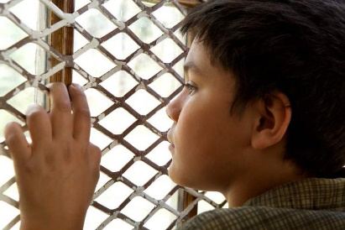
2. You will combine your quotes with other students and create a “found” or “black-out” poem. Your poem should reflect the “big ideas” or theme of the documentary.

Instructions for Found Poems (see example on the back of this sheet)

A. Edit your lines to ‘sound’ like a poem and arrange it to ‘look’ like a poem. You could even do a CONCRETE POEM, where the SHAPE of the poem on the page is a powerful symbol in the film.

B. You do not need to record the sentences the group decides to include in the poem exactly as they appear in the novel –you may edit them for poetic effect.
Example: “The sky was scattered once more with the incredible lamp of stars”
Options: 1. Incredible lamps of stars scattered the sky
2. Sky scattered –incredible lamps of stars
Example: “all men are created equal, educators will gravely tell you” (205).
“will he get justice?” (100).
“a lie as black as Tom Robinson’s skin” (204).
Becomes: All men are created equal?
Justice: a lie as black as Tom Robinson’s skin .

C. Neatly copy your poem onto blank paper, or type it on the computer. Include a Theme for your poem and 2-3 sentences explaining how your poem fits a theme of the film.
D. Give your poem a title.
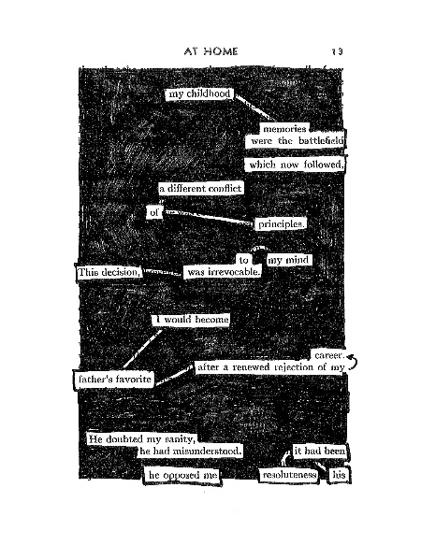
Instructions for Black-Out poems (example to the right of the instructions)

- Combine all the quotes that you have in a typed document and print it.
- Skim the lines for key words you want to use to create a poem
- Circle them with a pencil
- Take a black marker and cover the rest of the words so that only the ones you want are still showing
- Include a Theme for your poem and 2-3 sentences explaining how your poem fits a theme of the film.
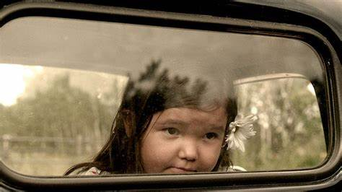
- Give your poem a title

