EFP 10 Name: ____________________
The Paragraph
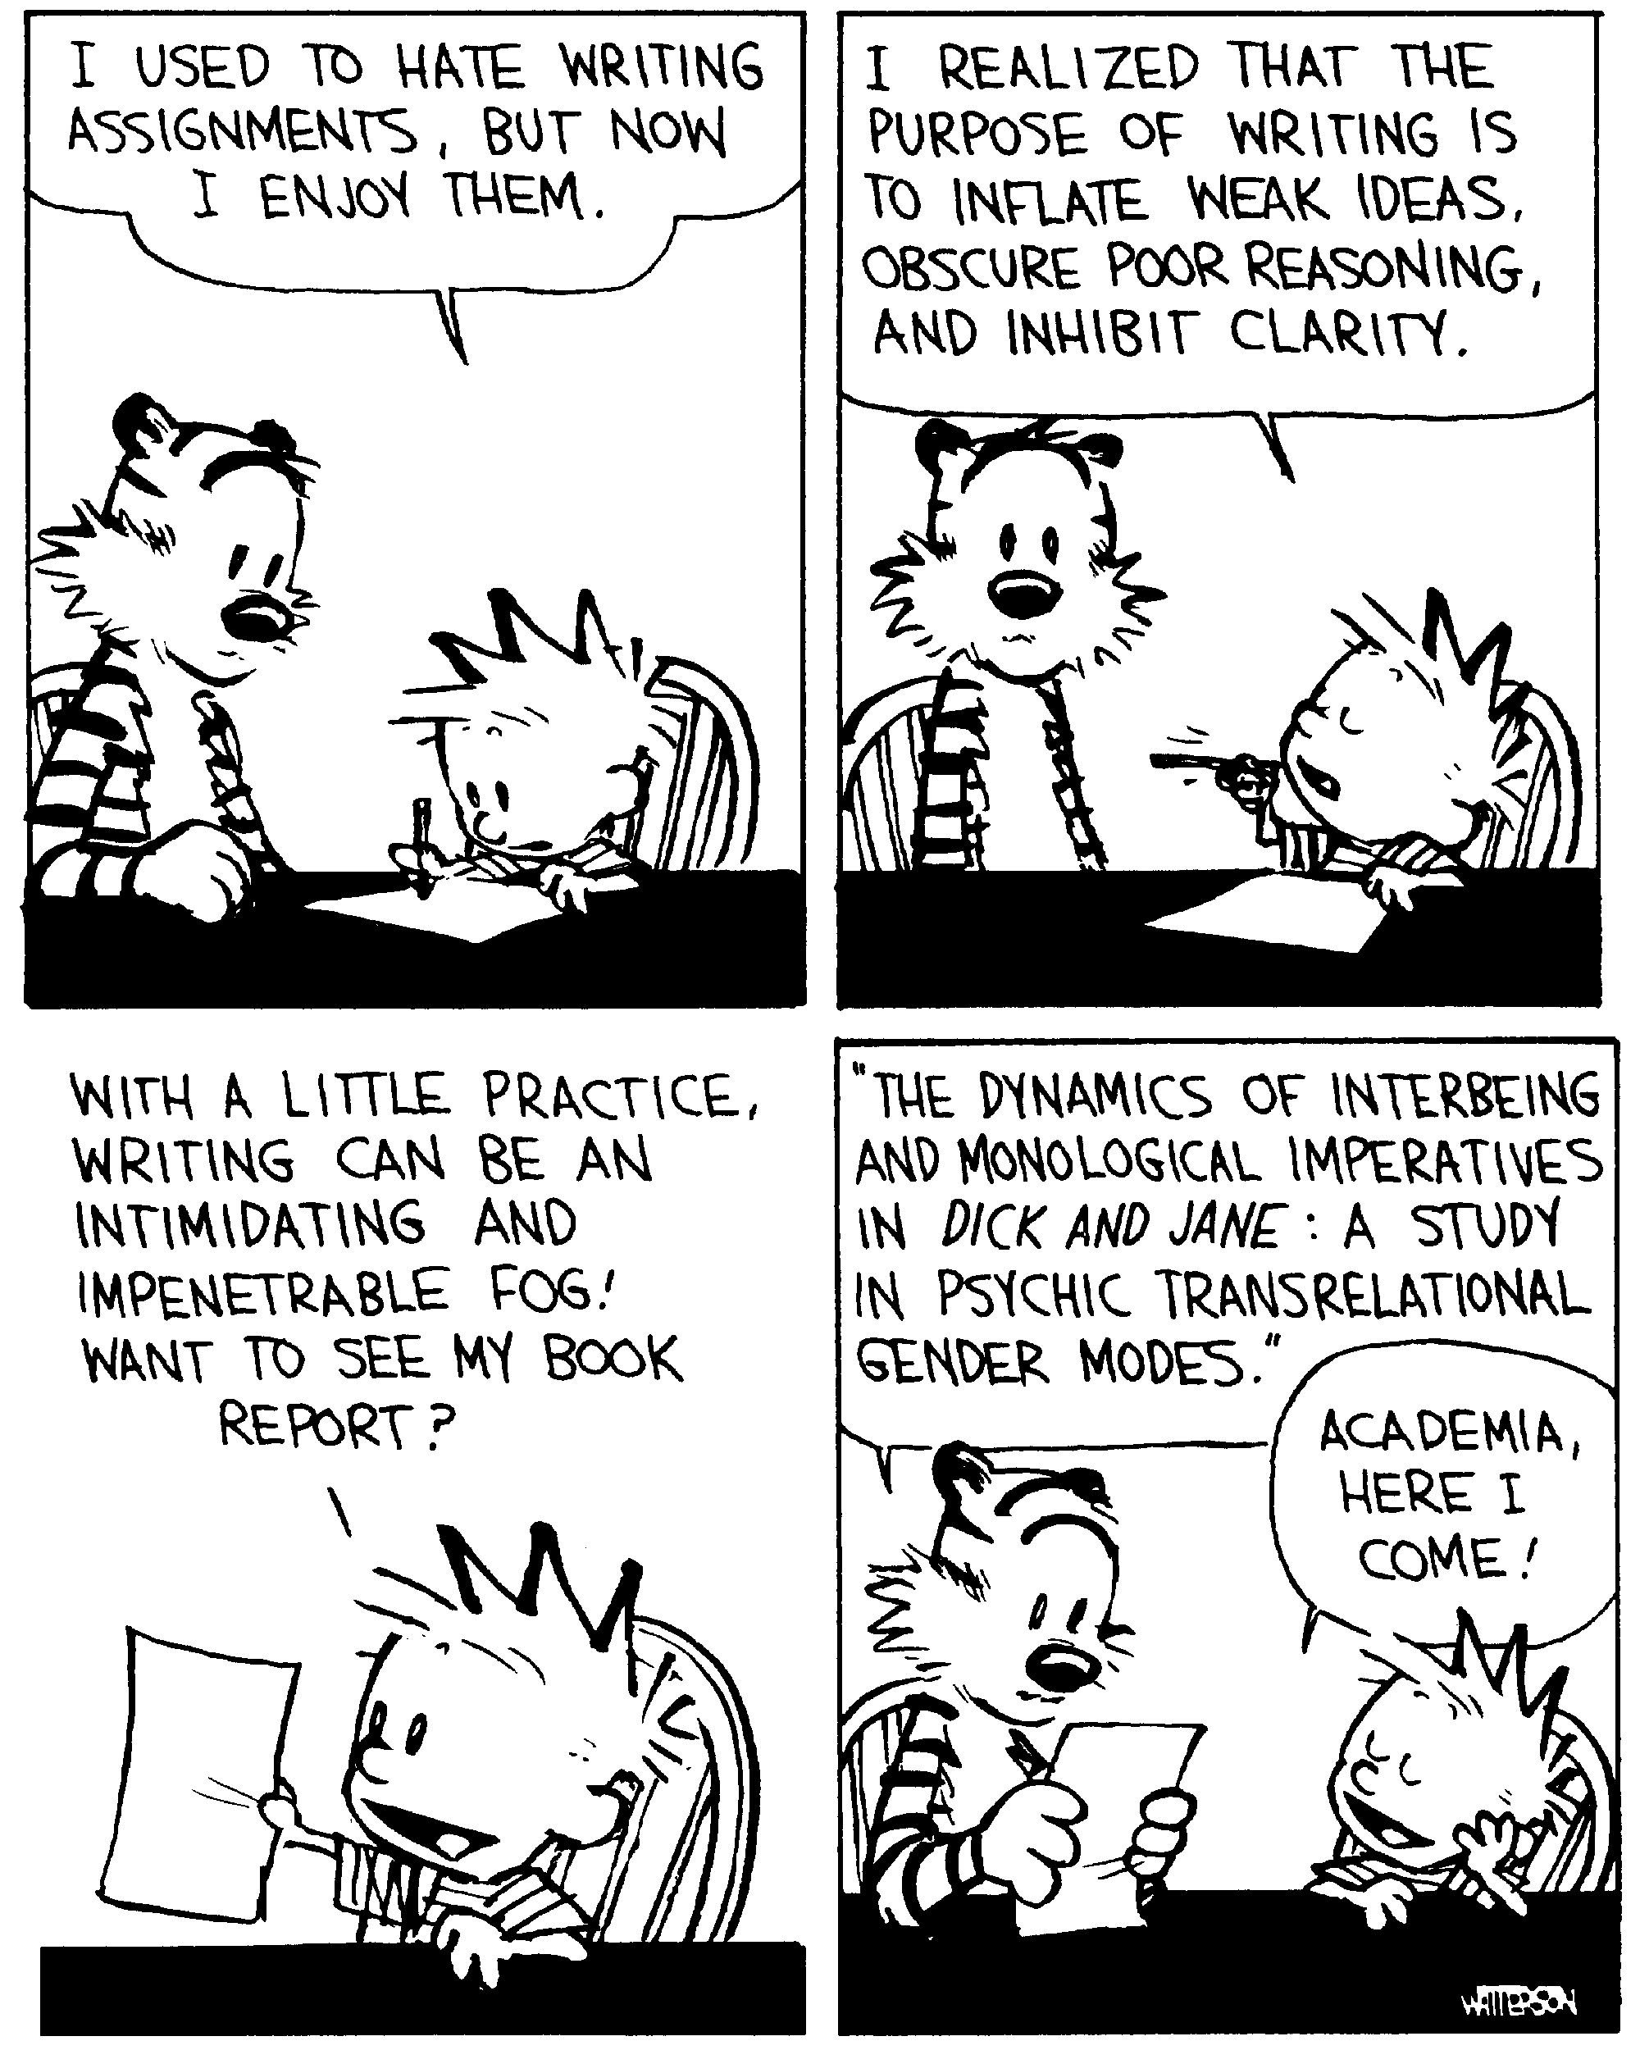
A paragraph is a series of sentences that develop a single topic. It consists of a topic sentence, at least 3 supporting ideas, transition words and a conclusion. When you think of a paragraph, remember the image of a hamburger.

The Upper Bun: The Intro
A Hook: something to get your reader interested in your topic (quote, story, metaphor, question etc.)

Summary (only needed if you are writing about literature): a one sentence summary of the story you are writing about to give the reader contex

The Topic Sentence (also called a thesis):
1. Rewords the ______________________ into a statement.
2. Centers the paragraph around a single main ___________________ that will be developed in the sentences that ____________________.
3. Is specific and __________________ (outlines the argument, contains the ___________________ and the ____________________ of the story).
4. In formal writing (just be safe and assume if you are writing it for school it is formal) NEVER use____________________________________________________________________ or say “In my opinion.” Also, stay in the present _____________________________. Use he, she it, one, they, him, her, or them instead.
Weak (topic: What is the best show on Netflix?) | Better
My Favourite show on Netflix was Grey’s Anatomy. | Grey’s Anatomy is the best show on Netflix because it has action, drama and comedy.
The Meat and toppings:
Supporting Ideas:.
-must have at least ____________
-paragraph should discuss how each point ________________the topic sentence. Use the SEX formula to remind yourself to discuss and explain each example
S (Statement: Mrs. Fitton is awesome)
E (Example: She is one of the world’s tallest midgets)
X (EXplanation: People flock from all corners of the earth to her as she the 9th wonder of the world)

-use ___________ or ________________ ideas from a text (story, movie, article etc) to help support your ideas.
Condiments: Transition words: (words that ______________ your ideas together).
The Lower Bun: Conclusions:
afterwards, also, as well as, at last, at the same time, before, first, for example, immediately,
in fact, later, meanwhile, next, not only, once, otherwise, previously, then, therefore, too, usually,
in comparison, secondly, finally, in addition, consequently, on the other hand, generally, as a result

-restates your main ____________and main _______________ different words
-Ways to conclude in an interesting way: ask a question, state the result of a process, evoke an image, use a quotation, call the reader to action, compare to something else (make a connection). -never introduce new info.

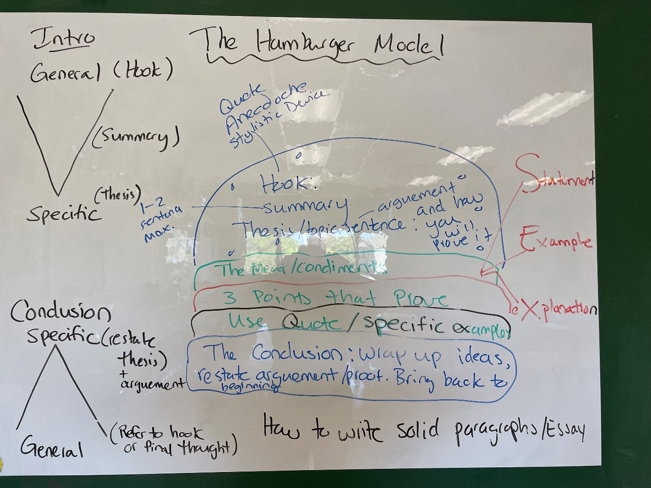
Support 4
Hook:
Topic Sentence:

Support 1 Support 2 Support 3

Conclusion:

