Mrs. Fitton
Summary of Chapter 6,7,8 Name___________________
Social Studies 11 Date:___________________

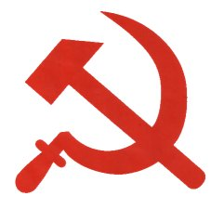
“You're an old-timer if you can remember when setting the world on fire was a figure of speech.”

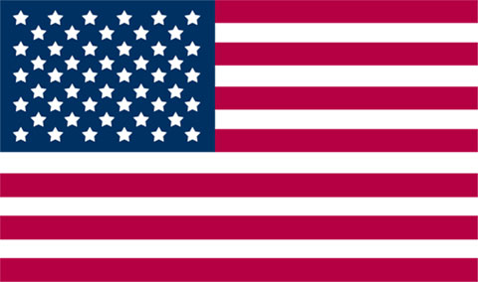
After WW2 the USA and USSR were the two remaining Superpowers on earth. Both developed nuclear weapons; due to the destructive capability of nukes, neither power wanted a direct war between them as it would mean the annihilation earth. Because the rivalry did not erupt into open conflict the period became known as the cold war, where each power sought to spread their influence around the globe. It was a war of ideology: Democracy vs Communism and would be fought through espionage and politics. US Senator Joseph McCarthy presided over the committee on “un-American” activities. Suspected communist could be persecuted, fired or blacklisted from jobs.

Departing from Isolationism, the USA formed NATO (North Atlantic Treaty Organization) with western nations in 1949. An attack on a NATO country meant an attack on members. The USSR countered by creating “The Warsaw Pact” in 1955. They allied with Eastern European countries controlled by themselves. Part of NATO, Canada kept a brigade & air squadrons in Europe & built military bases overseas.
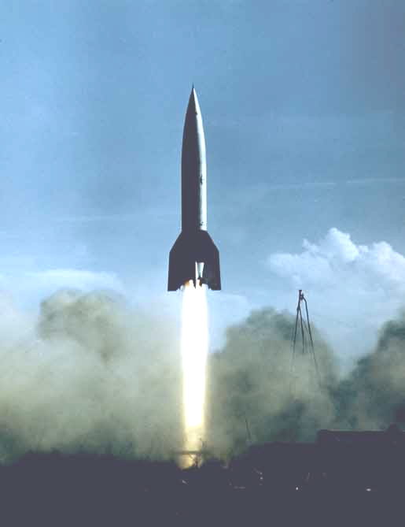
Because missiles could travel overseas, North America became vulnerable to attack. Canada built 3 lines of radar to detect soviet missiles so that a counter-attack could be launched. They were called the Pinetree, Mid-Canada Line and DEW (distant early warning) lines in the Arctic. (See p. 134 text). The creation of the lines to help the USA revealed a loss of independence. In 1957, Canada joined NORAD – a North American air defense program also run by the USA.

The United Nations was created based on the concept of collective security. The General Assembly is where member nations vote on issues of concern and use 3 options against aggressors 1. Condemn through speeches. 2. Use economic sanctions. 3. Respond with military. The Security Council maintains peace and security. BR/FR/USSR/USA/CHINA have permanent seats. 10 other members serve two year terms. The 5 permanent members can each veto to stop any resolution. Canada has been a strong supporter of the UN through various agencies; they have aided during natural disasters; and they have been involved in every major peace-keeping mission since 1956.


HOT HOT HOT

1. Korean Conflict: After WW2 Korea was divided into the Communist North and Democratic South. In 1950, the North invaded the south. The UN sent a peace-keeping mission and Lester Pearson, (Canada’s Min. of External Affairs) urged the sides to a ceasefire in 1953. The threat increased tension.

2. Suez Crisis: In 1956, Egyptian president Gamal Nasser seized the canal from BR/FR investors. When Nasser threatened to close the canal to Israeli ships, Israel attacked (with FR/BR support.) The USSR offered missiles and support to Egypt. The USA threatened retaliation against USSR involvement. Lester Pearson (now PM) proposed the UN enter with a Canadian General to resolve the conflict.

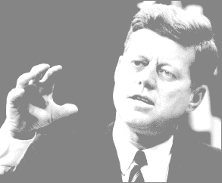
3. Cuban Missile Crisis: In 1962 the USA discovered missile bases in Communist Cuba. US President John F. Kennedy blockaded the island. USSR Premier Nikita Khrushchev eventually agreed to dismantle the bases if the US would not invade Cuba. The event also revealed Canada’s independence. PM Diefenbaker did would not put Canadian NORAD bases on alert & would not allow US planes with atomic weapons to land in Canada.

4. Vietnam had been divided into Communist North and Capitalist South. The USA offered to help the south stop the spread of communism. China and the USSR supported the North, the USA offered supplies and troops to the South. Brutal losses and TV news coverage of massacres forced the US to leave in 1973. Within two months the North crushed the South. PM Pearson openly criticized the war and was castigated by US President Johnson, leading to a strain in Canada-US relations.

“Mankind must put an end to war, or war will put an end to mankind”. ~John F. Kennedy, 1961

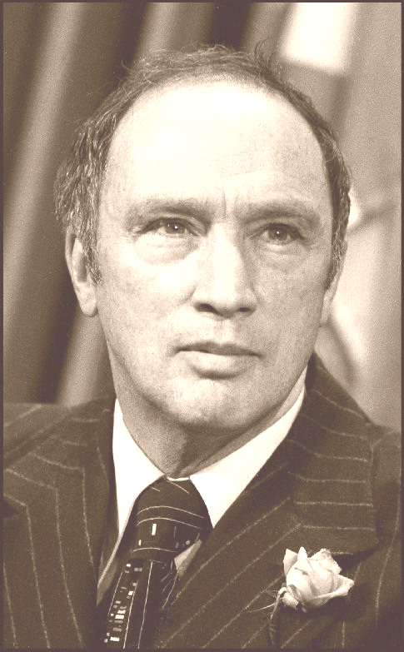
Popular PM Pierre Elliot Trudeau sought to lessen US influence in Canada by recognizing mainland China as a nation. He cut Canada’s defense budget & by 1984 removed all nuclear warheads from Canada to ease int’l tension. Trudeau saw Canada as “middle power” who would provide aid to poor countries and build bridges between communists and capitalists.

By the 1970s the USSR and USA agreed to reduce nuclear weapons during the 1972 SALT (Strategic Arms Limitation Treaty) talks. But tensions increased when the USSR invaded Afghanistan in 1979. Canada boycotted the 1980 Olympics in Moscow; the USA increased defense spending.
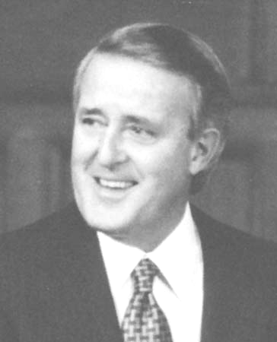

After Trudeau retired, Brian Mulroney was elected PM. He developed a close relationship with the US. Trudeau had created FIRA (Foreign Investment Review Agency) to limit foreign investment that was not of Canadian interest. Mulroney explained Canada was “Open for Business” by introducing free-trade (NAFTA- 1992) with the US and Mexico and removing tariffs. Do you agree with free-trade? (Read pg. 268-70 of Counterpoints!)

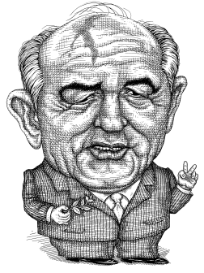
By the late 1980s Soviet leader Mikhail Gorbachev realized that the USSR could not continue the arms race with the USA. He cut military spending and introduced social, political and economic reforms. His policies of Glasnost (openness) and Perestroika (reconstruction) led to the erosion of communism in the USSR and Eastern Bloc countries. The USSR dissolved in 1991. The USA became the sole super-power.

The end of the cold war did not mean peace. Ethnic and regional conflict still exist throughout the world. In 1991 the USA invaded Iraq and declared that the UN and USA should concentrate on Peace-Making (forcing peace through military action) instead of Peace-Keeping (negotiating with warring factions). However, the failure of the UN to keep peace in the Persian Gulf, Yugoslavia and Africa has observers wondering what the future holds for the organization.


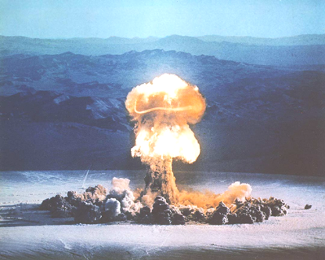
Globalization is a hallmark of the 21st century. Vast networks of business, communications and cultural links exist between all countries on the globe. Countries are now open for business & the internet has led to an increase in communication. Globalization can be positive for business (new markets/new products) but can lead to the loss of jobs to foreign manufacturers.

“The release of atom power has changed everything except our way of thinking... the solution to this problem lies in the heart of mankind. If only I had known, I should have become a watchmaker.”

~Albert Einstein

