Mrs. Fitton THE ROARING 20s
Name:_____________
Date:______________
Social Studies 11
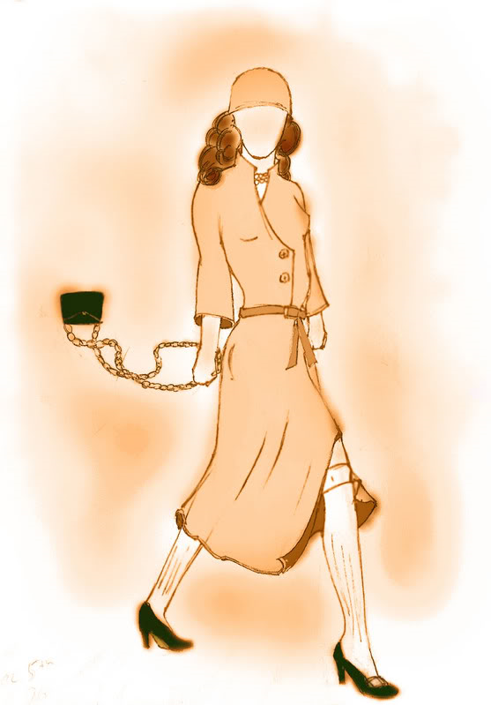
The 1920s are regarded as a decade of fun and prosperity. The era experienced tremendous economic and social growth, but the 1920s did not begin or end with fun and prosperity.

Soldier’s returning from the horrors of the “Great War” were greeted with no social care network and few jobs, since the economy had cooled. Management also refused to allow unionization citing that it was “Communist.” Frustration over poor working conditions led to the Winnipeg General Strike. 30,000 strikers confronted the police. One striker died and 30 people were injured. A later Royal Commission into the event concluded that the striker’s demands had been valid.


Regional challenges also posed problems for Canada in the 20s. Western Canada demanded free trade. However, to protect Eastern Canadian industry, Ontario and Quebec demanded tariffs on foreign imports. This growing division between parts of Canada would eventually lead to the formation of regional parties, like the Progressives.


Four events in the 20s reveal that Canada gained more independence from Britain. First, Canada did not support the British Invasion of Turkey. Second, Canada signed the Halibut Treaty (USA-Can agreement over fishing rights in North Pacific) without Britain’s approval. Third, Prime Minister King challenged the authority of Governor General Byng. Fourth, Canada requested recognition of its autonomy (freedom to govern themselves) in the Balfour Report. Accordingly, in 1931 the Statute of Westminster declared that Canada was now a country equal in status to Britain (Commonwealth).

The 1920s also witnessed economic growth because of Canada’s abundance of raw materials. The USA began to invest heavily in Canada, opening several branch plants. Canada also began to urbanize. By 1931 the number of citizens living in cities outnumbered the rural populace.

Women also made significant gains in the 1920s. With the right to vote, came the right to run in elections. However, women could not become judges because they were not considered “Persons” under law. In the famous “Person’s Case” the famous five (a group of five suffragettes) went to London to get support for the definition of a “person” to include women.

Socially, the 20s were marked by upbeat music, dancing and a change in female fashion. Women wore short skirts and more “provocative” clothing. On the artistic front, the Group of Seven and Emily Carr increased Canada’s sense of national identity through the creation of distinctly Canadian art.
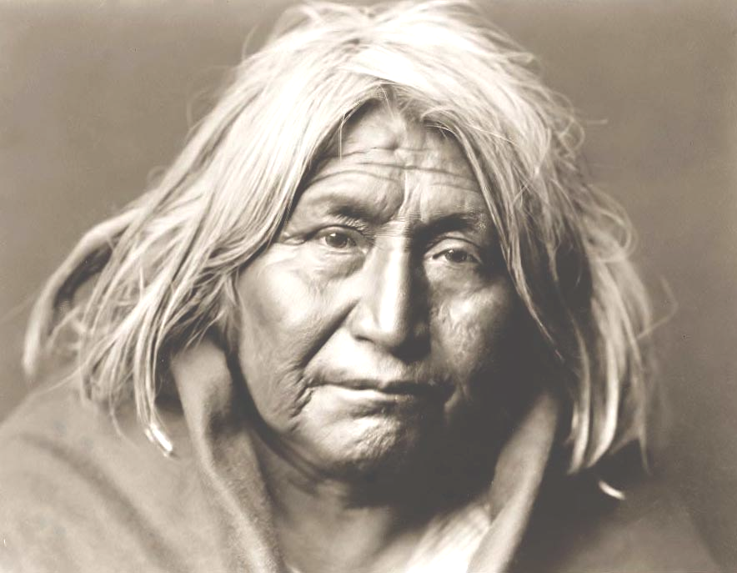
The 1920s did not roar for some segments of Canadian society. Aboriginals could not vote, were placed in residential schools and could not practice traditional ceremonies. African-Canadians were segregated and forced to attend separate schools and theatres in certain parts of Canada. Immigrants from Eastern Europe were often suspected of being communist and were reviled as “job thieves.” Asians fared no better: Japanese and Chinese immigration was tightly restricted.

The roaring twenties concluded on October 29th, 1929 when the New York Stock exchange crashed. The prosperous twenties then descended into the crushing poverty of the 1930s.
VOCABULARY - MANIA
After the 1920s Unit, you should be familiar with the following terms and how they
relate to Canadian history:

Winnipeg General Strike________________________________________________________________
Veteran_____________________________________________________________________________
Strike_______________________________________________________________________________
Socialism____________________________________________________________________________
Communism_________________________________________________________________________
Collective Bargaining__________________________________________________________________
One Big Union (OBU)_________________________________________________________________
Royal Commission____________________________________________________________________
CCF________________________________________________________________________________

Regionalism_________________________________________________________________________
The National Policy___________________________________________________________________
The Progressive Party__________________________________________________________________
Minority Government__________________________________________________________________
Arthur Meighen_______________________________________________________________________
Mackenzie King______________________________________________________________________
Chanak Crisis________________________________________________________________________
King-Byng Crisis_____________________________________________________________________
Balfour Report_______________________________________________________________________
Autonomy___________________________________________________________________________
Statute of Westminster_________________________________________________________________

Branch Plants________________________________________________________________________
Plebiscite____________________________________________________________________________
Prohibition__________________________________________________________________________
Urbanization_________________________________________________________________________

Agnes Macphail______________________________________________________________________
The Person’s Case____________________________________________________________________
Emily Murphy_______________________________________________________________________
Indian Act___________________________________________________________________________
Aboriginal Title_______________________________________________________________________

