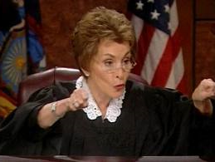
Mrs. Fitton Name:
Socials 9
TRIAL OF CHARLES STUART ROLES
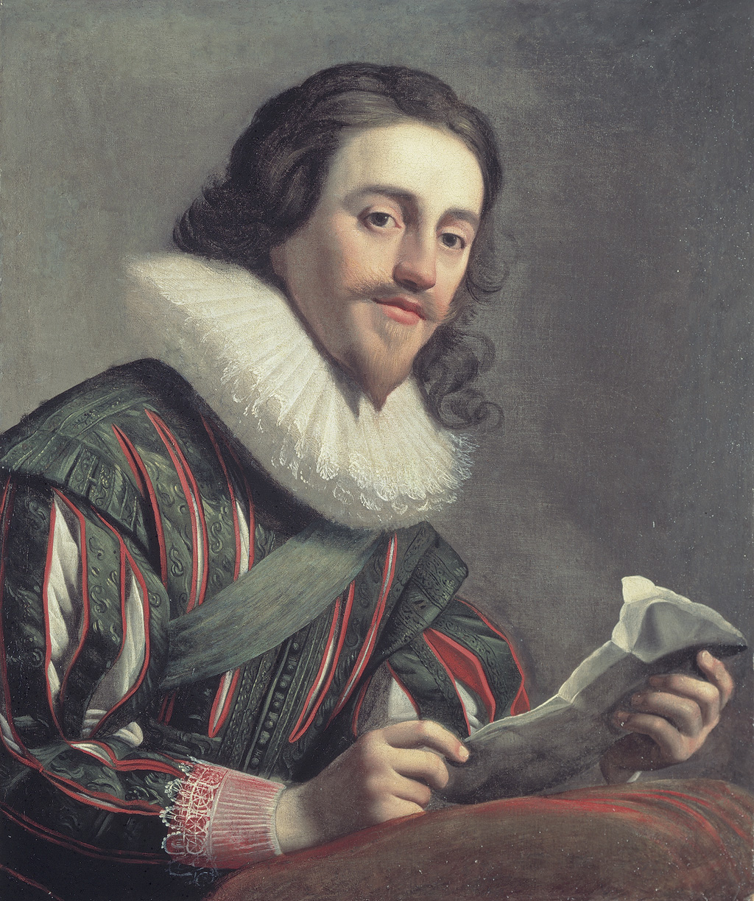

1) Charles Stuart
2) Judge
PROSECUTION
3) 1st Lawyer Charles I
4) 2nd Lawyer
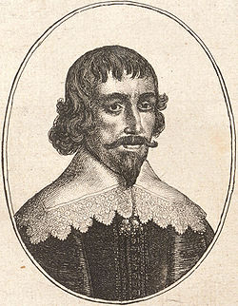
WITNESSES FOR THE PROSECUTION
5) Walter Prynn
6) Peasant
7) Puritan
8) Member of Parliament
DEFENSE
9) 1st Lawyer
10) 2nd Lawyer Walter Prynne
WITNESSES FOR THE DEFENSE
11) Charles II
12) Stratford or Laud (back from the dead)
13) Henrietta Maria 14) Professional Dwarf
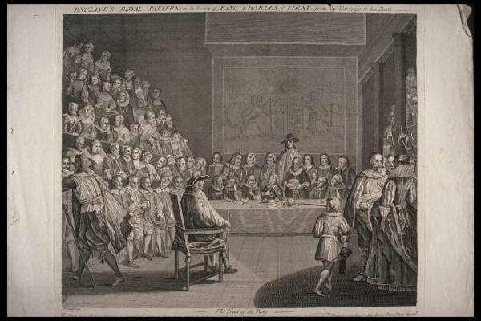
JURORS/ COURT STAFF
15) Juror 1
16) Juror 2
17) Juror 3
18) Juror 4
19) Juror 5
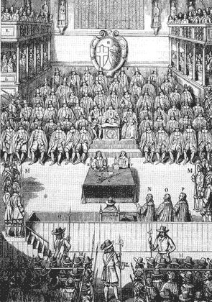
20) Juror 6
21) Juror 7
22) Juror 8
23) Juror 9
24) Juror 10
25) Juror 11
26) Juror 12
Roles in the Trial of Charles Stuart
People Conducting the Trial | Witnesses for the Prosecution | Witnesses for the Defense
Judge | Puritan | Charles II
Crown Council | Peasant | Stratford or Laud
Defense Counsel | Walter Prynn | Henrietta Maria
Sheriff | Parliament Member | Professional Dwarf
Jurors |  | Charles 1
Our class is going to conduct a re-trial of Charles and decide for ourselves whether he was guilty of high treason. You are expected select a role in the trial, research that role and prepare what you will say in the trial. Every student must submit notes outlining whether or not Charles was guilty or innocent. The notes will help you write a paragraph on the test.

Evaluation for the Trial:

Chart/notes /15 / 5 (Participation, Enthusiasm, Preparation) Total: /20

Trial Terms
Acquit: To declare a person “not guilty”
Badger: When an attorney seems overly argumentative or harsh on a witness
Counsel: A lawyer or group of lawyers who conduct a case in court.
Defendant: The accused/prisoner on trial.
Foreman: The member of the jury that speak on behalf of them.
Hearsay Evidence: Testimony based on what a witness has been told by another person and not on things he/she has seen or heard themselves; such evidence is not usually admissible.
Hung Jury: A jury that cannot reach a verdict due to strong disagreement between members.
Leading Question: A question put to a witness in such a way as to suggest the answer he should give. Such questions are not allowed in direct-examination, but can be used in cross-examination.
Objection: The process of challenging the validity or admissibility of evidence presented by the opposing side. Can also be used to challenge the way the opposing side is asking questions
Recess: A short break in a trial.
Sentence: The punishment given to a person convicted of a crime.
Sheriff: Officer of the court; protects those in court; ensures accused remains in custody.
Testify: To give evidence under oath or affirmation.
Verdict: The decision of a jury on the case considered. The decision in a criminal trial must be unanimous.

Court Setup and Terms to Know
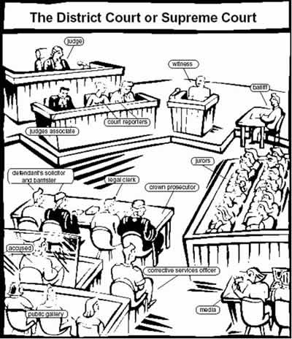
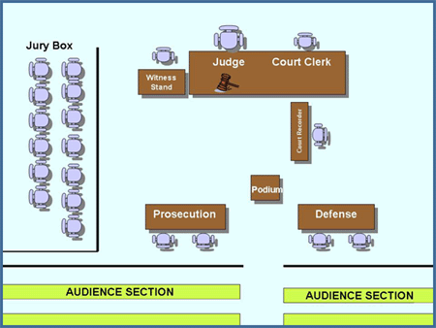

Stages in a Criminal Trial:
1. Arraignment: The accused stands up, the court clerk reads the charges against him and makes a plea (guilty or not guilty)

2. Opening Addresses:
The crown counsel makes an opening statement, summarizing what he will argue.
The defense counsel makes an opening statement, summarizing arguments.

3. Crown Calls Evidence:
A. Examination in Chief: The prosecutor must ask OPEN questions which let the witness tell their story. Questions which require only a YES/NO answer may be considered leading questions. Witnesses for the crown should help prove the Crown’s case.

B. Cross-Examination: Opportunity for the defense to weaken the Crown’s case by questioning the credibility of the witnesses.

C. Re-Examination (redirect): Chance for the Crown prosecutor to re-establish credibility (ask any additional questions that come to mind).

4. Defense calls Evidence: (Same procedure as above)

5. Closing Addresses: Crown and Defense both make closing statements, summarizing their arguments and trying to influence the jury.

6. Jury decision, Verdict Read, Defendant Sentenced.

So you are the CROWN PROSECUTOR

The Crown must help maintain law & order in our society.
When a crime is committed, the Crown’s job is to bring all the facts of the crime to the courtroom.

The Crown must prove: (to a certainty, beyond a reasonable doubt)

1. the date
2. the place
3. that the crime was committed
4. that the accused is the culprit
5. that all the elements of the crime have been fulfilled

STRATEGY NOTES

1. Read the applicable law. Know what you have to prove.

2. Talk to the witnesses & find out the following:
what happened?/where?/when?/who was at the scene of the crime?/intention?

3. PLAN HOW TO GET YOUR INFORMATION INTO COURT

a) Opening Statement - Purpose - to inform the judge of the nature of the case & to acquaint the court with the essential facts.
Include - name of the case/your name & colleague’s name/opponent’s name/facts & circumstances that led to the charge/conclusion.
Avoid - too much detail/testimony of each witness.

b) No leading questions of witnesses during direct examination.
A witness must tell what happened without any prompting

Correct  Tell the court what you saw.  How fast was the car travelling? | Incorrect  Did you see the green truck hit the red car?  Would you say the car was travelling at 100 km/hr?

No hearsay - may only ask witness their opinion about things which he saw or experienced.

No opinion - may not ask your witness their opinion about things other than common knowledge unless he is an expert in the field.

4. Anticipate your opposition - once you have prepared your case, you should spend time thinking about the other side’s case.

5. Cross Examination - you may ask leading questions of witnesses called by the defense lawyer. You want to show biases, mistakes, contradictions and to bring out further evidence concerning the case.
Never ask a question unless you know what the answer is. You may receive a statement that defeats your case.

6. Objections - if you think the defense is not following the rules of evidence you should object.

Objection your Honour.  Objection your Honour.  Objection your Honour.  Objection your Honour.  Objection your Honour. | The question is irrelevant.  That evidence is hearsay.  Counsel is asking for an opinion.  Counsel is leading the witness.  Counsel is harassing the witness.

The judge then stops the examination and may ask the defense to explain why he is pursuing that line of questioning. The judge then makes a decision.

Overruled - the defense. may continue.
Sustained - the defense must withdraw the question.

At the trial, the judge’s word is final.

7. Closing Statement - Be sure you tell the judge how you have proven your case.
The Crown must prove:

a) the date
b) the place
c) that the crime was committed.
d) that the accused is the culprit.
e) that all the elements of the crime have been fulfilled.

So you are the DEFENSE LAWYER

The defense lawyer’s job is to protect the rights of the accused. The defense does not have to prove anything - although a suitable defense should be prepared.

STRATEGY NOTES

1. Read the applicable law. Pick out all the elements, so you know what the Crown must prove.

2. Talk to the witnesses & find out the following:
what happened?/where?/who was at the scene of the crime?/intention?

3. PLAN HOW TO GET YOUR INFORMATION INTO COURT

a) Opening Statement - Purpose - to deny that the Crown has a valid cause & to outline (generally) the facts from the standpoint of the defendant.
Include - your name & colleague’s name/general theory of defense/facts that tend to weaken the Crown’s case/conclusion.
Avoid - too much detail/testimony of each witness/exaggeration & argument/strong points of the Crown’s case.

b) No leading questions of witnesses during direct examination.
A witness must tell what happened without any prompting.

Correct  Tell the court what you saw.  How fast was the car travelling? | Incorrect  Did you see the green truck hit the red car?  Would you say the car was travelling at 100 km/hr?

No hearsay - may only ask witness about those things which he saw or experienced.

No opinion - may not ask your witness their opinion about things other than common knowledge unless he is an expert in the field.

4. Anticipate your opposition - once you have prepared your case, you should spend time thinking about the other side’s case.

5. Cross Examination - you may ask leading questions of witnesses called by the Crown. You want to show biases, mistakes, contradictions and to bring out further evidence concerning the case.

Never ask a question unless you know what the answer is.
You may receive a statement that defeats your case.

6. Objections - if you think the Crown is not following the rules of evidence you should object.

Objection your Honour.  Objection your Honour.  Objection your Honour.  Objection your Honour.  Objection your Honour. | The question is irrelevant.  That evidence is hearsay.  Counsel is asking for an opinion.  Counsel is leading the witness.  Counsel is harassing the witness.

The judge then stops the examination & may ask the Crown to explain why he is pursuing that line of questioning. The judge then makes a decision.

Overruled - the Crown may continue

Sustained - the Crown must withdraw the question.

At the trial, the judge’s word is final.

7. Closing Statement - the crown must prove everything about the crime. The Crown must prove:

a) the date
b) the place
c) that the crime was committed
d) that the accused is the culprit
e) that all the elements of the crime have been fulfilled

The Crown must prove all these things to a certainty beyond a reasonable doubt.

If the crown fails to prove any of these things point them out to the judge in your closing statement

So you are the WITNESS or the ACCUSED

Witnesses and the Accused are the people who have seen or experienced the event in question.

Their task is to answer the lawyers’ questions.
They must answer clearly and truthfully so that the judge can understand what really happened.

STRATEGY NOTES: How to be a Witness or an Accused in a Mock Trial:

1. BEFORE YOU BEGIN, you will need to think about the following ideas:

a) Who are you?

When you play one of the roles in a mock trial, you need to know as much as you can about WHO that character is. Imagine what it feels like to be a witness or an accused. What would a witness or accused wear in court? How would they walk into the courtroom. How would they speak?
What kind of language would they use?

b) What is important in a trial?

An accused is innocent until proven guilty. Think about this idea. What does it really mean? How would a trial be different if we didn’t believe in this idea? Keep this idea in mind throughout the trial.

c) What happens in a trial?

A trial is a formal event. You have received materials which outline the correct steps for holding a trial. Make sure you know what the steps are and why they happen, before you begin the trial.

2. BEING INTERVIEWED BY THE LAWYERS

a) Read the fact sheets; do your research well.
b) Tell the lawyer who interviews you what happened and how you became involved.
Don’t tell anyone else. They will hear what you have to say in court.
c) If you find that there are details you must add, speak to your teacher about them.

AT THE TRIAL

a) You should remember that a witness gives information not only through the words they say but also through manners, clothes and attitude. Your dress and manner should reflect the character you want to show.
b) During the trial, answer the lawyers’ questions as honestly as possible. A witness’ evidence is the only information a judge has about what happened.
c) Tell your story to the court as clearly and completely as you can, without prompting.
d) After you give your evidence, you will be cross-examined by the lawyer representing the other side.
The lawyer will ask questions about parts of your evidence. Answer their questions clearly but as briefly as possible.
- If a lawyer asks you a question you can’t answer, tell them you don’t know.

Crime: Charles is accused of treason. Treason means acting against the government or trying to overthrow it.

For the Prosecution (Guilty)
-Notes on the causes of the civil War
-Pg. 28-38 in Crossroads
-Notes on negative aspects of an absolute monarch

For the Defense (Not Guilty)
-Pg. 29 in Counterpoints quote about The Divine Right of Kings
-Notes on the positive aspects of an absolute monarch
-Pg. 34, 37 & 38 in Counterpoints

I am playing ___________________________________________
Who I am and what I would believe________________________________________________________
____________________________________________________________________________________________________________________________________________________________________________________________________________________________________________________________________________________________________________________________________________________

Innocent (at least 5 reasons) | Guilty (at least 5 reasons)

