Timmothy Lezard
When/where were born: June 1st, 1972
Penticton Indian Band council
“I changed their minds in the first 30 seconds of meeting them”
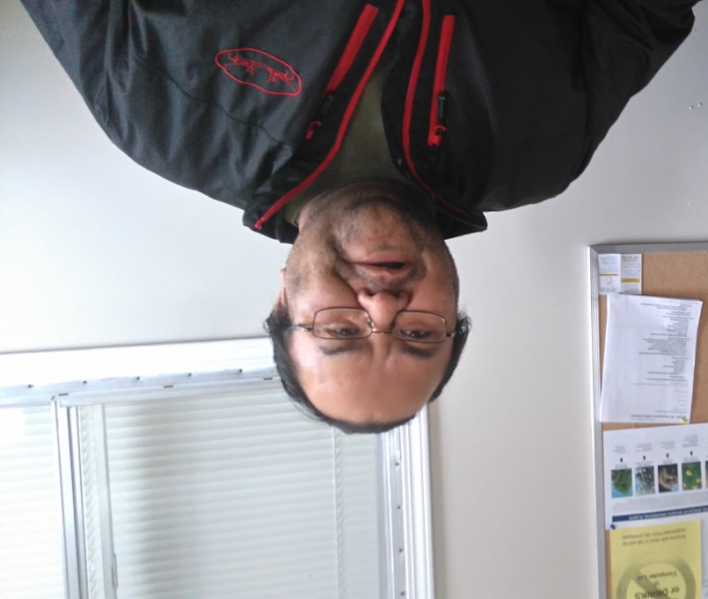
“My first class at South Okanagan Secondary School was honors science 10. The teacher asked me 3 times if I was in the right class. Can you believe it? 3 times. Each time I answered ‘well is this Science honors 10’ and he’d said ‘yes’ and then ask me again. Once he finally believed that I was in his class, he started asking us all questions. The first one was something like ‘What do you call an energy releasing chemical reaction?’ I waited for a while to see if anyone was going to answer but no one did. Everyone was just looking at one another thinking each other had the answer. After a few seconds I said to the teacher ‘well, it’s an exothermic reaction isn’t it?’ Suddenly the whole class started muttering to each other in stun. Then the teacher asked another question and again no one answered so I did and this time the class was silent. All of them had already made up their minds before I arrived about what I was going to be like because I had long hair and was an Aboriginal.”
“Did their minds change after they met you that day?”
“I changed their minds in the first 30 seconds of meeting them.”

