IS 4 Name: ________________________
Child Labour The Young and the Rightless

Directions: Use the historical documents to reconstruct the working conditions for children during the Industrial Revolution by answering the question below for a Chimney Sweep, Miner or Factory Worker

Chimney Sweep
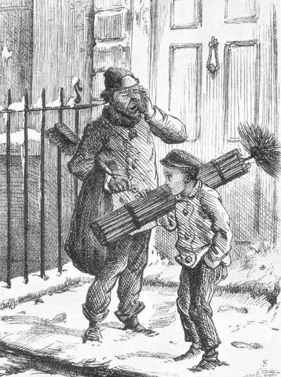
1. The Average length of a working day of the child

2. Coffee and Lunch breaks

3. The Safety conditions (include accident or accident reports)

4. The Health conditions (include the unhealthy conditions)

5. The age of the workers

6. The treatment by their supervisors.

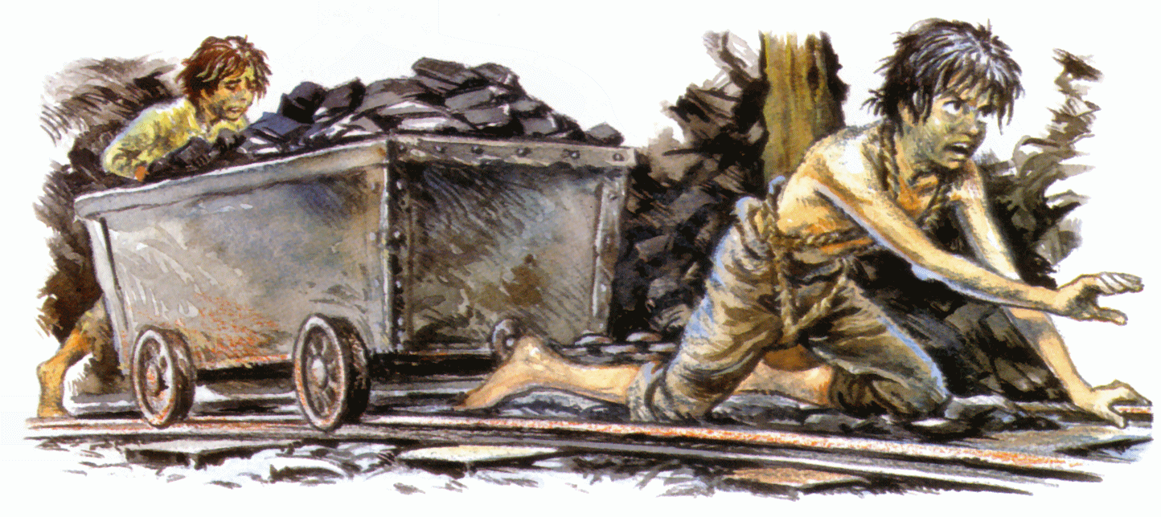

Miner

1. The Average length of a working day of the child

2. Coffee and Lunch breaks

3. The safety conditions (include accident or accident reports)

4. The Health conditions (include the unhealthy conditions)

5. The age of the workers

6. The treatment by their supervisors.

Factory Worker
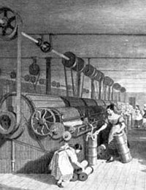
1. The Average length of a working day of the child

2. Coffee and Lunch breaks

3. The Safety conditions (include accident or accident reports)

4. The Health conditions (include the unhealthy conditions)

5. The age of the workers

6. The treatment by their supervisors.

The Factory Act of 1802
-All factory rooms must be well ventilated and lime-washed twice a year.
-Children must be supplied with two complete outfits of clothing.
-The work hours of children must begin after 6 a.m., end before 9 p.m., and not exceed 12 hours a day.
-Children must be instructed in reading, writing and arithmetic for the first four years of work.
-Male and Female children must be housed in different sleeping quarters.
-Children may not sleep more than two per bed.
-On Sundays children are to have an hour's instruction in the Christian Religion.
-Mill owners are also required to attend to any infectious diseases.
-Fines of between £2 and £5 could be imposed on factory owners, but the Act established no inspection regime to enforce conditions. The act failed to provide a clear law of the hours one is permitted to work and failed to include supervision to make sure the law was being followed. The law was largely ignored by the factories but paved the way for more factory acts to follow.

Factory Act of 1878
-This Act brought all the previous Acts together.
-Now the Factory Code applied to all trades.
-No child anywhere under the age of 10 employed.
-Compulsory education for children up to 10 years old.
-10-14 year olds only be employed for half days.
-Women were to work no more than 56 hours per week

