- The Industrial Revolution (finally a revolution where the monarch gets to keep their head)
Hi, I’m Queen Victoria and I get to keep my head!

Introduction
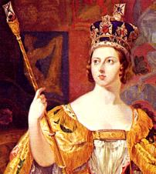
-started in approximately the 1700
-transformed society
-continues even now
-real beginning of the modern world as we know it today

-changes for your great-grandparents:

*Cars and airplanes

*Television and satellites

-Changes for you: Smart phones, Social Media

Who comes to find you if you are in trouble (ie. Too many late slips). Go see this person for information on European society before the Industrial Revolution and during/after the Revolution.

- BEFORE/AFTER The Industrial Revolution

Old Society New Society

1. Farms 1. Factories/cities

2. Britain made/used what 2. Get materials from
it had in its own country colonies (like Canada!)

3. You interacted and 3. “The earth was made for
enforced technology Dombey and Son to trade in on the land by building the sun and the moon were
a house or a farm made to give them light.
Rivers and seas were made
to float their ships”
-Charles Dickens
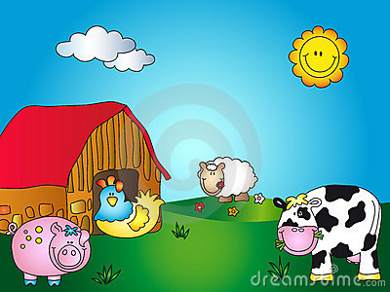
Quote show that Victorians saw the environment as something to control and manipulate, not adapt to.
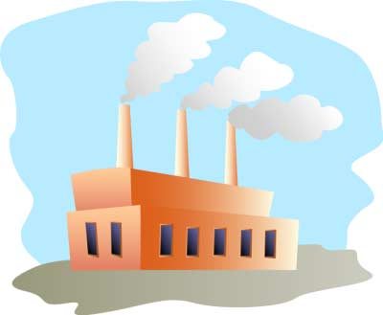

Need something interesting to read? Need a quiet place to work? Where do you go? Look outside this place to find out why the Industrial Revolution happened in Britain first.
- Why Britain First?

1. Labour supply (serfs kicked off lands during enclosure so unemployed and population growth)

2. Middle class had influence in government (because many were in the parliament), so they passed laws that favoured business

3. Test Act prohibited Catholics from the army/church and government; so have to go into business, have $ to invest.

4. Raw material at home (coal) and in colonies (wood etc)

5. Government supported technology/science (many inventions)

6. New farming technology

7. Good Transportation (waterways, roads, trains)

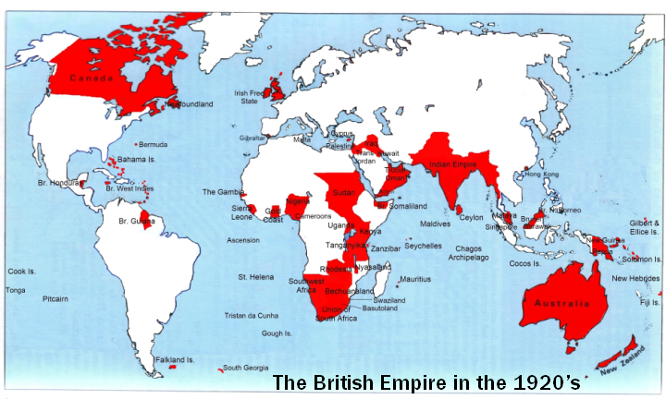
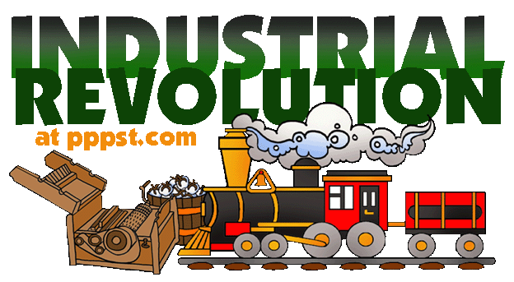
8. Could sell finished products to colonies (so have a market)

Go to the place in the school where you can hear heavy metal music blasting, smell oil paints and pottery clay and there you will find information on the Agricultural Revolution

- The Agricultural Revolution

Medieval Times:

Feudal system = inefficient
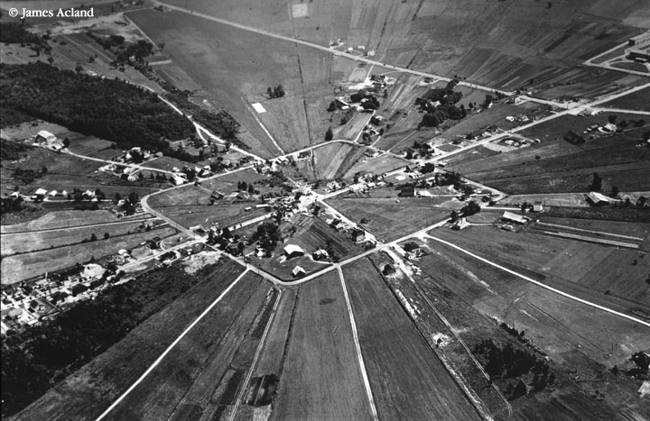

Enclosure (started in Renaissance) sped up in 1700s

-Enclosure (definition): taking away small parcels of land from serfs and combining them in to large farms

Want to change your timetable? Need someone to talk to about personal issues? Ask this person and as a bonus find information on new attitudes towards farming.

5.New Attitudes Towards Farming

*Farms now for money/business (not just survival)

*Farmers now want technology to advance farming techniques

*Can now grow enough food to feed a city

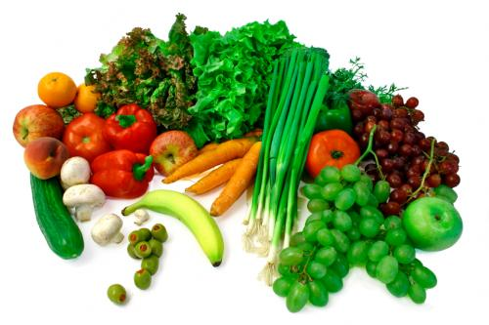

You decide you want to ripped for beach season. Go to the place where you can work off your Christmas cookies and there you will see information on new breeds of animals

- New Breeds of animals

-Before animals kept for milk and wool

-Lacked enough fodder (animal food) to keep over winter so they killed them before winter and ate them

-Bred new sheep that had thicker wool and animals with more meat. Also heartier so that they get less diseases

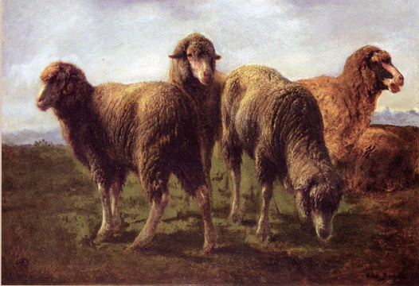

Look where all the teachers go to eat their lunch for information on new crop techniques and technology for farming!

7. New Crops Techniques and Farming Technologies

-Now that farms are for profit and not just survival, farmers willing to invest money in farming techniques that will make them richer

-Goal is to make an acre of land produce more crops (and therefore $), while lowering the cost of raising the crops

8. Two New Crops Techniques and Technologies

Technology

Jethro Tull’s Seed Drill

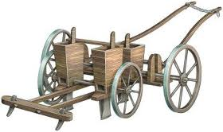
-When soil is broken up (cultivated) and enriched with manure, crops grow better.

Quit “Horsing around” and go to the place where Maggie’s mascot stands proud for the community to see and find out why Jethro Tull’s Seed Drill was better than the old method of broadcasting.

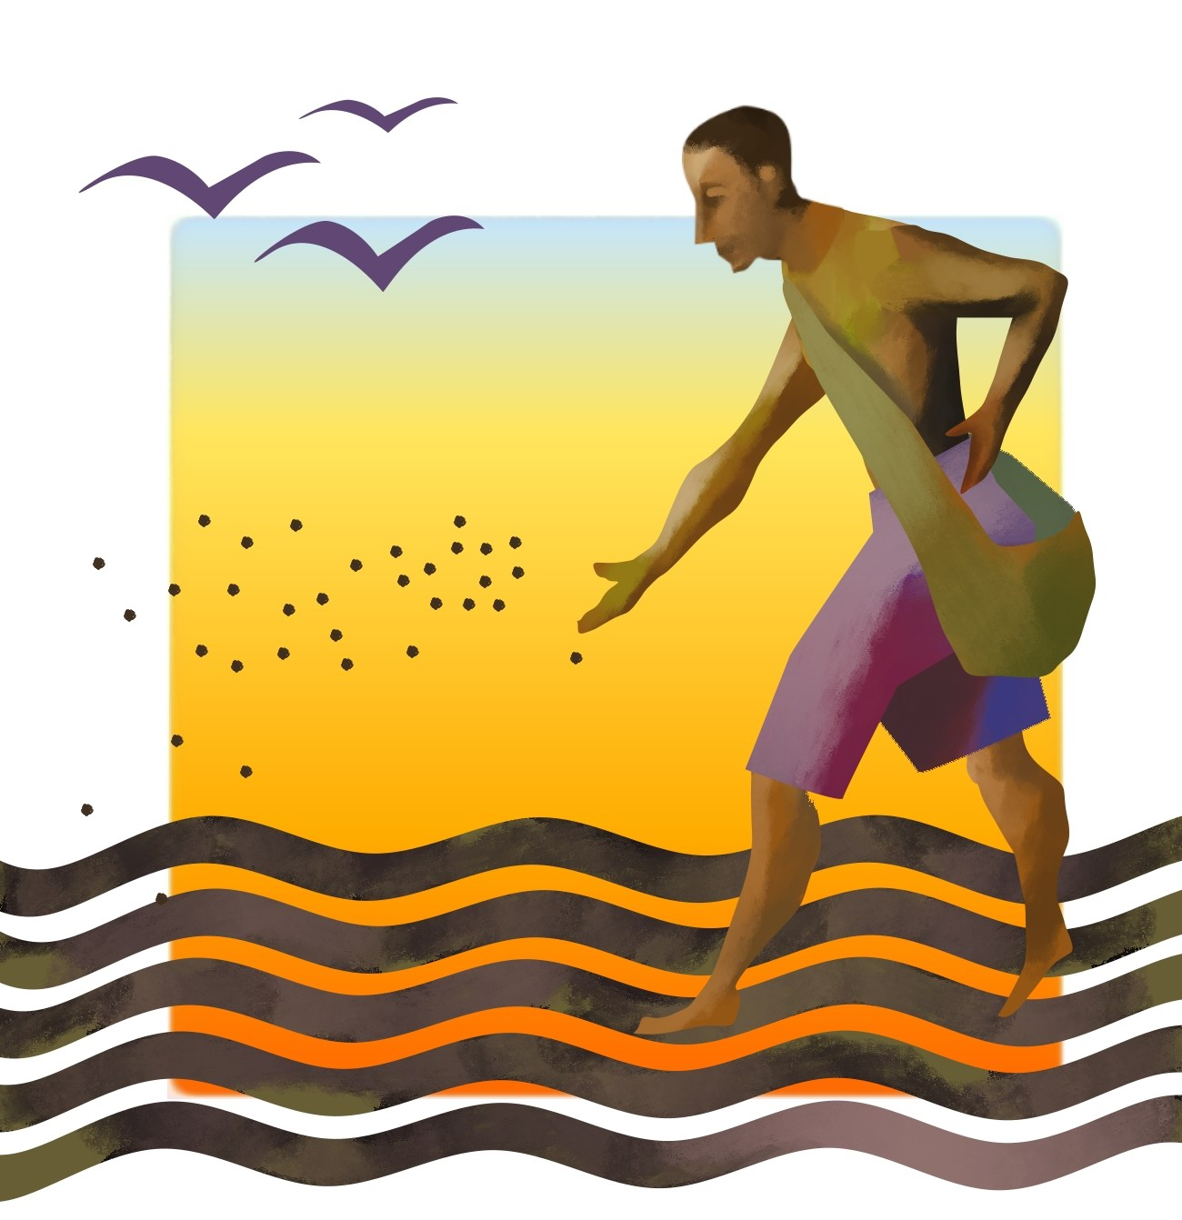
The Seed Drill
Why this was better than the old method?

Old Method= Broadcasting

Wasteful and the birds eat the seeds

Why the New Method is Better

*Less Waste
*Rows = faster (to plant and upkeep)
*Can farm with fewer people
*Weeding easier
*Less eaten by animals
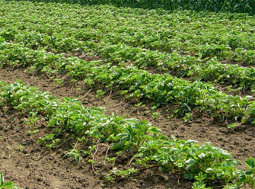

If you need help in with your classes or need a quiet place to work you might go to this room and hang out with Mr. Redford and Mrs. Darby or to find information on Turnip Townsend!

10. Turnip Townsend

*No need to keep one field fallow (empty) like in Medieval times

*Turnips and Clover release nutrients into the soil and are inexpensive fodder for animals

*Easier to maintain larger crops, now cities can grow (can feed people who don’t work on farms)
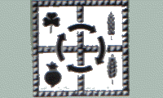

Hablas Espanol? Who would you go to ask how to say “The Industrial Revolution” in Spanish or French? (again, go to the class, not in it)

1. Where do you go to sign in or out of the school or pay your school fees? Go outside this area to discover our last Statement of Inquiry for this class

2. Need something interesting to read? Need a quiet place to work? Where do you go? Look outside this place to find out how the Industrial Revolution changed our lives.

3. Go to the place in the school where you can hear heavy metal blasting, smell oil paints and pottery clay, and there you will find information on what life was like before and after the Industrial Revolution

4. Want to change your timetable? Need someone to talk to about personal issues? Go there to find out why the Industrial Revolution happened in Britain first.

5. You decide you want to ripped for beach season. Go to the place where you can work off your winter weight, play basketball or archery and there you find out about the Agricultural Revolution,

6. Quit “Horsing around” and go to the place where Maggie’s mascot stands proud for the community to learn about “Enclosure.”

7. Want to learn how to make a table, chair or anything out of wood? Head to this location for information on
to find information on new breeds of animals.

8. Hablas Espanol? Who would you go to ask how to say “The Industrial Revolution” in Spanish or French? (again, go to the class, not in it). There you will find out about new farming technology during the Industrial Revolution.

