English 10 First Peoples Name(s):

Tradition Vs. The Modern World Short Story “The Country Between Us” by Richard Wagamese

Part A: Things to work on the bus/walk:

Think about the following 2 quotes. Which one do you personally agree with more? Discuss with your partner and be prepared to explain why you picked the quote you did.

Quote 1: “The earth was made for [businesses to make money], and the sun and moon were made to give them light. Rivers and seas were formed to float their ships" (natural resources are there to benefit people)

Quote 2: “We cultivated our land, but in a way different from the [other people]. We endeavor to live with the land; they seemed to live off it”

Now answer the following questions:

1. In what ways do you use the land? Think of the many ways the land provides for you daily (from the time you wake up until the time you go to sleep).
______________________________________________________________________________________________________________________________________________________________________________________________________________________________________________________________________________

2. How does it make you feel? What does it do for your mind, body or spirit?
______________________________________________________________________________________________________________________________________________________________________________________________________________________________________________________________________________

3. How do you show appreciation for the land? ____________________________________________________________________________________________________________________________________________________________________________________

4. Name 4 plants that you see (the actual name of the plant, not just “tree”)

a.

b.

c.

d.

5. Record 5 different examples of mankind overpowering nature (building something or using industry that destroys the natural environment).

a. c. e.

b. d.

WHILE WE WALK PART 1: Read this excerpt of Braiding Sweetgrass by Potawatomi author Robin Wall Kimmerer. In this section, Robin describes her Indigenous culture’s worldview of land.

“…. One thing our people could not surrender was the meaning of land. In the settler mind land was property, real estate, capital, or natural resources. But to our people, it was everything: identity, the connection to our ancestors, the home of our nonhuman kinfolk, our pharmacy, our library, and the source of all that sustained us. It was a gift not a commodity.” (Wall-Kimmerer, 2015, p.17)
Wall-Kimmerer, R. (2015). Braiding Sweetgrass: Indigenous Wisdom, Scientific Knowledge and the Teachings of
Plants. Milkweed Editions, Minneapolis.
WHILE WE WALK PART 2: Read the description of how the Syilx/Okanagan people traditionally lived in this area. Look at this map of the traditional territory of the Okanagan Nation → a group that represents 8 unique communities in the Okanagan.
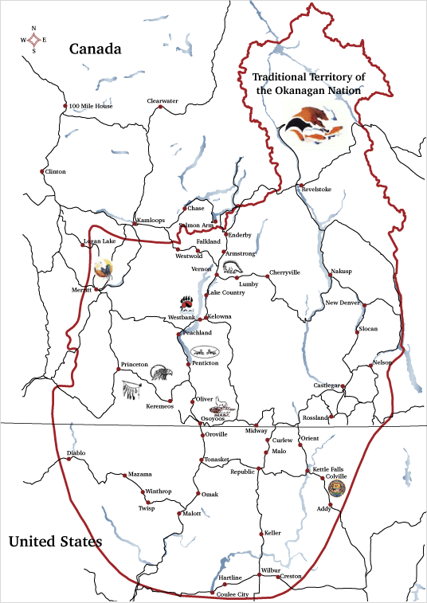
For thousands of years, the Okanagan people were self-reliant and well provided for through their own ingenuity and use of the land and nature. We lived united as a nation with a whole economy, travelling the breadth and depth of our territory, hunting and fishing, growing and harvesting, crafting and trading to meet our needs. Colonization divided us from one another and from our way of life. We were divided from the resources we relied upon, and our self-sufficient economy collapsed.

About, Okanagan Nation Alliance Business Development Unit, 2007. http://www.okanagannationbusiness
.com/about.shtml. Accessed 13 Feb 2021.

Map from
http://www.okanagannationbusiness.com/map.shtml

WHILE WE WALK PART 3: Based on Robin Wall Kimmerer’s quote, the map, and the description of traditional Syilx ways of life, what do you understand about the relationship that many Indigenous cultures have with the land? (Write your answer on the lines below.)

____________________________________________________________________________
____________________________________________________________________________
____________________________________________________________________________
____________________________________________________________________________
________________________________________________________________________________________________________________________________________________________

AT THE DESTINATION: Write down one important quote from the story and why it is important OR a connection you made to the quote.

Listening: Write down 3 different sounds that you heard that were not natural to the environment.

OUR PERSONAL CONNECTIONS TO THE LAND/LAND ACKNOWLEDGEMENTS

Pose for a photo of yourself spending time on the land today.
A: Hold up a photo on your phone of you doing something you love on the land.
B: Point to an area of Penticton where you do something you love on the land
ON THE BUS BACK: Today we thought about how this area has been home to many different people, who lived in many different ways, over generations. Please write your own personalized land acknowledgement that recognizes this history below. These will be printed and posted in our classroom.

Vocabulary for land acknowledgements:  Traditional: recognizes lands traditionally used and/or occupied by the Syilx people or other First Nations in other parts of the country.  Ancestral: recognizes land that is handed down from generation to generation.  Unceded: refers to land that was not turned over to the Crown (government) by a treaty or other agreement. | Write your own personalized land acknowledgement here:  I would like to acknowledge that I am fortunate to live and learn on the traditional / ancestral / unceded (circle 1 or more) territory of the Syilx people. __________________________  ________________________________________________________________________________________________________________________________________________________________________________________________(a reason you feel lucky to live here.)  Example: I would like to acknowledge that I am fortunate to live, work, and learn on the traditional and unceded territories of the Syilx people. I enjoy the beaches, hiking, and eating local foods here, and I am grateful that I have the opportunity to use this land.

Lesson Wrap Up: Reflect back to the quotes we discussed at the beginning of the lesson. Think about the positive and negative results of the way we interact with the environment. Write down as many positive and negative impacts of modernization as you can (minimum 5 per side.

Gain from Industry/Technology Lose from Industry/technology

During the drive/walk back:

- Find 2 people’s favourite TV shows. (Write down the student’s name and the titles).

- Find 3 other classmates and ask them what is the farthest destination they have ever travelled to.

Name: Destination:

Name: Destination:

Name: Destination:

- With a partner, discuss one piece of technology that you think would be the hardest to give up. Justify your choice below.

