What are two themes of the Story?  The theme of ___________________  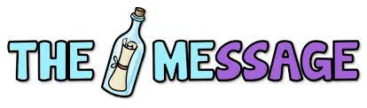  by _______________________________  Is that _________________________ | 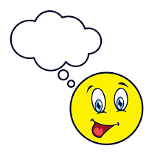  Provide 3 significant quotes and why they are significant | Top three characters and what do they do for the story?  (Remind us of something, teach us a lesson, help propel a character, a plot line, contribute  to conflict? Comic relief? Wise fool? A foil? What Purpose does each serve?)
Comment on Cinematography – The Good, The Bad, The Ugly. Comment on  aspects of the Cinematography. The sound, music, editing ae also fair game.  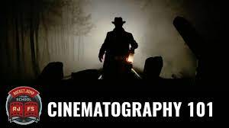  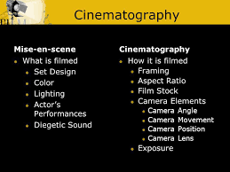 | 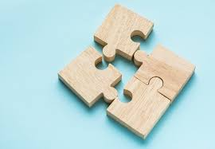  A Connection. What can you connect to in the movie (Personal, text to  text, text to world). How does this connection help you understand  the theme/character/conflict ect. in a deeper way? | RATE THE FILM AND JUSTIFY YOUR RATING; OR DRAW A PICTURE THAT REPRESENTS THE FILM  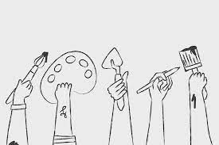  OR THEME AND EXPLAIN IT.

