Language and Literature Name:

Passion Project
Make Your Own Project Project

What IS this project? Great question. That’s up to you. It should be completed using approximately 5 in class working days. Your project will be written by you, defined & generated by you, and approved by you and me while working with you to finalize your project.

Your project “challenge” should be geared towards solving a problem or discovering a mystery that is of great interest and concern to you! If you stick true to this goal of creating that challenge for yourself, your project will be something that you’ll not want to stop working on and will result in something VERY useful to you and likely others!

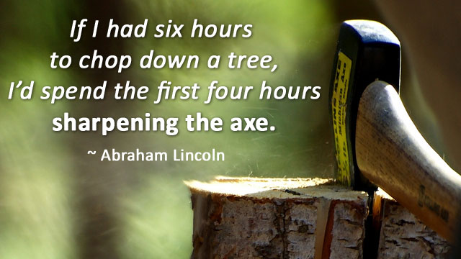

So what do I do?

Brain-Storm #1
Write down the topic you are MOST interested in:

_____________________________________________________

Write down THREE questions about that topic that you’d like to find out more about / learn more about how to do it!

- _____________________________________________________

- _____________________________________________________

- _____________________________________________________

Brain-Storm #2
Write down a second topic that you are VERY interested in:

_____________________________________________________

Write down THREE questions about that topic that you’d like to find out more about / learn more about how to do it!

- _____________________________________________________

- _____________________________________________________

- _____________________________________________________

Driving Challenge Time!

Problem to solve / Mystery to discover:
__________________________________
__________________________________

What I’ll “do” to solve this problem:
__________________________________
__________________________________

So now...create your challenge sentence:

I will (design, construct, plan, produce, invent, devise, create) a
___________________________

to (critique, detect, discover, judge, monitor, evaluate)
(why, where, when, how, what)
______________________________

http://rubistar.4teachers.org/

This above statement WILL BE your challenge. Before writing the above statement / developing your challenge, it will be helpful to use the three questions you have come up with as a general guide. These questions should represent what you have the most interest in, related to investing. The above challenge should be thoughtful and thorough, not one that can be answered / solved with a one or two or three or ten or twenty sentence response.

Total Points = 80
- Process (4 / day) = 40
  - Missed school => 1 freebie (as long as it’s excused). All others need to have 50 minutes of working outside of class made up!
- Product = 40
  - YOU will create rubric for this!
20% Time Links

What is google 20% time: https://www.youtube.com/watch?v=iBYOxoJp1ns
How Does 20% Time Work In Edu: http://www.20timeineducation.com/

