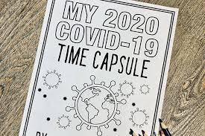
Individuals and Society Pandemic Time Capsule
Preamble: Right now, you are living through history. Every generation has a historical event that defines them (ie world wars, September 11th etc.). Living through a Global Pandemic will be something your generation will remember. Because of this historic time, you will be creating a Digital Time Capsule to remember the COVID-19 Pandemic. You will be a historian gathering primary sources. We will also use your information to introduce and discuss historical thinking skills we will use throughout the course.
Criteria: Create a Google Slides presentation/video or other presentation method of your choice. In your Digital Time Capsule, you must have the following:

- 1. _______________3 Pictures- find 3 pictures that you think best represent the pandemic. Each picture should have a caption as to WHY you think they are the best representative.

- 2. _______________3 Important Dates- list 3 important dates, what happened on those dates, and why they were important. You can include pictures with your important dates.
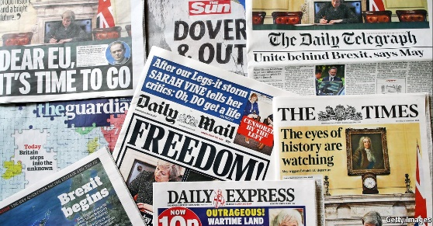
- 3. _______________2 Newspaper Articles- find 2 newspaper articles. The articles can be from a physical newspaper or a website. They must be from reliable news sources. You should include a picture of the headline of the article as well as a link to the article (or a picture if it is a physical newspaper). Explain why you picked those stories.

- 4. _______________2 Uplifting stories/pictures/videos- find 2 stories about something uplifting, happy or people doing something good for the world during this time. Include the actual story/picture/video as well as any links.

- 5. _______________1 Map/chart- find one map or chart that shows some aspect of the pandemic. Include a picture of the map/chart and a caption explaining what it is showing.

- 6. _______________1 News briefing- find 1 news briefing from this time. This means a government official giving information about the pandemic. Include the actual video and a link to the video along with a caption.

- 7. _______________1 Picture of an empty landmark- find a before and after picture of an empty landmark that was closed due to the pandemic. Example: Times Square in New York City

- 8. _______________1 Meme/Tweet/Social Media Post- find 1 meme/tweet/social media post that will remind you of the pandemic. Please make sure it is school appropriate and not offensive to those affected by the Coronavirus.

- 9. ________________ 1 slide with a paragraph summarizing a controversial topic during the pandemic. Include at least one picture with your explanation.

- 10. _______________ 3 unanticipated consequences of the pandemic (ie. Lockdowns, masks, safety measures, quarantines).

- 11. _______________1 Personal historical reflection- write a 150-300 (more is fine) paragraph historical reflection. Discuss your memories of living through this pandemic. Alternatively, you could record a video of yourself and attach the video instead of writing a reflection. The video should be about 2 minutes long. Include at least 3 pictures of your life during the pandemic to go with your historical reflection.
Here are some questions to think about to help guide your reflection:
- How has your daily life changed? What is closed or changed around you?
- What are you hearing on the news or from family members?
- Has anyone close to you been affected by the Coronavirus?
- How has school changed for you?
- What are your thoughts/feelings during this time?
- What would you want to tell someone in the future about living through a pandemic?
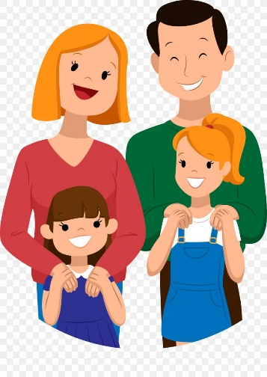
Tips: Here are some things to keep in mind while making your Digital Time Capsule:
- You are trying to remember your experiences during the pandemic. It should be as if you are collecting all your memories.
- Include all pictures, links and videos directly on your slides presentation. (Go to “insert” then click “image” or “video” or “link”).
- Be Creative! Make your Digital Time Capsule colorful and historic!
- Share your project with me (efitton@sd67.bc.ca)

Due: ____________________________
Criterion B: Investigating
Achievement Level | Level Descriptor | Task-Specific Clarification
0 | The student does not reach a standard described by any of the descriptors below. | Less than half of the required components.
1-2 | The student:  - collects and records limited information, not always consistent with the research question, | Has most of the required information.
3-4 | The student:  - uses a research method(s) to collect and record mostly relevant information, | May be missing one of the required components, but the rest is there.
5-6 | - uses research method(s) to collect and record appropriate relevant information, | Has all of the required information
7-8 | The student:  - uses research methods to collect and record appropriate, varied and relevant information, | Meets all of the requirements with interesting and engaging examples.
Criterion C: Communicating
Achievement Level | Level Descriptor | Task-Specific Clarification
0 | The student does not reach a standard described by any of the descriptors below. | Contains only a few pictures and no explanations.
1-2 | The student:  - communicates information and ideas in a limited way, using a style that is limited in its appropriateness to the audience and purpose, | Presentation is disorganized and hard to follow. Explanations are missing or hard to understand.
3-4 | The student:  - communicates information and ideas satisfactorily by using a style that is somewhat appropriate to the audience and purpose, | Presentation is mostly organized. Explanations may be short, but they are all included.
5-6 | The student:  - communicates information and ideas accurately by using a style that is mostly appropriate to the audience and purpose, | Presentation is organized and easy to follow. Explanations and captions are an appropriate length and all are included.
7-8 | The student:  - communicates information and ideas effectively and accurately by using a style that is completely appropriate to the audience and purpose, | Presentation is organized and engaging. Explanation are thorough and well thought out.

