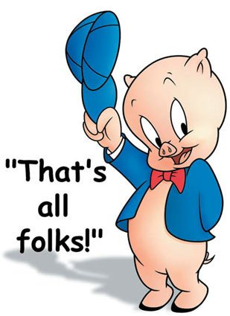
Mrs. Fitton Name:
/50 MARKS
Social Studies 9 Date:

Tests are only one way to measure student success. Only a certain percentage of the populace are “good test writers.” Indeed, research indicates that students can find more success in education if they are given alternatives to traditional assessment. Accordingly, for the Napoleon project in Social Studies 9, you will reveal your cumulative knowledge of this historical figure in any one of a variety of ways.
DUE DATE: The completed project is due on ________________________________.
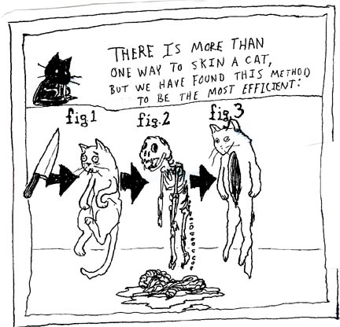
You must be half done and show Mrs. Fitton on ______________
If you have no made substantial headway at this point, your parents will be contacted.

The Project: The project aims to determine your understanding of concepts and vocabulary learned throughout the Napoleon unit without using a test. Pay attention to notes, matrixes, videos, the unit outline and general trends that were emphasized during class time.

Suggested Project Ideas:
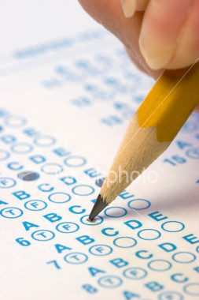
Create A UNIT Exam
-20 multiple choice questions that cover all chapter studied.
-5 matching/ true-false
-3 written (higher level questions)
-1 Essay topic (must be thematic)
-Answer key (essay/written should be in point form)
-Should LOOK like a Unit Test

Unit Matrix
-Draw a unit Matrix
-Include Key terms and points
-Necessary Vocabulary
-Pictures or Drawings
-Leave blank spaces for students to put answers (on separate sheet, provide answers.
-Use unit outline and textbook as a Guides.
-Cannot Copy Ms. Foote’s or will redo.

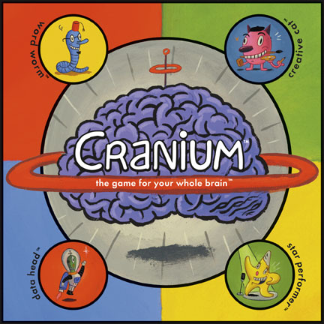
Napoleon Board Game
-Create a Board game that covers many events/people from the Napoleon unit.
-Should cover the whole chapter and have 20 in-depth game cards. Not as easy as looks.
-Game board should have historical depth and be aesthetically superior.

Napoleon Essay
1. Write a biography of Napoleon’s entire life. Organize it into the following sections: rise to power, First Consul/Emperor of France, downfall.
2. Analyze Napoleon’s successes and failures as leader of France.
Criteria-strong thesis, proper grammar and spelling, multi-paragraph, bibliography

Comic or Poem
-create a comic book or a rhyming narrative poem that retells the story of Napoleons rise to power and downfall.
-poem should be 20-40 lines long and typed.
-comic book should be coloured and look professional.

Newspaper
Create a newspaper that includes: straight news stories, at least one of the following: human interest story/feature story, editorial OR political cartoon, obituary, an advertisement OR calendar of local events. Each section should cover a different event of the Napoleonic era.

These are only eight suggestions. You may show your learning in an alternate fashion (ie. video, police report, research something you are interested in depth, but consult with Mrs. Fitton first and I will be happy to discuss the viability of your idea.
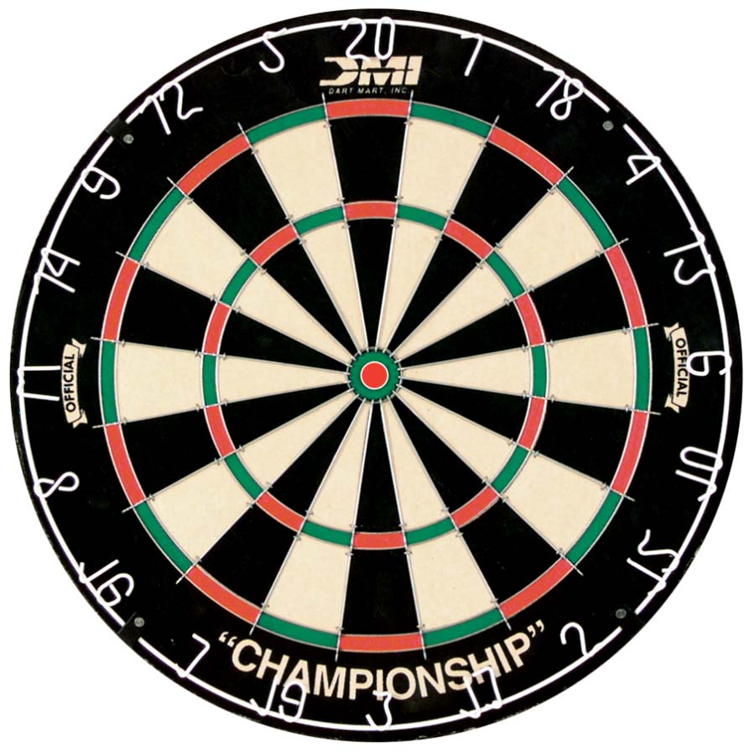
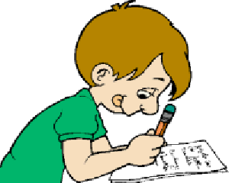
Major themes of the Napoleon Unit:
*Do not repeat the mistakes of the past * Power corrupts
*It is possible to rise from humble beginnings* How ideas of the revolution spread
*Napoleon’s rise and fall to the rest of Europe.

Important Terms, Characters and Events. Your Project must contain at least 20 of
them. They must be used in the correct context in terms of our look at the French Revolution. Use this as a checklist while working on your project. Before you hand your project in, you must check off on this list the terms that you covered.

Napoleon Bonaparte Josephine Marie-Louise Emperor
First Consul Napoleonic Code Whiff of Grapeshot Haiti
Horatio Nelson Duke of Wellington tariffs Civil law
Abolition Toussaint L’Ouverture Madame de Stael Continental System
Grand Armee Hussars Infantry Young Guard
Old Guard Treaty of Tilsit Guerilla Warfare Nationalism
Goya Patriotism Russian campaign Tsar Alexander
Primary Sources Abdication Exile Hundred Days
Elba St. Helena Waterloo Congress of Vienna
Secondary Sources Bias Corroborate Battle of Trafalgar
Prussia Austria Poland Egypt
Corsica Artillery Officer “Great Men of History Theory”

Assessment (Please self-evaluate by circling or highlighting where you think your project falls and include this sheet with your project when you hand it in):
Category | 5 | 4 | 3 | 2 | 1
1. Terms, Events and  Characters | More than 20 of  The vocabulary  Included and  Used in correct  Context. | 100% of the  vocabulary  Included and  Used in correct  Context. | 70-90% of  The vocabulary  Included and  Used in correct  Context. | 50-69 % of  The vocabulary  Included and  Used in correct  Context. | Less than 50% of  The vocabulary  Included and  Used in correct  Context.
2. Historical Accuracy | All details accurately  Relate to specific time  Period | Most details  Accurately to specific  Period | Some details  Accurately relate to  Specific time period | Details relate to  Incorrect time period | No historical accuracy  present
3. Grammar/Spelling | No grammar/spelling  Errors present | No more than 1  Grammar/spelling  Errors present | No more than 3  Spelling/grammar  Errors present | No more than 5  Spelling/grammar  Errors present | More than 5 spelling/  Grammar errors  present
4. Project  Understanding  And Purpose | Project establishes a  Clear purpose and  Demonstrates a clear  Understanding of the  Time period | Project is clear and  Demonstrates a mostly  Clear understanding  Of the time period | Project is mostly clear  And demonstrates  Some understanding  Of the historical  Period. | Project is not clear  and does not  demonstrate an  understanding of the  Historical period | Project does not relate  to the time period or  mention much about  Napoleon
5. Layout and  presentation | Layout and  presentation of project  is exceptional | Layout and  presentation of project  is good | Layout and  presentation of project  is satisfactory | Layout and  presentation of project  is less than satisfactory | Layout and  presentation of project  is poor

/50
Teacher Comments:

