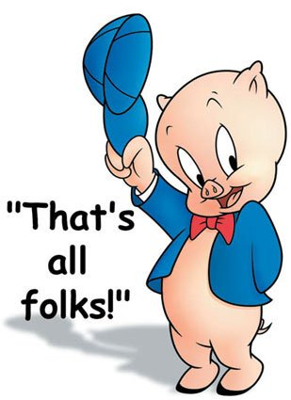
Mrs. Fitton Name:
Individuals and Society Date:

Tests are only one way to measure student success. Only a certain percentage of the populace are “good test writers.” Indeed, research indicates that students can find more success in education if they are given alternatives to traditional assessment. Accordingly, for the Napoleon project in I&S, you will reveal your cumulative knowledge of this historical figure in any one of a variety of ways.

The Project: The project aims to determine your understanding of concepts and vocabulary learned throughout the Napoleon unit without using a test. Pay attention to notes, powerpoints, videos, the unit outline and general trends that were emphasized during the lessons.

Criteria:
1. The project must show an understanding of at least 15 vocabulary words (See next page for ideas on words to use)
2. The project should show an understanding of how the Napoleon unit relates to our statement of Inquiry: Revolution creates change and is affected by people who have a lack of access to power and privilege.

Criterion:
A: Knowing and understanding
- use a wide range of terminology in context
- demonstrates knowledge and understanding of subject-specific content and concepts through developed descriptions, explanations, and examples.
C: Communicating
- communicates information and ideas effectively using an appropriate style for the audience and purpose
- structure information and ideas in a way that is appropriate to the specified format

Suggested Project Ideas:

Musical playlist/soundtrack
-Create a 5 song minimum soundtrack for Napoleon’s life. If you were making a movie of his life, what songs would go at key moments? Or fit his personality?
-Write a paragraph for each song explaining how and why it fits. Don’t forget to include Napoleon vocabulary words.
-Include the lyrics for the songs as well above or below your paragraphs
Create A UNIT Exam
-15 multiple choice questions that cover all chapter studied.
-5 matching/ true-false
-2 written (higher level questions)
-1 paragraph topic
-Answer key (essay/written should be in point form)
-Should LOOK like a Unit Test

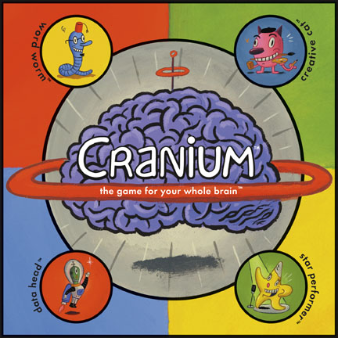
Napoleon Board Game
-Create a Board game that covers many events/people from the Napoleon unit.
-Should cover the whole chapter and have 20 in-depth game cards. Not as easy as looks.
-Game board should have historical depth and be aesthetically superior.

Napoleon’s Social Media
-create a Twitter feed, Instagram account, Facebook, TickTocks or any other kind of social media platform for Napoleon.
-Use hastags, pictures, comments and feeds to try to creatively show what you know about Napoleon’s life
-with the project, include a write up explaining what you were trying to show

Newspaper
Create a newspaper that includes: straight news stories, at least one of the following: human interest story/feature story, editorial OR political cartoon, obituary, an advertisement OR calendar of local events. Each section should cover a different event of the Napoleonic era.
Comic/Poem/Song
-create a comic book or a rhyming narrative poem that retells the story of Napoleons rise to power and downfall.
-poem should be 20-40 lines long and typed.
-comic book should be coloured and look professional.

These are only six suggestions. You may show your learning in an alternate fashion (ie. video, scrapbook, police report, research something you are interested in depth, but consult with Mrs. Fitton first and I will be happy to discuss the viability of your idea.

Unit Statement of Inquiry: Revolution creates change and can be affected by people who believe that they have a lack of acces to power and privilege

Important Terms, Characters and Events. Your Project must contain at least 15 of
them. They must be used in a way that shows that you understand what they mean. You may include a short write up with your project that explains how you used them if you think it would help. Use this as a checklist while working on your project.
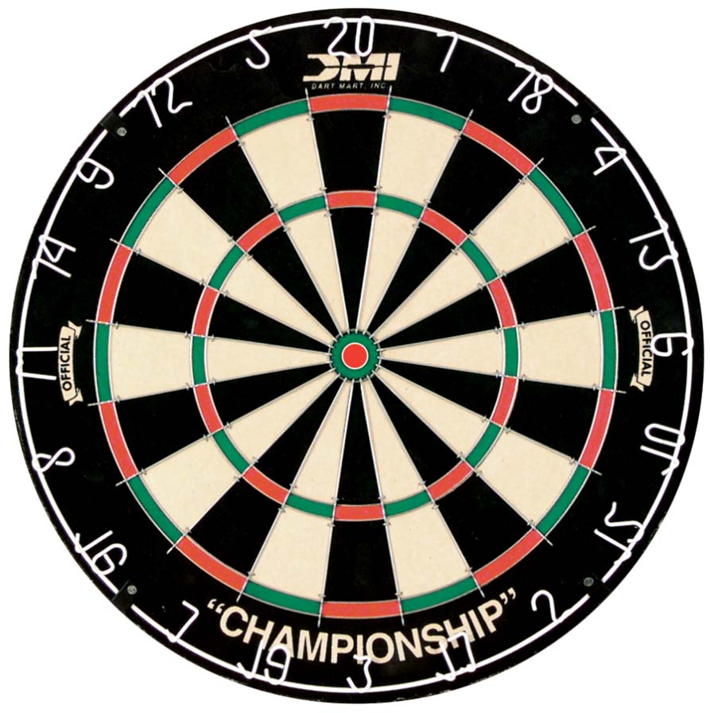
Napoleon Bonaparte Josephine Spanish Occupation
First Consul Napoleonic Code Whiff of Grapeshot
Horatio Nelson Duke of Wellington tariffs
Toulon Haitian Slave Revolt Russian Invasion
Grand Armee Napoleon’s Censorship Infantry
Napoleon’s metals Treaty of Tilsit Guerilla Warfare
Francisco Goya Napoleonic Code Continental System
Russian campaign Congress of Vienna Hundred Days
Tsar Alexander Scorched Earth Policy Nationalism
Primary Sources Logistics Exile
Elba St. Helena Waterloo
Secondary Sources Bias Corroborate
Prussia Austria Emperor
Corsica Artillery Officer Propaganda
Key Parts ideas of the unit/theme | How Those Elements will be Demonstrated in your project
SIO: Revolutions create change and are affected by people who believe that they lack access to power and privilege  15 Terms My project will show understanding of  1. 2.  3. 4.  5. 6.  7. 8.  9. 10.  11. 12.  13. 14.  15. 16. | How my project with demonstrate the SOI  Terms  Project Medium (Type of project):

