Mrs. Fitton WORLD WAR 2: CANADA’S ROLE Name:
Social Studies 11 Date:

Instructions: View the film “World War 2: Canada’s Role” and respond to the questions below. Page numbers after questions refer to the Counterpoints textbook. Read the section in your text for more detail. You will be given class time to do this.

The Early War:
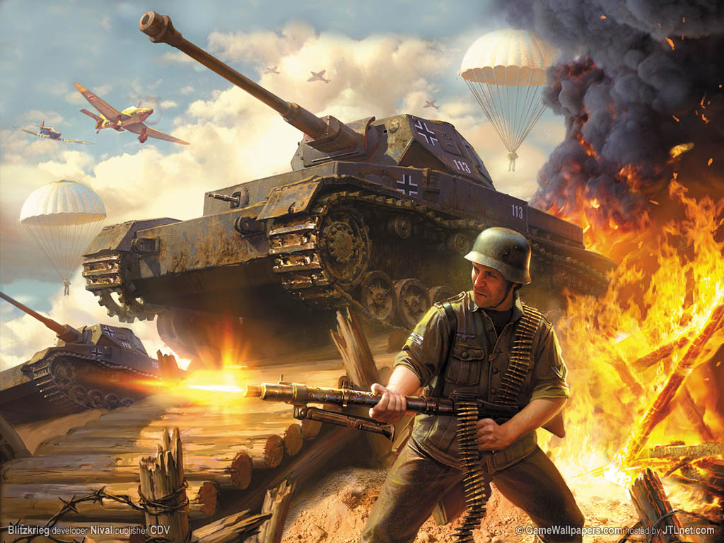
1. What is meant by “Blitzkrieg.” List its main elements.

2. What was the significance of Dunkirk and the fall of France for:
A. Britain

B. Canada

3. What was Canada’s main role early in the war (Page 131)

4. How did Canada pay for the war effort? What was “Lend Lease”?

Canadians at War
5. Where and when did Canadian troops first fight in WW II? (Page 137)

Why was this action controversial?

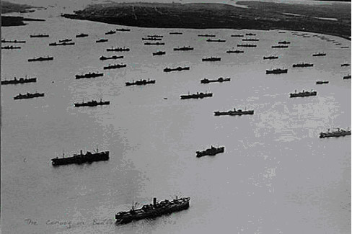
6. How were Canadian air crews (139) and Navy (138) used early in the war?

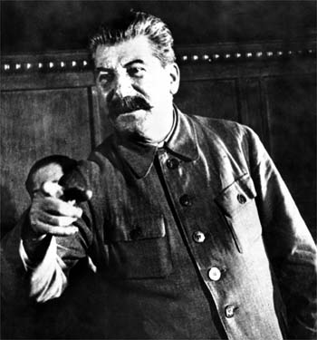
The Darkest Hours

7. Why was 1942 described as the “darkest hours” for the allies opposed to Hitler?

8. What was the Soviet Union pressuring the Western Allies to do at this time? Why?

Turning the Tide (Use Counterpoints as well)
9. What was the Dieppe Raid? Who took part? Why was it controversial? (142-143)

10. What difficult campaign did Canadians participate in from 1943-1945? (Page 144)

11. What was “D-Day?” What was Canada’s Role? (Page 146-147).

Canada’s Role in the War at Sea (Page 138).
12. Describe the role played by the Canadian Navy in the allied war effort.

13. What was the “Merchant Marine?” How was it “short-changed” by the Canadian Government?

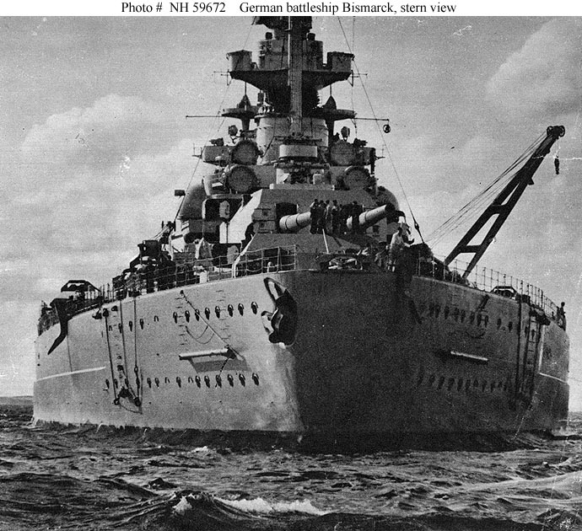
14. Why was the Battle of the Atlantic of great importance? What was the turning point?

15. What were WRENS and what was their significance? (138)

Canada’s Contribution to the Air War (Page 139)
16. What was the Commonwealth Air Training Plan? Where did it take place?

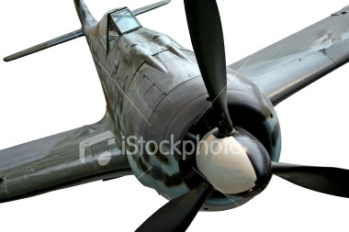
- Why was PM King so pleased with this development?

17. What was the main job of the Canadian Air Force in the last half of the war?

18. What was controversial about this task? What did the people involved think about it?

Canadians on the Home Front (153-159)
19. Who made the major decisions about the war on the allied side?

20. Conscription was an issue in WWII, how was it resolved? What was the outcome? (155-156)

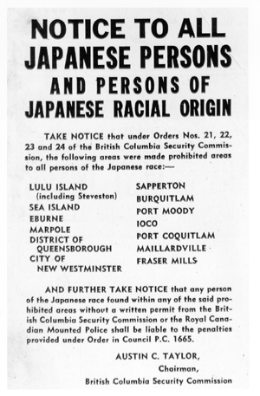
21. What action did the government take against Canadians of Japanese origin during WWII? What reasons were given for this action? (157)

Victory (147-149)
22. Where were Canadian soldiers engaged at the close of WWII?

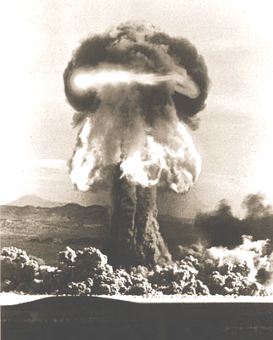
23. How did the war in Europe end?

24. What ended the war against Japan? What was Canada’s contribution?

Changes on the Home Front (Page 155, 158-159)
25. Provide details of social changes in Canada because of WWII
Subject that received social chance | Details about social change that occurred
A. The role of Women
B. Labour Relations
C. Compensation for Veterans
D. Social Safety Net

