Land Acknowledgement Field Trip
Name:_____________________________ Date:_________________________________

ON THE BUS THERE: Today we will learn about the importance of land acknowledgements to help us recognize the Indigenous history of the places we live. To help us with this, it is important to consider the ways that we feel connected to the land.
Please answer these questions to reflect on your relationship with the land.

1. In what ways do you use the land? Think of the many ways the land provides for you daily (from the time you wake up until the time you go to sleep).
____________________________________________________________________________________________________________________________________________________________________________________________________________________________________

2. How does it make you feel? What does it do for your mind, body or spirit?
____________________________________________________________________________________________________________________________________________________________________________________________________________________________________

3. How do you show appreciation for the land? ____________________________________________________________________________
________________________________________________________________________________________________________________________________________________________
WHILE WE WALK PART 1: Read this excerpt of Braiding Sweetgrass by Potawatomi author Robin Wall Kimmerer. In this section, Robin describes her Indigenous culture’s worldview of land.

“…. One thing our people could not surrender was the meaning of land. In the settler mind land was property, real estate, capital, or natural resources. But to our people, it was everything: identity, the connection to our ancestors, the home of our nonhuman kinfolk, our pharmacy, our library, and the source of all that sustained us. It was a gift not a commodity.” (Wall-Kimmerer, 2015, p.17)
Wall-Kimmerer, R. (2015). Braiding Sweetgrass: Indigenous Wisdom, Scientific Knowledge and the Teachings of
Plants. Milkweed Editions, Minneapolis.
WHILE WE WALK PART 2: Read the description of how the Syilx/Okanagan people traditionally lived in this area. Look at this map of the traditional territory of the Okanagan Nation → a group that represents 8 unique communities in the Okanagan.
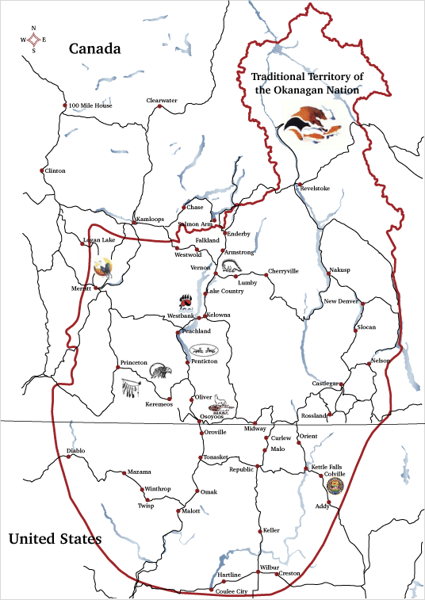
For thousands of years, the Okanagan people were self-reliant and well provided for through their own ingenuity and use of the land and nature. We lived united as a nation with a whole economy, travelling the breadth and depth of our territory, hunting and fishing, growing and harvesting, crafting and trading to meet our needs. Colonization divided us from one another and from our way of life. We were divided from the resources we relied upon, and our self-sufficient economy collapsed.

About, Okanagan Nation Alliance Business Development Unit, 2007. http://www.okanagannationbusiness
.com/about.shtml. Accessed 13 Feb 2021.

Map from
http://www.okanagannationbusiness.com/map.shtml

WHILE WE WALK PART 3: Based on Robin Wall Kimmerer’s quote, the map, and the description of traditional Syilx ways of life, what do you understand about the relationship Okanagan people have with the land? (Write your answer on the lines below.)

____________________________________________________________________________
____________________________________________________________________________
____________________________________________________________________________
____________________________________________________________________________
Erica Fitton and Laura Savoie SD #67

AT THE TOP: Enjoy the view of Penticton. Talk to your partner about how the land is used.
Based on your discussion and what you see, what do you understand about the relationship that the dominant culture has with the land now? (Write your answer on the lines below.)

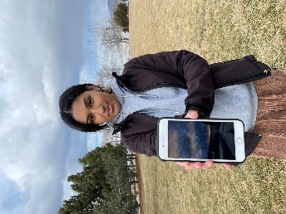
___________________________________________________________________
___________________________________________________________________
___________________________________________________________________
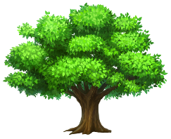
___________________________________________________________________
___________________________________________________________________
Pose for a photo of yourself spending time on the land today.
A: Hold up a photo on your phone of you doing something you love on the land.
B: Point to an area of Penticton where you do something you love on the land
ON THE BUS BACK: Today we thought about how this area has been home to many different people, who lived in many different ways, over generations. Please write your own personalized land acknowledgement that recognizes this history below. These will be printed and posted in our classroom.

Vocabulary for land acknowledgements:  Traditional: recognizes lands traditionally used and/or occupied by the Syilx people or other First Nations in other parts of the country.  Ancestral: recognizes land that is handed down from generation to generation.  Unceded: refers to land that was not turned over to the Crown (government) by a treaty or other agreement. | Write your own personalized land acknowledgement here:  I would like to acknowledge that I am fortunate to live and learn on the traditional / ancestral / unceded (circle 1 or more) territory of the Syilx people. If you are Syilx, please start with “ I would like to welcome you to the territory___________________________  ________________________________________________________________________________________________________________________________________________________________________________________________(a reason you feel lucky to live here.)  Example: I would like to acknowledge that I am fortunate to live, work, and learn on the traditional and unceded territories of the Syilx people. I enjoy snowboarding, hiking, and eating local foods here, and I am grateful that I have the opportunity to use this land for my own purposes.

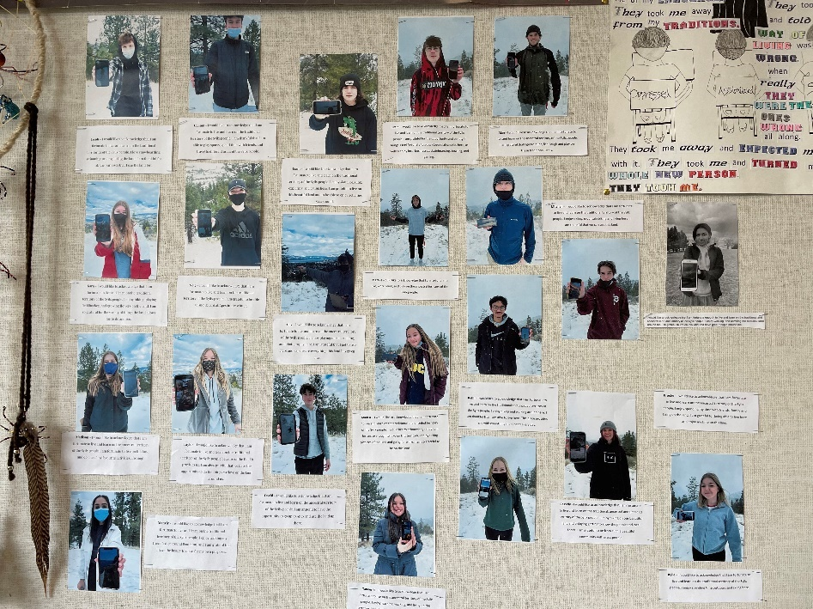
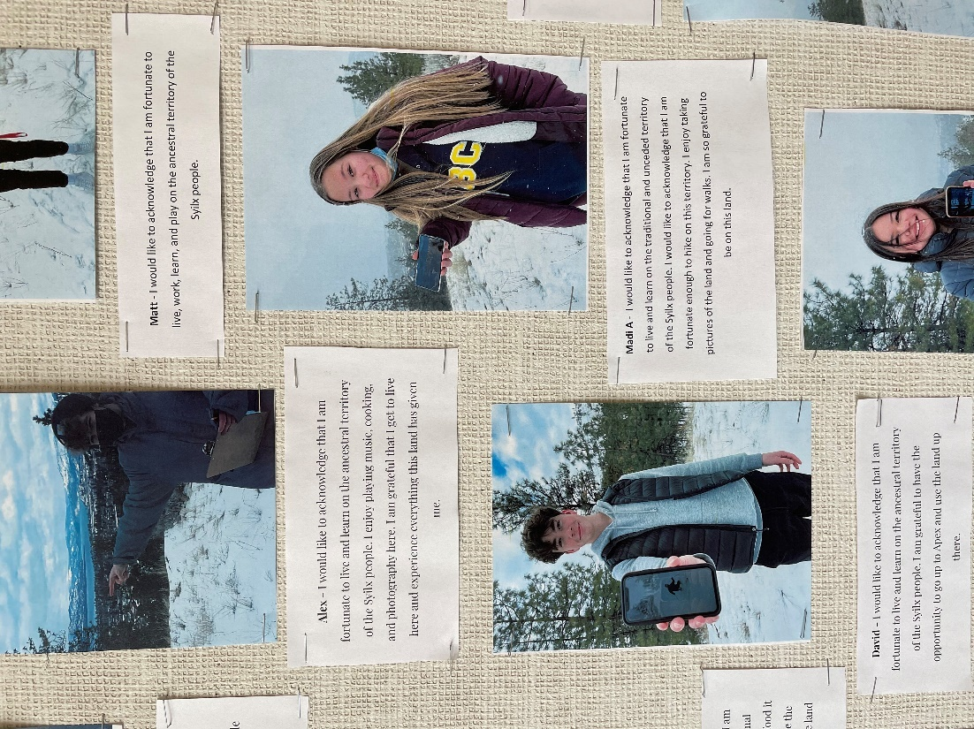
Erica Fitton and Laura Savoie SD #67

