The King Arthur Legends Name: _________________
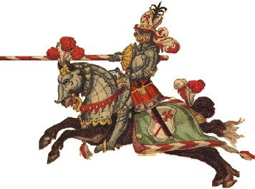
APK: List everything you know about Knights and The King Arthur myth

Vocabulary: The words below are important to understanding the King Arthur legends.
*Chivalry: the rules and customs of medieval knighthood.

*Legend: True stories greatly exaggerated over time, but often mistaken as history.

*Grail: a cup or chalice that in medieval legend was associated with unusual powers, esp. the regeneration of life and, later, Christian purity. It was much sought after by medieval knights and was believed to be the cup used by Jesus at the Last Supper. It has come to symbolize an ideal or a goal

*Camelot: the legendary site of King Arthur's palace and court, possibly near Exeter, England and believed to be a period of great happiness and ideals, which is also what it now symbolizes

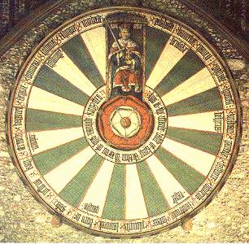*Excalibur: Arthur sword given to him by the Lady of the Lake. If someone were in a fight using this sword they would never lose. The sword symbolizes truth and justice

The Ten Commandments of the Code of Chivalry
1. Thou shalt believe all that the Church teaches, and shalt observe all its directions.
2. Thou shalt defend the Church. 3. Thou shalt repect all weaknesses, and shalt constitute thyself the defender of them. (Women, old and children) 4. Thou shalt love the country in the which thou wast born. 5. Thou shalt not recoil before thine enemy. 6. Thou shalt make war against the Infidel without cessation, and without mercy. 7. Thou shalt perform scrupulously thy feudal duties, if they be not contrary to the laws of God. 8. Thou shalt never lie, and shall remain faithful to thy pledged word. 9.Thou shalt be generous, and give largess to everyone. 10. Thou shalt be everywhere and always the champion of the Right and the Good against Injustice and Evil.
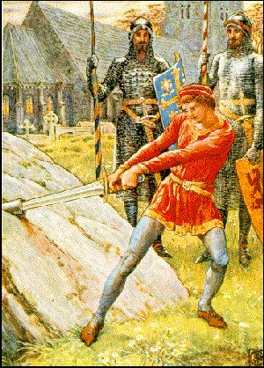
Task: List some examples of modern day knights (people who you believe follow any othe rules of chivalry). Describe (beside their name) why you chose them (minimum of three)
Example: The boys who led the pink shirt campaign: As grade 12s who lead the school, they defended the weak by standing up for the boy who was teased

1.

Why do they fit?

2.

Why do they fit?

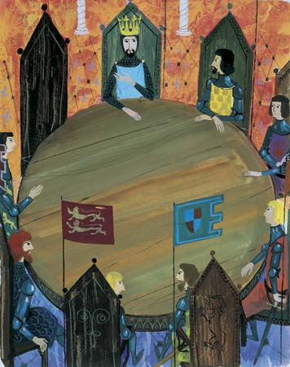
3.

Why do they fit?

