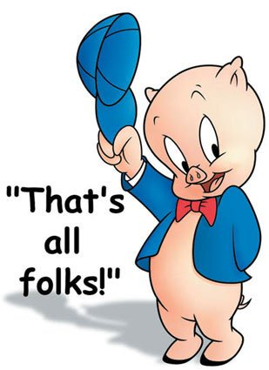
Mrs. Fitton Name:

IS year 4 Date:

Final Exams are only one way to cumulatively assess what you’ve learned this year. To develop of life long passion of history, the final project allows you to choose your own destiny and relate it to a “Big Idea” that we have studied this year! As a class, we will have a “Science Fair” style final project. You will research a topic of choice, relate it to a SOI or Big Idea of the course (see below) and present using a medium that is suited to your talents and passions. On the last day of class (Tuesday we will meet and as a class do a science fair where you are welcomed to bring food that somehow relates to the topic you’ve explored. It is a final farewell to our historian community.

DUE DATE: The completed project is due on Tuesday January 21.
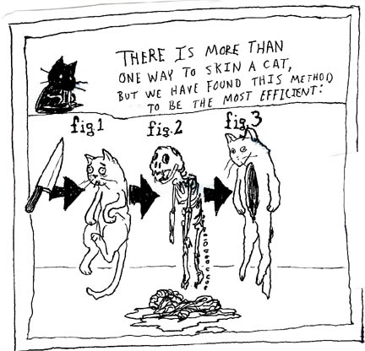
You must be half done and show Mrs. Fitton on Friday January 17
If you have not made substantial headway at this point, you will be required to work with Mrs. Fitton at lunch/tutorial to ensure your success.

The Project: The project aims to show off your emergent skills as a historian, and to familiarize you with how to research and relate it to the big ideas of our course. You will be required to use APA citations to cite the materials you use to research. You must use at least THREE valid sources for researching this project
Suggested Project Ideas:
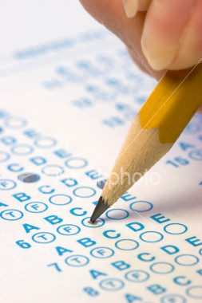
Create A Term Paper
- Research several articles on a topic of your choice
-Create and refine a thesis
-Follow proper format of a term paper
-Use the University of Ottawa History Student handbook to guide you
-Proper use of quotes/citations
-800-1500 words maximum.

Unit Mind Map / Pictorial Matrix
-Draw a Matrix or artistic piece that shows your knowledge
-Include Key terms and points
-Pictures or Drawings
-Must demonstrate an argument/research
-Needs proper citation
-Reveals a depth of understanding enhanced by your artistic abilities.

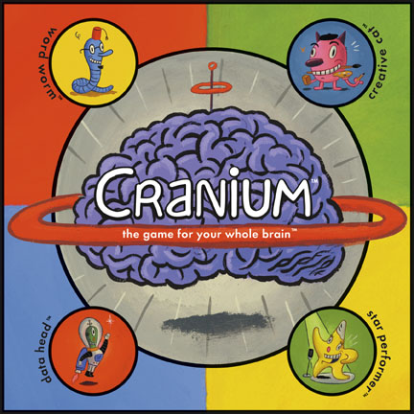
What will help you in your Career?
-In this class we have future police officers, nurses, lawyers, army personnel, secretaries, parents, construction workers, etc.
-Create your own type of demonstration of learning where you research and present in a way that will help you gain skills / present knowledge in a way you would in your future career.

Video/Animation - Anything
- Create a video newscast, Rick Mercer Rant, Horrible Histories, Histeria, or anything using the medium of video that helps you articulate your thesis and viewpoints.
-Must reveal grade 9 level of research
-Must somehow include citations
-Must demonstrate a superior level of understanding.

Documentary
-Using film or pictures gathered from the internet, create a documentary with an overdub that explains the your argument.
-Post to youtube for final evaluation.
-You may download and show archival footage or re-enact key scenes yourself.
-Should also include evidence of research and citations
Science Fair Poster
- Create a research project poster
- Must contain a relevant thesis
- Must display variety of arguments / viewpoints about the topic
- Must synthesize various viewpoints and eventually reveal important conclusions
-Aesthetically appealing
-Requires evidence of research/citations

These are only a few suggestions. You may show your learning in an alternate fashion (ie. police report, radio show, Rick Mercer Rant, Crash Course in History, Epic Rap Battle of History, board game, Musical Score or any idea you have, but consult with me first and I will be happy to discuss the viability of your idea. Remember, you will likely have to support your creative work (if you choose to do something that is not written) with additional written analysis to ensure that you have submitted a project that demonstrates a grade 9 level of understanding.
Getting Started
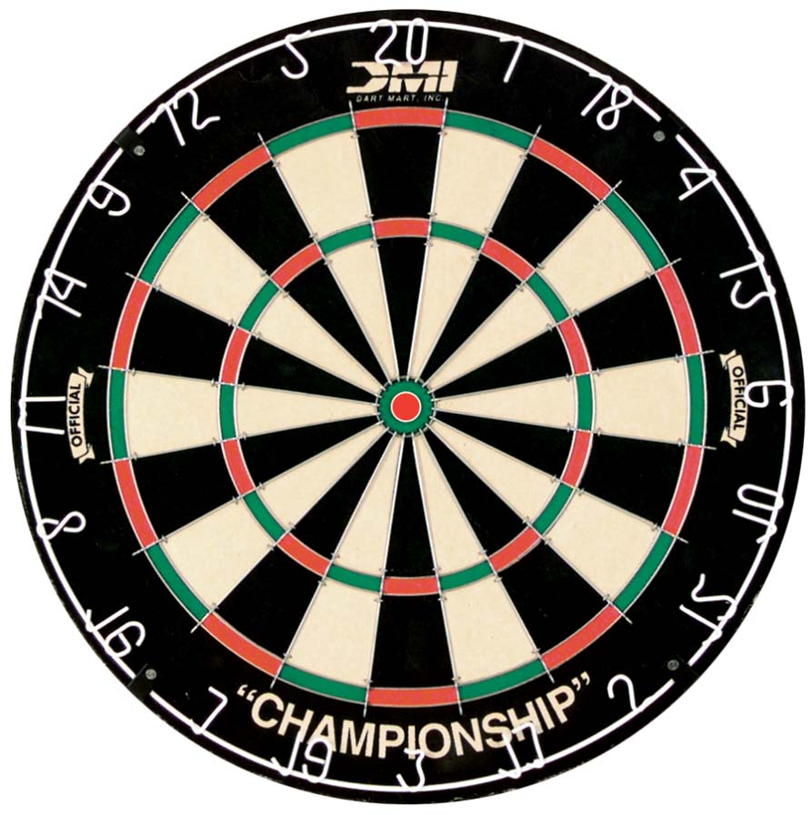
Tips to stay on target: Think of your topic Read some articles on your topic or watch some videos Choose a thesis (argument, pre-determined by the big ideas of this course) Find academic articles/videos/websites to support highlight examples to support your argument start the writing / creative process Done!

1. Topics in history you are interested in (could be something we studied this year that you want to take further, could be something entirely unrelated to this course)

2. Choose one of the statements of inquiry we studied year OR a “Big Idea of Social Studies 9” from the BC curriculum to be the thesis (argument) you will prove in your project. In your project, you must CLEARLY display your thesis AND a concluding paragraph (minimum of 5-8 sentences) about HOW your topic (with specific examples) relates to your thesis

Example:
Topic: Canada’s role in World War One

Thesis: Collective identity is constructed and can change over time

Concluding paragraph: When the war began in 1914, Canada’s identity was overwhelmingly British. Canada did not have control over their foreign affairs and had no choice but to enter the conflict when Britain declared war. However, this did not seem to bother most Canadians who could be heard in cities singing patriotic British songs such as “God Save the King” and “Rule Britannia.” Canadians also volunteered in numbers that were higher than anticipated. When asked for 25 000 volunteer soldiers, 30 000 immediately volunteered. This British identity was altered by Canada’s participation in the war. For one thing, Canadians stayed together in battle as the CEF instead of being absorbed into the British Army. This meant that when Canada succeeded in battle, their victories could truly be viewed as Canadian, not British. For example, in Ypres, Canadians held off the Germans during a gas attack when everyone else retreated. Canadians also saw success in Vimy Ridge where all four divisions fought together and capture the area that French and British had desired since 1914. As a result of their courage and valour in battle, Canada earned the right to sign the Treaty of Versailles, the first international treaty Canada had ever participated in. In five short years Canada had gone from a British identity, to a beginning of a Canadian one.
Statements of Inquiry | Big Ideas in Socials 9 BC Curriculum
Geography and 19th century Canadian history units  Understanding our time, place and space can help us understand our history, perspectives and identity | The physical environment influences the nature of political, social and economic change
World War One  Conflict can lead to a change in identity and global perspectives | Collective identity is constructed and can change over time
The American, French and Revolutions and Napoleon  Innovation and Revolution create change and can be affected by people who believe that they have a lack of access to power and privilege | Disparities in power alter the balance of relationships between individuals and between societies
Industrial Revolution:  Scientific and technological innovation revolutionized the world and changed every aspect of modern life. | Emerging ideas and ideologies profoundly influence societies and events.
Your thesis (Choose one of the above statements):

3. What are some potential ideas of how you would like to present it? Do you need me to get you any devices or materials?

Criterion A: Knowing & Understanding
Achievement Level | Level Descriptor | Task-Specific Clarification
0 | The student does not reach a standard described by any of the descriptors below.
1-2 | The student:  - demonstrates basic knowledge and understanding of content and concepts with minimal descriptions and/or examples.
3-4 | The student:  - demonstrates adequate knowledge and understanding of content and concepts through satisfactory descriptions, explanations and examples.
5-6 | The student:  - demonstrates substantial knowledge and understanding of content and concepts through accurate descriptions, explanations and examples.
7-8 | The student:  - demonstrates detailed knowledge and understanding of content and concepts through thorough accurate descriptions, explanations and examples.

Criterion B: Investigating
Achievement Level | Level Descriptor | Task-Specific Clarification
0 | The student does not reach a standard described by any of the descriptors below.
1-2 | The student:  - collects and records limited information, not always consistent with the research question,  - makes a limited evaluation of the process and results of the investigation.
3-4 | The student:  - uses a research method(s) to collect and record mostly relevant information,  - evaluates some aspects of the process and results of the investigation.
5-6 | The student:  - uses research method(s) to collect and record appropriate relevant information,  - evaluates the process and results of the investigation.
7-8 | The student:  - uses research methods to collect and record appropriate, varied and relevant information,  - thoroughly evaluates the investigation process and results.
Criterion C: Communicating
Achievement Level | Level Descriptor | Task-Specific Clarification
0 | The student does not reach a standard described by any of the descriptors below.
1-2 | The student:  - communicates information and ideas in a limited way, using a style that is limited in its appropriateness to the audience and purpose,  - documents sources of information in a limited way.
3-4 | The student:  - communicates information and ideas satisfactorily by using a style that is somewhat appropriate to the audience and purpose,  - sometimes documents sources of information using a recognized convention.
5-6 | The student:  - communicates information and ideas accurately by using a style that is mostly appropriate to the audience and purpose,  - often documents sources of information using a recognized convention.
7-8 | The student:  - communicates information and ideas effectively and accurately by using a style that is completely appropriate to the audience and purpose,  - consistently documents sources of information using a recognized convention.

Criterion D: Thinking Critically
Achievement Level | Level Descriptor | Task-Specific Clarification
0 | The student does not reach a standard described by any of the descriptors below.
1-2 | The student:  - summarizes information to a limited extent to make arguments,
3-4 | The student:  - summarizes information to make arguments,
5-6 | The student:  - synthesizes information to make valid arguments,
7-8 | The student:  - synthesizes information to make valid, well-supported arguments,

Topic: ___________________________________________

Source 1: Citation information:
Record (in your own words) 5-8 facts you learned about your subject

Source 2: Citation information:
Record (in your own words) 5-8 facts you learned about your subject

Source 3: Citation information:
Record (in your own words) 5-8 facts you learned about your subject

Source 4: Citation information:
Record (in your own words) 5-8 facts you learned about your subject

