Name: ____________________________________________
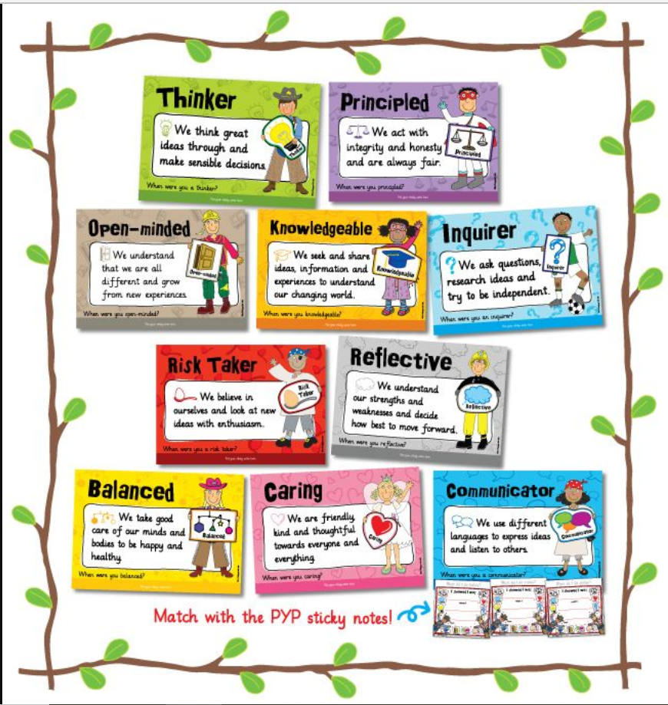

What IB Learner Profile traits did you use in this activity? Please explain HOW you used them
_______________________________________________________________________________________________________________________________________________________________________________________________________________________________________________________________________________________________________________________________________________________________________________________________________________________________________________________________________________________________________________________________________________________________________________________________________________________________________________________________________________________________________________________________________________________________________________________________________________________________________________________________________________________________________________________________________________________________________

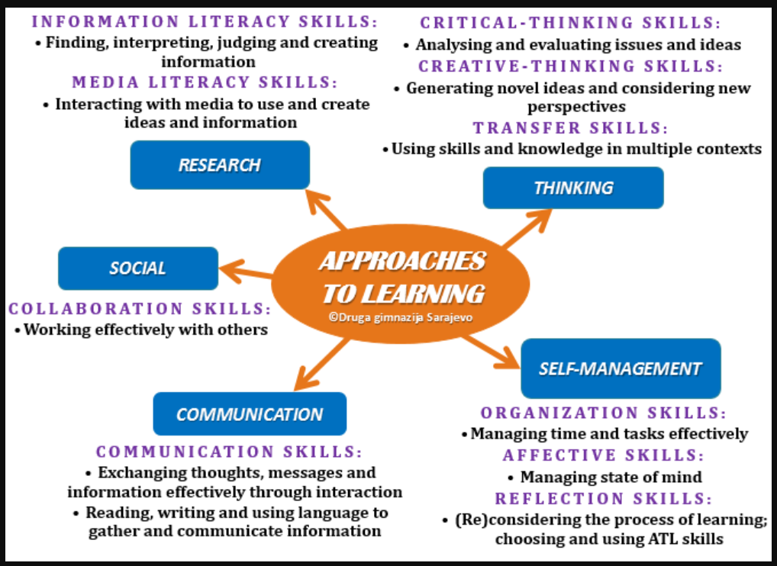
What ATL’s did you use in this activity? Please explain HOW you used them (with specific examples)
___________________________________________________________________________________________________________________________________________________________________________________________________________________________________________________________________________________________________________________________________________________________________________________________________________________________________________________________________________________________________________________________________________________________________________________________________________________________________________________________________________________________________________________________________________________________________________________________________________________________________________________________________________________________________________________________________________________________________________________________________________________________________________________________________________________________________________________________________________________________________________________________________________________________________________________________________________________________________________________________

