English 10

How to approach a poem on the exam (and keep all of your hair)

1. Scan the text for pictures, titles and bold words to help you predict what it will be about.

2. Read the questions

3. Read the poem and think about the following:

* Pay attention to the title; it may provide insight.

* Read the poem twice. Start with the most basic level of understanding. Try putting each stanza in your own words. Make sure you are able to explain what is happening in the poem or what is being described.

* Identify the speaker of the poem. Who is telling you a story or describing something?

* Look for clues that might give the poem cultural or historical context.

* Consider the mood of the poem. Is it light, funny, reflective, somber…?

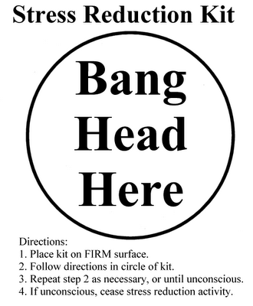
* Look at the imagery. Which images are powerful?

* Finally, what’s the point? Is there a theme? Not every poem has a deep meaning. Some poems merely capture a scene or an image. If there is a theme, express it in a complete sentence. “Dreams” does not accurately describe a theme. “It is important to follow through on your dreams” is more accurate and complete.

4. Read the poem again and answer the questions.

