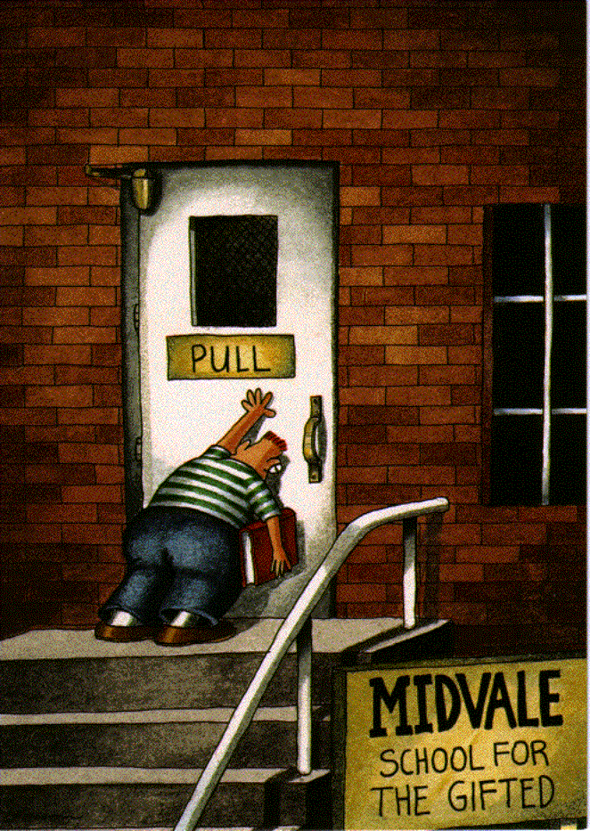
English 9 Name: ____________
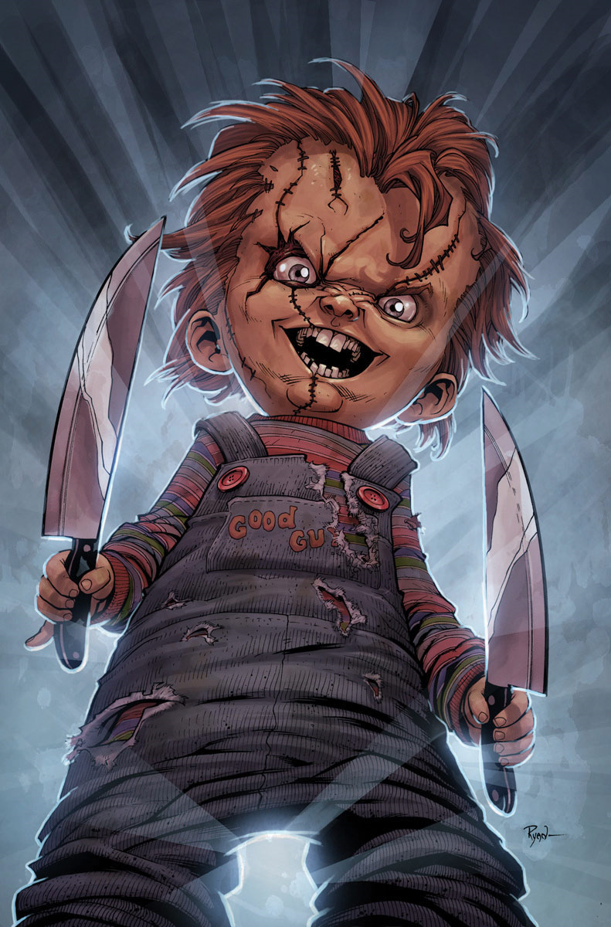
IRONY: a discrepancy between what is & what appears to be. There are 3 types:
*Situational: Difference between what was expected and what actually happened
Example: Procrastinate now, don’t put it off. The first video ever played on MTV was "Video Killed the Radio Star"
*Dramatic: When the audience has information that character(s) in the story do not have.
Example: In a horror story when we know the killer is behind the door upstairs, but the heroine walks into the room anyway.
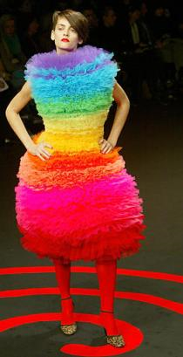
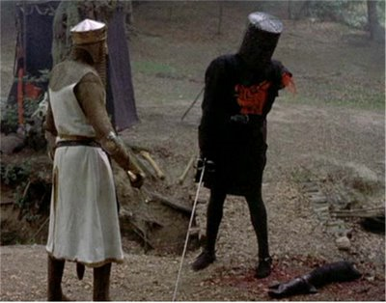
*Verbal: Difference between what is said and what is meant. This term should not be confused with sarcasm where there is an insulting or ridiculing intention behind what is said.
Example of verbal irony: “The Professor’s lecture was as clear as mud.” Also, in Monty Python when the black knight has his arm cut off and he says it is just a scratch.
Example of sarcasm: “Nice Dress” (when you actually think it is the most hideous thing you have ever seen).
Directions: Read the songs and poem below for examples of the different kinds of irony. Answer the questions.
“IRONIC” Alanis Morrisette
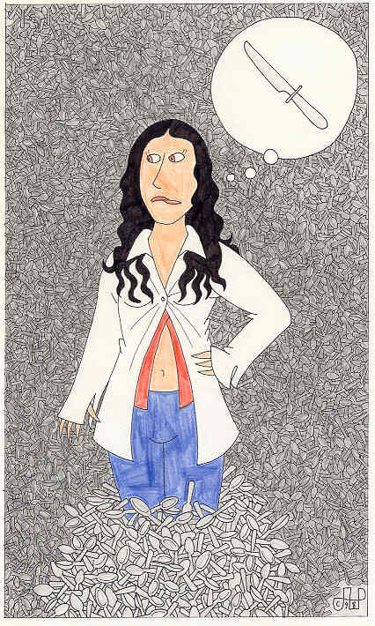
An old man turned ninety-eight
He won the lottery and died the next day
It's a black fly in your Chardonnay
It's a death row pardon two minutes too late
Isn't it ironic ... don't you think
It's like rain on your wedding day
It's a free ride when you've already paid
It's the good advice that you just didn't take
Who would've thought ... it figures
Mr. Play It Safe was afraid to fly
He packed his suitcase and kissed his kids good-bye
He waited his whole damn life to take that flight
And as the plane crashed down he thought
'Well isn't this nice...'
And isn't it ironic ... don't you think
Well life has a funny way of sneaking up on you
When you think everything's okay and everything's going right
And life has a funny way of helping you out when
You think everything's gone wrong and everything blows up
In your face
It's a traffic jam when you're already late
It's a no-smoking sign on your cigarette break
It's like ten thousand spoons when all you need is a knife
It's meeting the man of my dreams
And then meeting his beautiful wife
And isn't it ironic... don't you think
A little too ironic... and yeah I really do think...
Life has a funny way of sneaking up on you
Life has a funny, funny way of helping you out
1. Underline and label an example of each kind of irony.
2. List some examples of situations in this song which are bad luck and not irony at all. ________________________________________________________________________________________________________________________________________________________________________________________________________________________________________________________________________________________
Helping you out

“RICHARD CORY” By: Edwin Arlington Robinson (1869-1935)
Whenever Richard Cory went downtown,
We people on the pavement looked at him:
He was a gentleman from sole to crown,
Clean favored, and imperially slim.
1. Find, underline and label an example of each kind of irony.
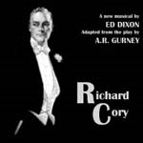
And he was always quietly arrayed, And he was always human when he talked;
But still he fluttered pulses when he said,
“Good morning,” and he glittered when he walked.
And he was rich -- yes, richer than a king,
And admirably schooled in every grace:
In fine, we thought that he was everything
To make us wish that we were in his place.
So on we worked, and waited for the light, And went without the meat, and cursed the bread,
And Richard Cory, one calm summer night,
Went home and put a bullet through his head.
Paragraph Formula:
1. Topic Sentence: Re-word the question as an argument. Include the name of the poet(s) and the poem(s).
3. Use quotes to prove your points.
4. Discuss the quotes. (How do you know these are examples of irony, why is it irony? What does the use of irony achieve?)
5. Conclude with a bang: why is irony important? What is the effect in each poem? (Comedy, Shock, Happiness)
6. Discuss both poems.
Include as much information as possible.

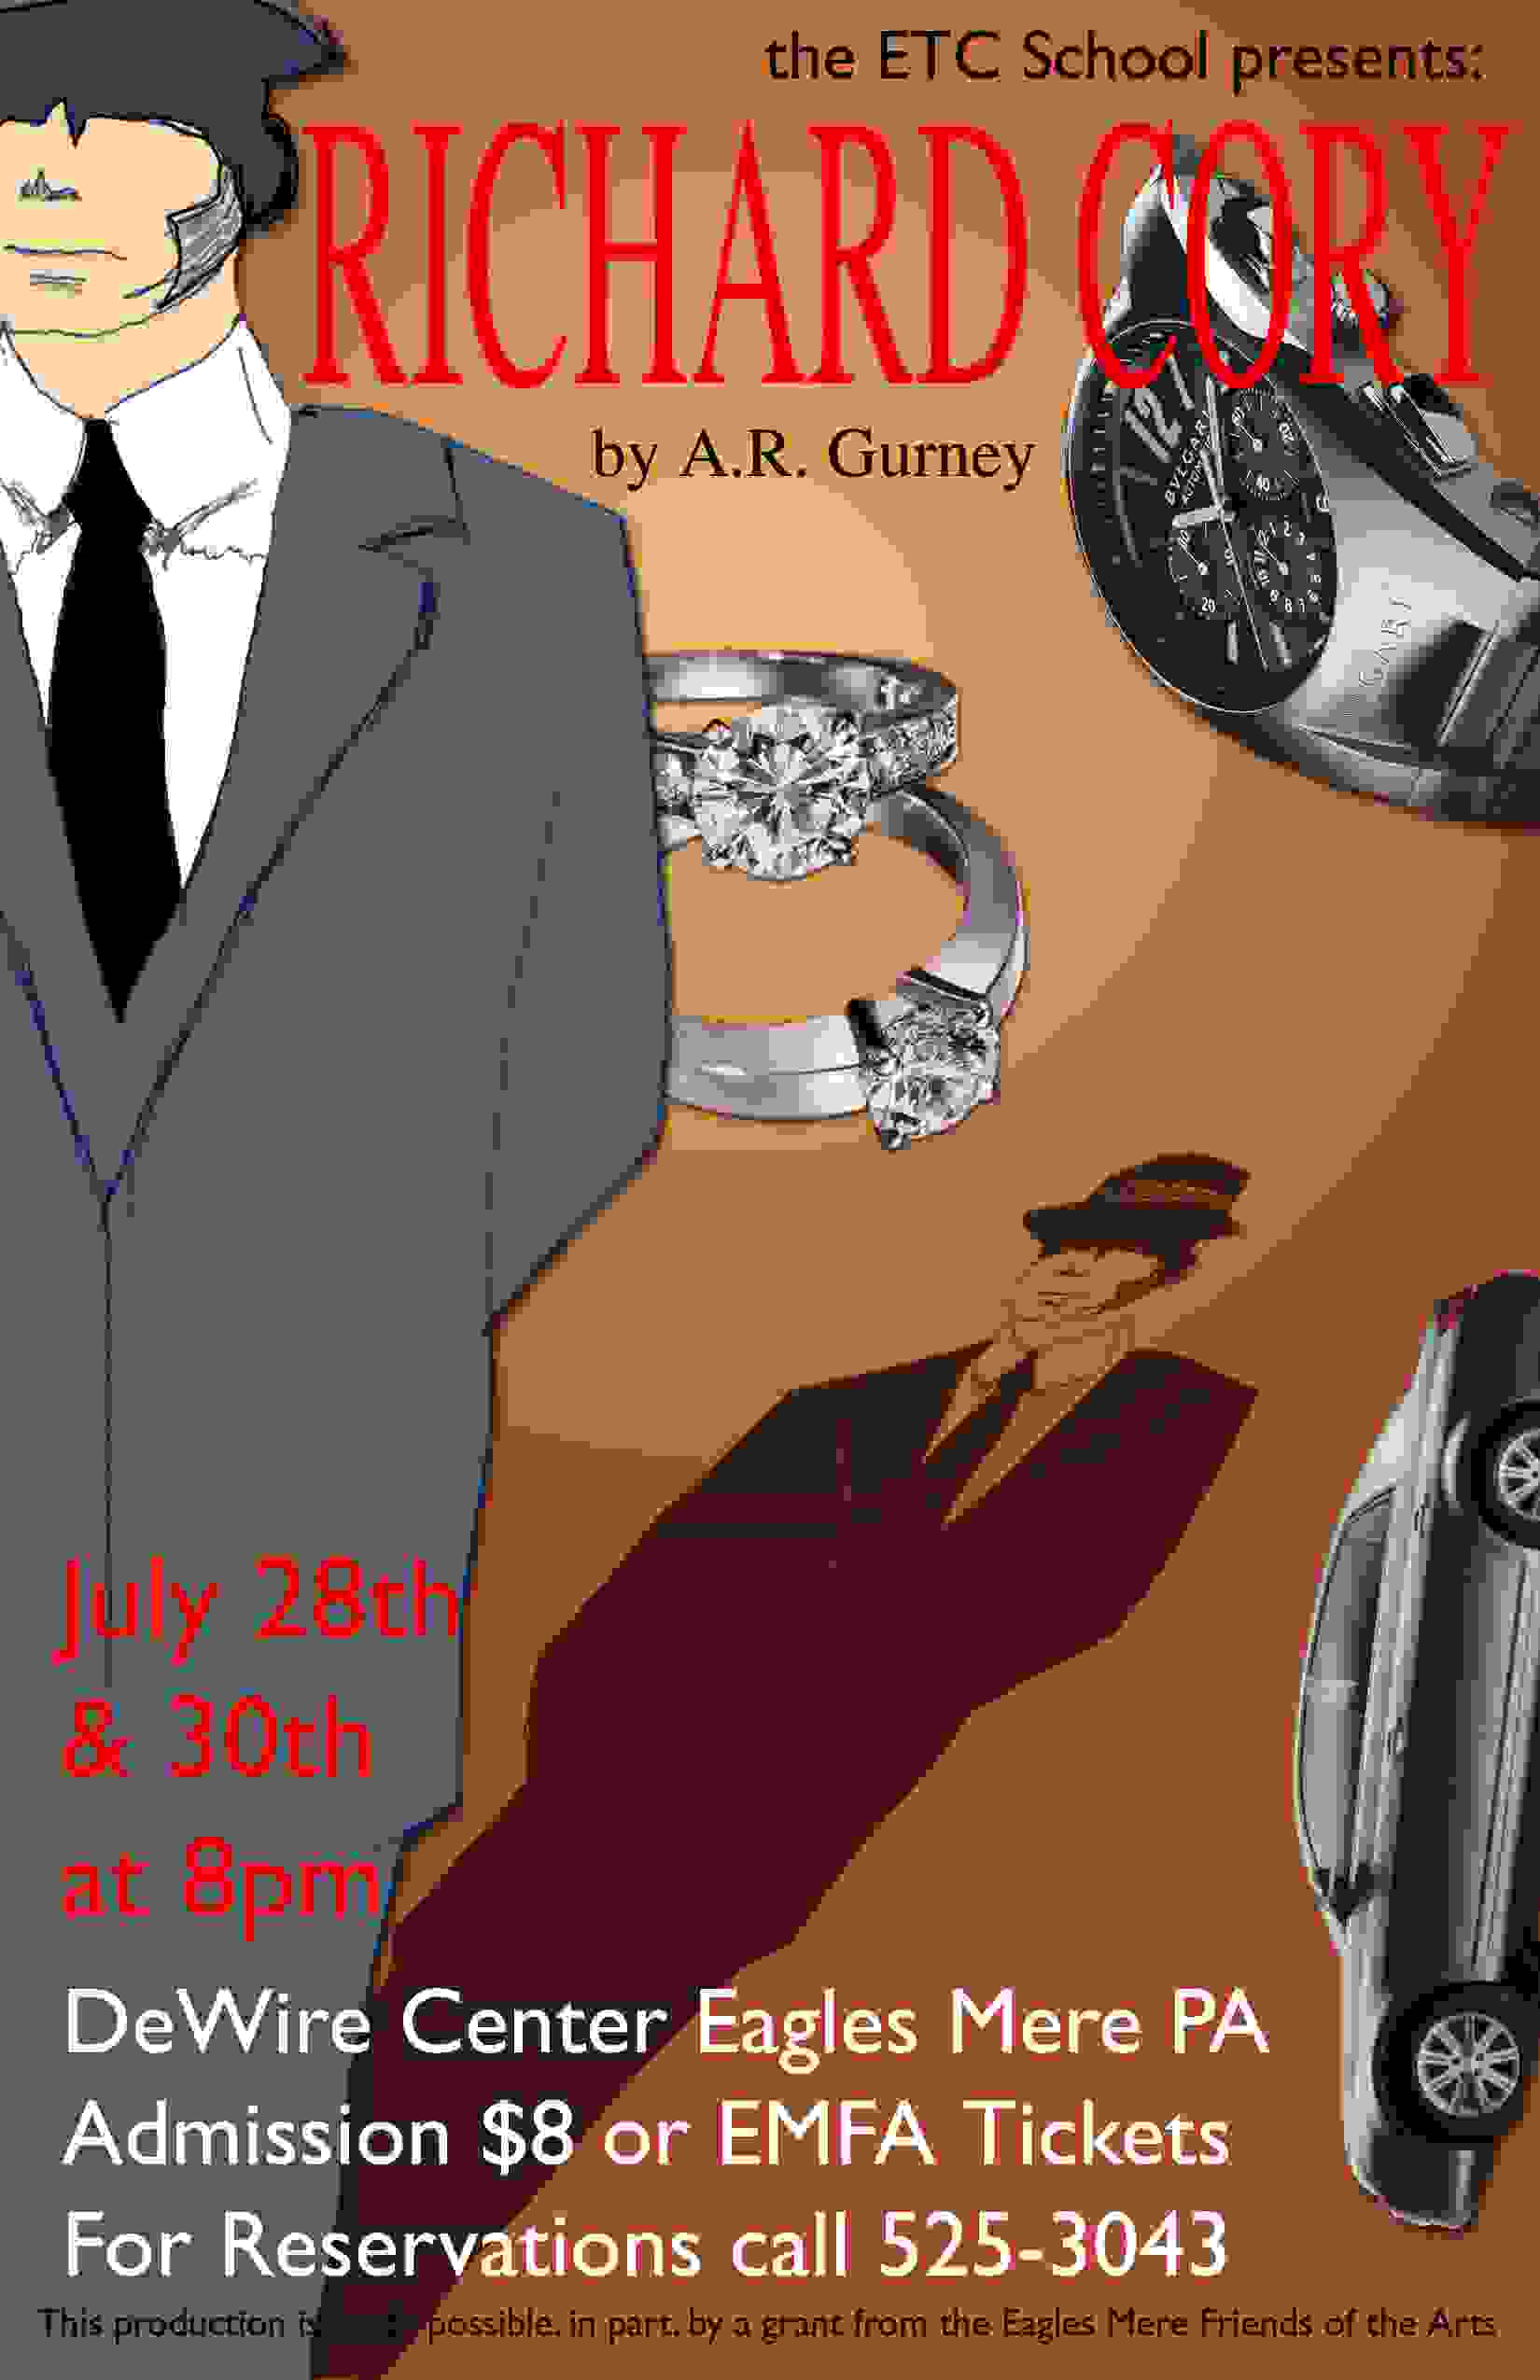
“Richard Cory” Simon and Garfunkel They say that Richard Cory owns one half of this whole town,
With political connections to spread his wealth around.
Born into society, a bankers only child,
He had everything a man could want: power, grace, and style.
Chorus: But I work in his factory
And I curse the life I’m living
And I curse my poverty
And I wish that I could be,
Oh, I wish that I could be,
Oh, I wish that I could be
Richard Cory.
The papers print his picture almost everywhere he goes:
Richard Cory at the opera, Richard Cory at a show.
And the rumor of his parties and the orgies on his yacht!
Oh, he surely must be happy with everything he’s got.
He freely gave to charity, he had the common touch,
And they were grateful for his patronage and thanked him very much,
So my mind was filled with wonder when the evening headlines read:
Richard Cory went home last night and put a bullet through his head.
Topic: Both Alanis Morrisette and Edwin Robinson use irony. Discuss.

________________________________________________________
_________________________________________________________________________________________________________________________________________________________________________________________________________________________________________________________________________________________________________________________________________________________________________________________________________________________________________________________________________________________________________________________________________________
__________________________________________________________________________________________________________________________________________________________________________________________________________________________________________________________________
__________________________________________________________________________________________________________________________________________________________________________________________________________________________________________________________________
________________________________________________________________________________________________________________________________________________________________________________________________________________________________________________________________________________________________________________________________________________________________________________________________________________________________________________________________________________________________________________________________________________________________________________________________________________________________________________________________________________________________________________
__________________________________________________________________________________________________________________________________________________________________________________________________________________________________________________________________
____________________________________________________________________________________________________________________________________________________________________________

