Social Studies 9 Name: KEY

The Revolution Begins (pg. 204-213 in Crossroads)
The disparity of the poor, extravagance of the nobles and the new ideas of the philosophes collided together in the in the 1780s, when a series of famines exacerbated the situation. France was now ripe for a radical and bloody revolution.

Directions: In your groups, read the section of the textbook you were assigned aloud (each person should read a paragraph until the section is complete). Then, fill in the blanks for your section. Afterwards, you will be assigned a new group where you be the expert on your section and will teach the information to your group.

The Crisis and War, Famine and Unemployment pg. 204-06
-Money spent by the royal family far exceeded the amount that could be raised through TAXES . France was bankrupt.
-Huge amount spent on SEVEN YEARS WAR and AMERICAN REVOLUTION
-French Philosophes and American and English Revolutions inspired middle class people to demand change
- FAMINES in the 1780s created a food crisis in France
-40 000 CHILDREN were abandoned.
-INDUSTRIAL REVOLUTION put French people out of work.
-Unemployed people had little to do but gather and talk about a government that seemed unwilling to HELP them.
-when crowds rioted in Paris over the high price of bread, the king’s troops opened FIRE
-King’s popularity fell even LOWER
-Louis responded to the crisis by having critics of the government IMPRISONED or KILLED.
-Desperate for money and a solution to the problems, he called the Estates General

Estates General pg. 206
-PARLIAMENT that met on royal command. Seldom called, last meeting in 1614
-Included representatives from the three sections of society
-First Estate = clergy, Second Estate = aristocrats, Third Estate = middle class
-every group voted as a BLOC (each had one vote), but while third estate was twice as big as the rest, the bloc voting meant that 1st and 2nd estate could always out vote them to protect their privileges.
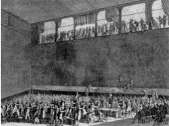
-Louis hoped the meeting would help RAISE money but he had no intention of surrendering his POWER
Tennis Court Oath

The Third Estate pg. 207
-The first concreate step towards revolution and change came when the THIRD estate broke away from the other estates
-Led by COUNT MIRABEAU the third declared that they would form a completely new GOVERNMENT called the National Assembly.
-their goal was to write a new CONSTITUTION for France.
-the king locked them out of the meeting room, so they responded by moving to the Royal Tennis Courts. Here they swore the TENNIS COURT OATH, a pledge that they would continue meeting until France had a new GOVERNMENT
-Louis was forced to have the first and second estate join the National Assembly.

The Fall of the Bastille pg. 207/8
-Riots soon broke out again over the high price of BREAD, as the immediate problem of poverty and starvation had not been addressed.
-Started attacking city prisons, hoping to free political PRISONERS
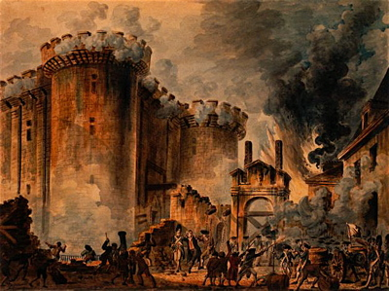
-Louis responded by sending foreign mercenary TROOPS, which citizens thought he would use on them, so they began to arm themselves
-July 14, 1789 a mob attacked a royal prison called the BASTILLE, released the SEVEN prisoners, cut off the governor’s head and paraded through the streets
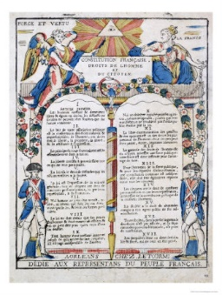
-This FRIGHTENED Louis and he agreed to send away his troops. National Guard was formed to keep order in Paris

Declaration of the Rights of Man and the Citizen pg. 209
-August 26, 1789 the National Assembly passed the Declaration of the Rights of the Man and the Citizen.
- It set out BASIC rights that the government must follow
-Modelled after the US DECLARATION OF INDEPENDENCE and the philosophes
-Guaranteed EQUALITY to all citizens, as well as freedom of SPEECH, religion, security and property
-Ended certain privileges for nobles
-rights to vote and participate in government were only given to “active citizens” who were Catholic property-owning MEN over the age of 25
-It also excluded WOMEN
The Great Fear pg. 211
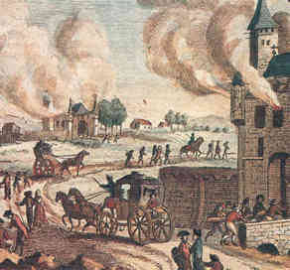
-Revolution mostly occurred in Paris and Versailles, but it began to spread to the country
-Peasants were afraid that the King’s soldiers would bring a BLOODY end to the revolution, resulting in a panic called the Great Fear.
-Peasants stormed rural aristocratic chateaux, burned them to the ground and killed 100s of people
-Stormed into offices and burned feudal certificates and papers that recorded their obligations to the lords.

Paris and The King pg. 211-212
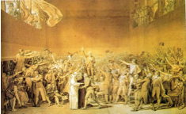
-August 4, 1789, The National Assembly met in Versailles and abolished all feudal rights and privileges and ended serfdom. Then, they declared all people equal before the law.
The National Assembly
-Huge change in a short period of time
-People worried king out of touch of conditions in cities, felt government should be in Paris instead of Versailles.
-On Oct. 5, 1789, hungry and frustrated women decided to march 22 km to
Versailles to meet directly with the king.
-They attacked the National Assembly and the Palace and Louis agreed to go to Paris. This was a sign that the people were gaining power and the monarchy was losing control.

Citizens and Constitutions pg. 213
-New constitution passed by the National Assembly, which declared that noble titles were now useless, and everyone—both rich and poor—was given the title of citizen. The government also seized control of the church.
-Many aristocrats fled France to try to figure out how to restore the old system (called émigrés)
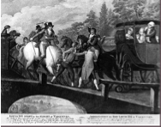
-In 1791 Louis tried to flee to get help from other European monarchs to restore his monarchy
Flight To Varennes
-Worst thing he could do, proved he was untrustworthy and that he didn’t support democratic changes.
-Royal family recognized at Varennes, arrested and imprisoned.
-In the Legislative Assembly, three groups fought for power. Radicals wanted France to be a republic (no king), Moderates wanted a Constitutional Monarchy (like England), and
Monarchists wanted to restore most of the king’s powers.

Summing it all up:
In the table below, please record or draw the 2 most important things that happened in each section.
A Crisis | France is bankrupt
The Estates General
The Third Estate Breaks away
The Fall of the Bastille
Declaration of the Rights of
Man and the Citizen

The Great Fear

Paris and the King
Citizens and the Constitution

Social Studies 9 Name:
The Revolution Begins (pg. 204-213 in Crossroads)
The disparity of the poor, extravagance of the nobles and the new ideas of the philosophes collided together in the in the 1780s, when a series of famines exacerbated the situation. France was now ripe for a radical and bloody revolution.

Directions: In your groups, read the section of the textbook you were assigned aloud (each person should read a paragraph until the section is complete). Then, fill in the blanks for your section. Afterwards, you will be assigned a new group where you be the expert on your section and will teach the information to your group.
The Crisis and War, Famine and Unemployment pg. 204-06
-Money spent by the royal family far exceeded the amount that could be raised through _________ . France was bankrupt.
-Huge amount spent on ___________________________and _____________________________
-French Philosophes and American and English Revolutions inspired middle class people to demand change
-__________________________ in the 1780s created a food crisis in France
-40 000_______________________ were abandoned.
-________________________________ put French people out of work.
-Unemployed people had little to do but gather and talk about a government that seemed unwilling to________ them.
-when crowds rioted in Paris over the high price of bread, the king’s troops opened____________________
-King’s popularity fell even______________________
-Louis responded to the crisis by having critics of the government____________________ or __________________.
-Desperate for money and a solution to the problems, he called the Estates General

Estates General pg. 206
-____________________________ that met on royal command. Seldom called, last meeting in 1614
-Included representatives from the three sections of society
-First Estate = clergy, Second Estate = aristocrats, Third Estate = middle class
-every group voted as a ___________________ (each had one vote), but while third estate was twice as big as the rest, the bloc voting meant that 1st and 2nd estate could always out vote them to protect their privileges.
-Louis hoped the meeting would help _____________ money but he had no intention of surrendering his___________
Tennis Court Oath

The Third Estate pg. 207
-The first concreate step towards revolution and change came when the_____________________ estate broke away from the other estates
-Led by ___________________________ the third declared that they would form a completely new_____________________ called the National Assembly.
-their goal was to write a new ______________________________for France.
-the king locked them out of the meeting room, so they responded by moving to the Royal Tennis Courts. Here they swore the _______________________________, a pledge that they would continue meeting until France had a new _________________________________
-Louis was forced to have the first and second estate join the National Assembly.

The Fall of the Bastille pg. 207/8
-Riots soon broke out again over the high price of ___________________, as the immediate problem of poverty and starvation had not been addressed.
-Started attacking city prisons, hoping to free political________________________________
-Louis responded by sending foreign mercenary ____________________, which citizens thought he would use on them, so they began to arm themselves
-July 14, 1789 a mob attacked a royal prison called the ________________, released the _________________ prisoners, cut off the governor’s head and paraded through the streets
-This________________________ Louis and he agreed to send away his troops. National Guard was formed to keep order in Paris

Declaration of the Rights of Man and the Citizen pg. 209
-August 26, 1789 the National Assembly passed the Declaration of the Rights of the Man and the Citizen.
- It set out _____________________ rights that the government must follow
-Modelled after the US ________________________________and the philosophes
-Guaranteed____________________ to all citizens, as well as freedom of _______________________, religion, security and property
-Ended certain privileges for nobles
-rights to vote and participate in government were only given to “active citizens” who were Catholic property-owning _______________________ over the age of 25
-It also excluded _____________________
The Great Fear pg. 211
-Revolution mostly occurred in Paris and Versailles, but it began to spread to the country
-Peasants were afraid that the King’s soldiers would bring a ____________________end to the revolution, resulting in a panic called the Great Fear.
-Peasants stormed rural aristocratic__________________, burned them to the ground and killed 100s of people
-Stormed into offices and burned ________________________ certificates and papers that recorded their obligations to the lords.

Paris and The King pg. 211-212
-August 4, 1789, The National Assembly met in Versailles and abolished all feudal rights and privileges and ended serfdom. Then, they declared all people equal before the law.
The National Assembly
-Huge change in a short period of time
-People worried king out of touch of conditions in cities, felt government should be in _____________________instead of ___________________________.
-On Oct. 5, 1789, hungry and frustrated _______________decided to march _________ to
________________________ to meet directly with the king.
-They______________________ the National Assembly and the Palace and Louis agreed to go to Paris. This was a sign that the_______________were gaining power and the _________ ___was losing control.

Citizens and Constitutions pg. 213
-New constitution passed by the National Assembly, which declared that ______________ were now useless, and everyone—both rich and poor—was given the title of ___________. The government also seized control of the church.
-Many ____________________ fled France to try to figure out how to restore the old system (called émigrés)
Flight To Varennes
-In _____________________Louis tried to flee to get help from other European monarchs to restore his monarchy
-Worst thing he could do, proved he was______________ and that he didn’t support ________________________.
-Royal family recognized at Varennes, arrested and _________________________
-In the Legislative Assembly, three groups fought for power. Radicals wanted France to be a _______________ (no king), Moderates wanted a ________________Monarchy (like England), and ___________________________ wanted to restore most of the king’s powers.
Summing it all up:
In the table below, please record or draw the 2 most important things that happened in each section.
A Crisis | France is bankrupt
The Estates General
The Third Estate Breaks away
The Fall of the Bastille
Declaration of the Rights of
Man and the Citizen

The Great Fear

Paris and the King
Citizens and the Constitution

