SS11 Name: ________________________ French/English Relations
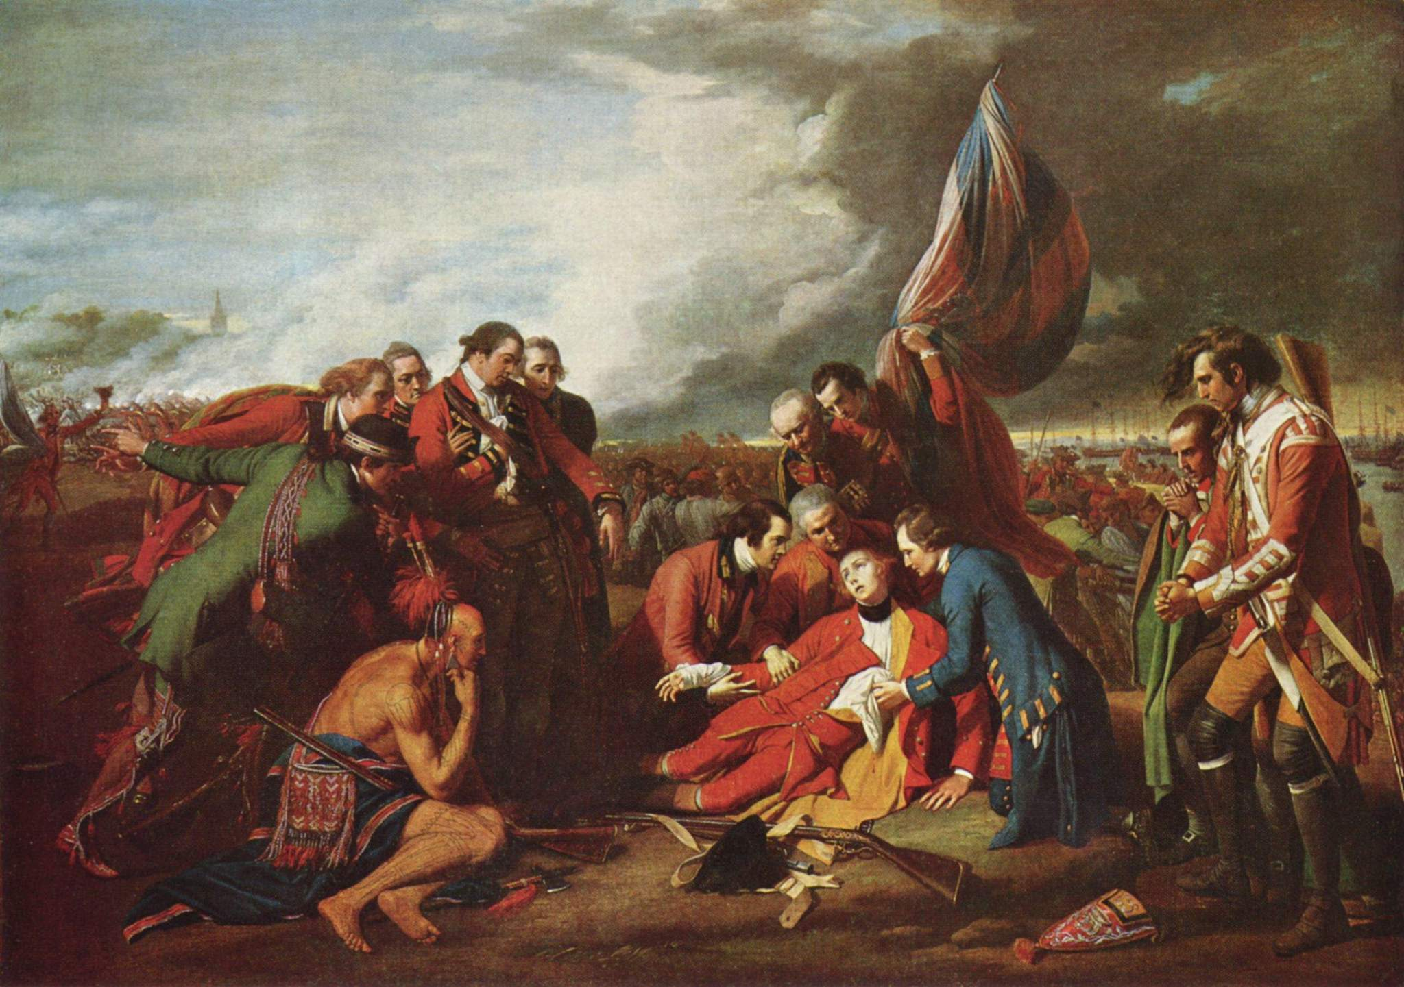
1763 Battle of the ___________________________ of ________________________________

-End of the 7 years war.
-British defeat ________________________________. Quebec is given as a _______________________ to the British.
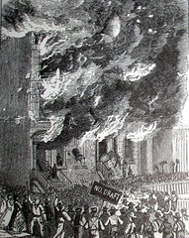
-The license plate slogan ________________ ___________________ ___________________ commemorates this event; they will never forget that they were conquered by the British.

World War 1 and 2

-PM promises no conscription, and then has to back out. English ok with it; French riot and protest.
-Mad that they are forced to fight a war for their British conquerors and French abandoners.

Maurice Duplessis and the ________________________ _____________________________ (pg. 182-3)

-Remember the Padlock Law???
-Premier of Quebec 1936-39 and 1944-59.
-Strong nationalist; believed Quebec was a ____________________________ society (not just another Canadian Province).
-Introduced own flag because of this (fleur-de-lys).
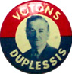
-Wanted Quebec to be traditional (praised farming, families and faith) and ____________________________.
-Church played large role in schools and hospitals.
-Emphasized classic studies (language, philosophy) not sciences, so Quebec produced few businessmen, engineers or scientists.
-Duplessis hated Communism, loved business so encouraged foreign businesses to invest in Quebec.
-Promised cheap labour and no unions in exchange for a donation to his party.
-Lots of bribery and corruption (ie. Duplessis orphans).

The _____________________________ Revolution (pg. 217)
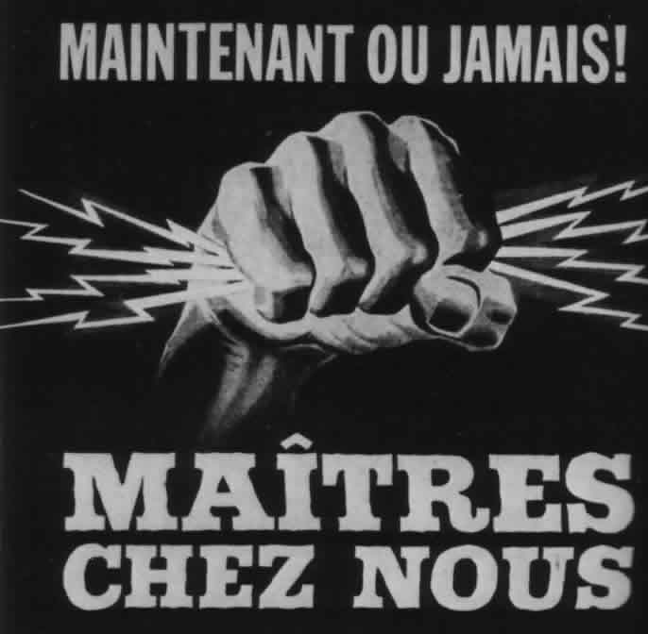
-1959 Duplessis died, John ______________________ came to power (Liberal) won with the slogan “it’s time for a change.”
-Wanted to stamp out corruption (allow unions, jobs by merit, increase wages) and modernize economy, politics and education. Get rid of total control of church.
-This was known as the Quiet Revolution because all the changes were underneath the _____________________.
-Encouraged science and technology, get rid of total control of church.
-Wanted to be Maitres Chez Nous ( _____________________ in our own _____________________) control own economy (ie. _________________________) and ________________________ language should dominate.

Rene Levesque and The ___________________________ _________________________ (PQ) pg. 218-9

-Some felt the Quiet Revolution was not ______________________________.
-PQ formed with the goal of ________________________________ from ______________________________ (separatism).
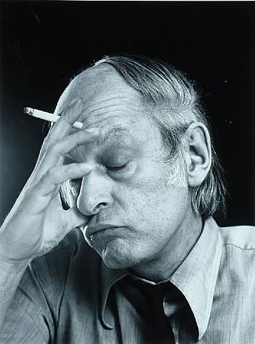
-Felt Canada was dominated by the English (have all key cabinet posts, etc), Francophone could not get French education outside of Quebec, had to speak English in governments and stores etc.
-Believed they must be their own nation; should divorce instead of a marriage of 2 unworkable cultures.
-Canada’s response: tried to ____________________________ it by creating a new non-British flag and making Canada _________________________. Known as the _________________________ and ________________________ commission (Bi&Bi Commission).
-Some Canadians embrace, others say we are giving too much attention to Quebec.
-Quebec thought it wasn’t enough, want “special status in constitution.
-Trudeau angers them by saying they are a “province like any other.”
-Terrorist group called Front Du Liberation Du Quebec (FLQ) is formed.

FLQ/October Crisis (pg. 220)
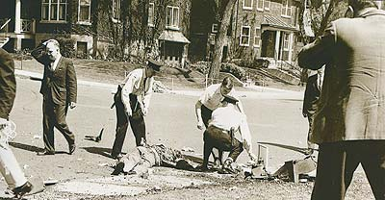
-Slogan: “Quebec libre” (free Quebec).
-Blew up mailboxes and destroyed other symbols of English power in Quebec.
-October, 1970, kidnapped a British diplomat _______________________ _______________________.
-Demanded, in exchange for his return, FLQ members in prison be let out and their manifesto to be read in public.
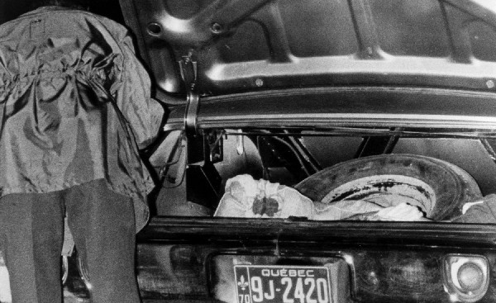
-Agreed to manifesto, but not prison releases, so they kidnapped Quebec MP _____________ __________________.
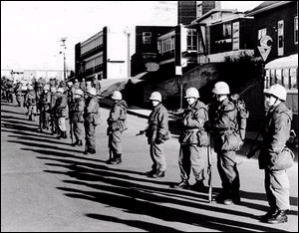
-Trudeau invoked the ___________________ _____________________ _________________________ and put Quebec under _______________________ law (army in Montreal, suspend civil liberties, pro-separatists arrested and held without charge.
-Many shocked he would do this.
-October 17, Laporte’s body is found.
-Negotiated free passage to ________________________ in exchange for Cross.
-450 arrested, only small amount ever charged.

PQ in Power and the 1980 Referendum (pg. 221, 257)

-1974 Bill 22 passed by Liberal: French sole language of Quebec, only language of workplace and services, if not proficient in French leave.
-Many thought this was not enough and elected the PQ in next election
-Promised they would have a ___________________________ on separating from _____________________________.
-Bill _________________________ : French only language in Quebec, all outdoor signs French and all _______________
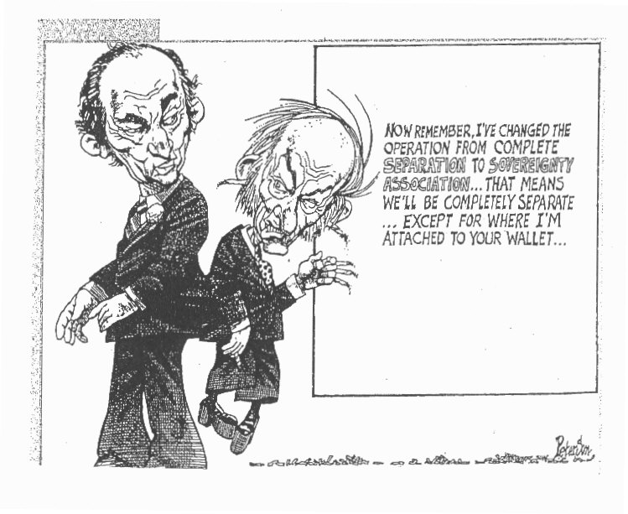
to Quebec must learn __________________________________.
-French liked this, saw their language and culture as in trouble, English saw it as oppressive and wanted the federal government to stand up against separatists.
-1980 had referendum. Promised sovereignty association (politically separate, but economically close).
-________________________ said yes, ______________________________ said no.
-Trudeau, trying to keep the country together decides to change the ______________________________. Feels a Canadian Constitution would make French happy.
-Trudeau angers Levesque when he purposely leaves him out of “Kitchen Compromise” (constitution can be changed if 7 out of 10 province representing 50% of population agree; therefore Quebec can be ignored if Ontario supports something).

Meech Lake Accord and Charlottetown Accord (pg. 262)

-Mulroney in power knew ________________________ Compromise angered Quebec. Said he would __________________________ the constitution.
-Make Quebec a ____________________________ society. Trudeau criticized this; everyone would want the same.
-This backfired when _______________________ __________________________ (a Cree) said Aboriginals are distinct too, other provinces piped up too and Trudeau said I told you so.
-Meech Lake died in June 1990.
-Separatism soared to 64%.
-Lucien Bouchard resigned from Mulroney’s cabinet and formed the Bloc Quebecois, federal party committed to separatism.
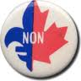
-Mulroney tried again in Charlottetown Accord offering Quebec to be distinct, Aboriginal self-government and Senate reform.
-This was voted down too.

1995 Referendum and the ____________________________ Act (pg. 264)

-Angered by defeat of Meech Lake, had another referendum. This time full sovereignty (no ties).
- ______________________________ yes __________________________ no.
-BQ discussed having another referendum.
-Tired of referendums, Chretien passed ___________________________ Act: Government must decide what a ____________________________ is (must be clear, not just 51%).
-Today is separatism an issue?
-Last leader of Quebec called the _____________________ flag a “dirty piece of cloth,” but does the election of NDP and decline of BQ mean separatism is fading?

