I found a good video on fake news, but I couldn’t find a good one on important Canadians. The videos I found were either too long, or too boring. I think the video I linked below captures what we were hoping for. It covers the world’s most powerful people currently in 2023. I also posted some fake and real photos below that I found interesting. Feel free to use or not use whatever you like!

How Fake News Gets Into You

Top 10 Most Powerful People In The World 2022

Real
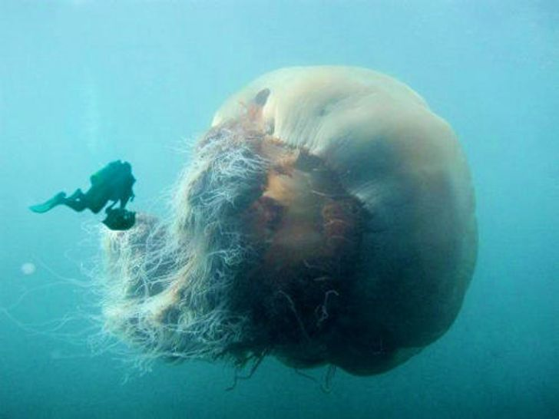

Real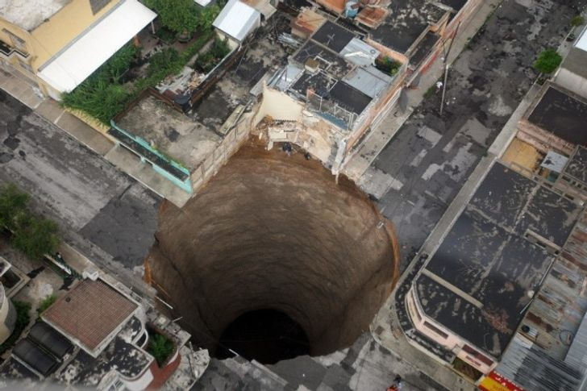

Real
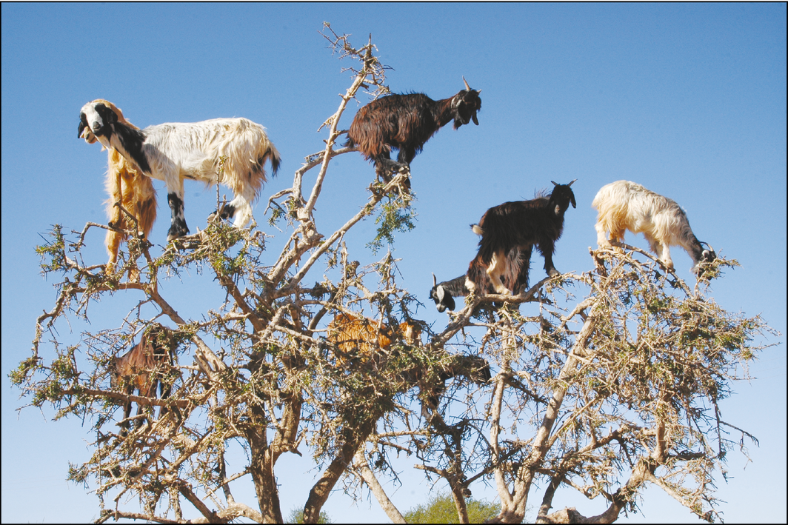

Fake
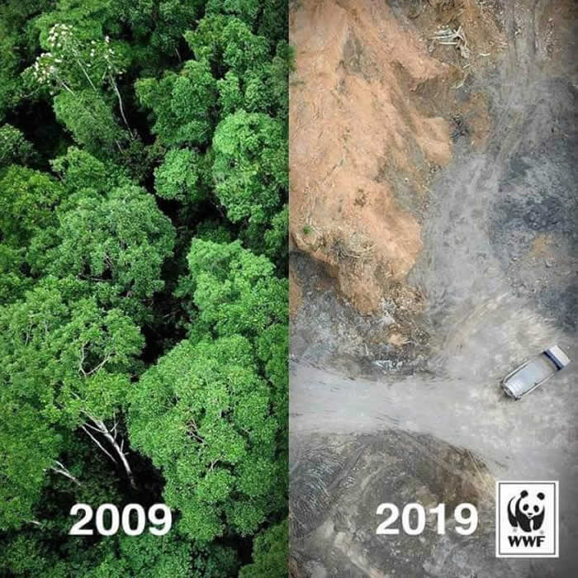

Fake

Fake (Not the Ogopogo)
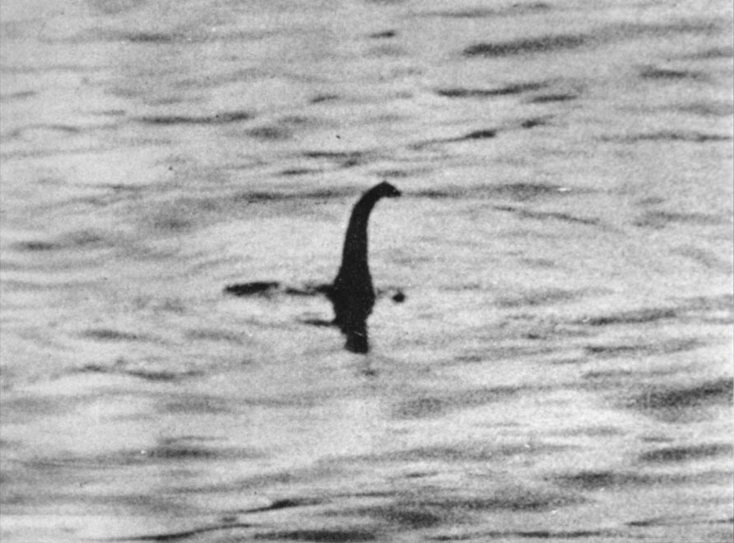

Real
Fake
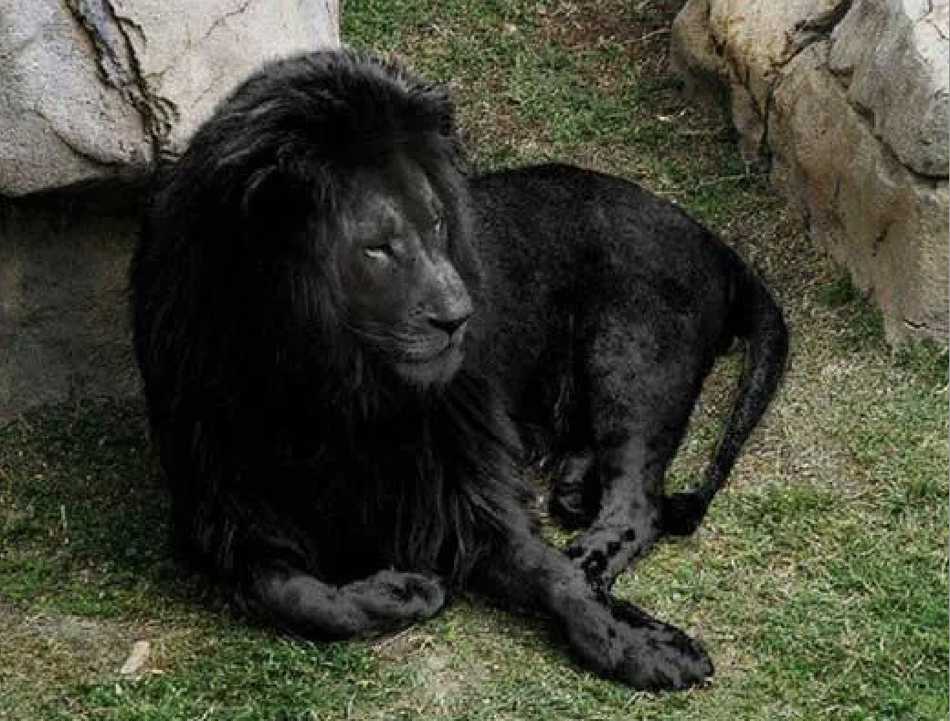

Real
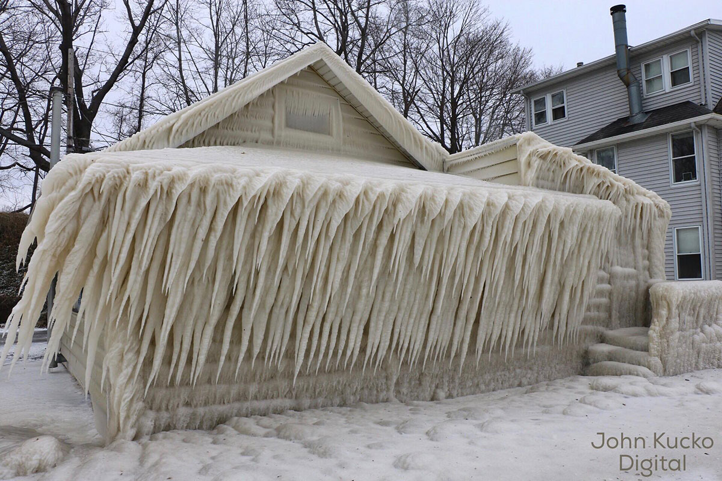

Fake (Way too cold to wear that riding in those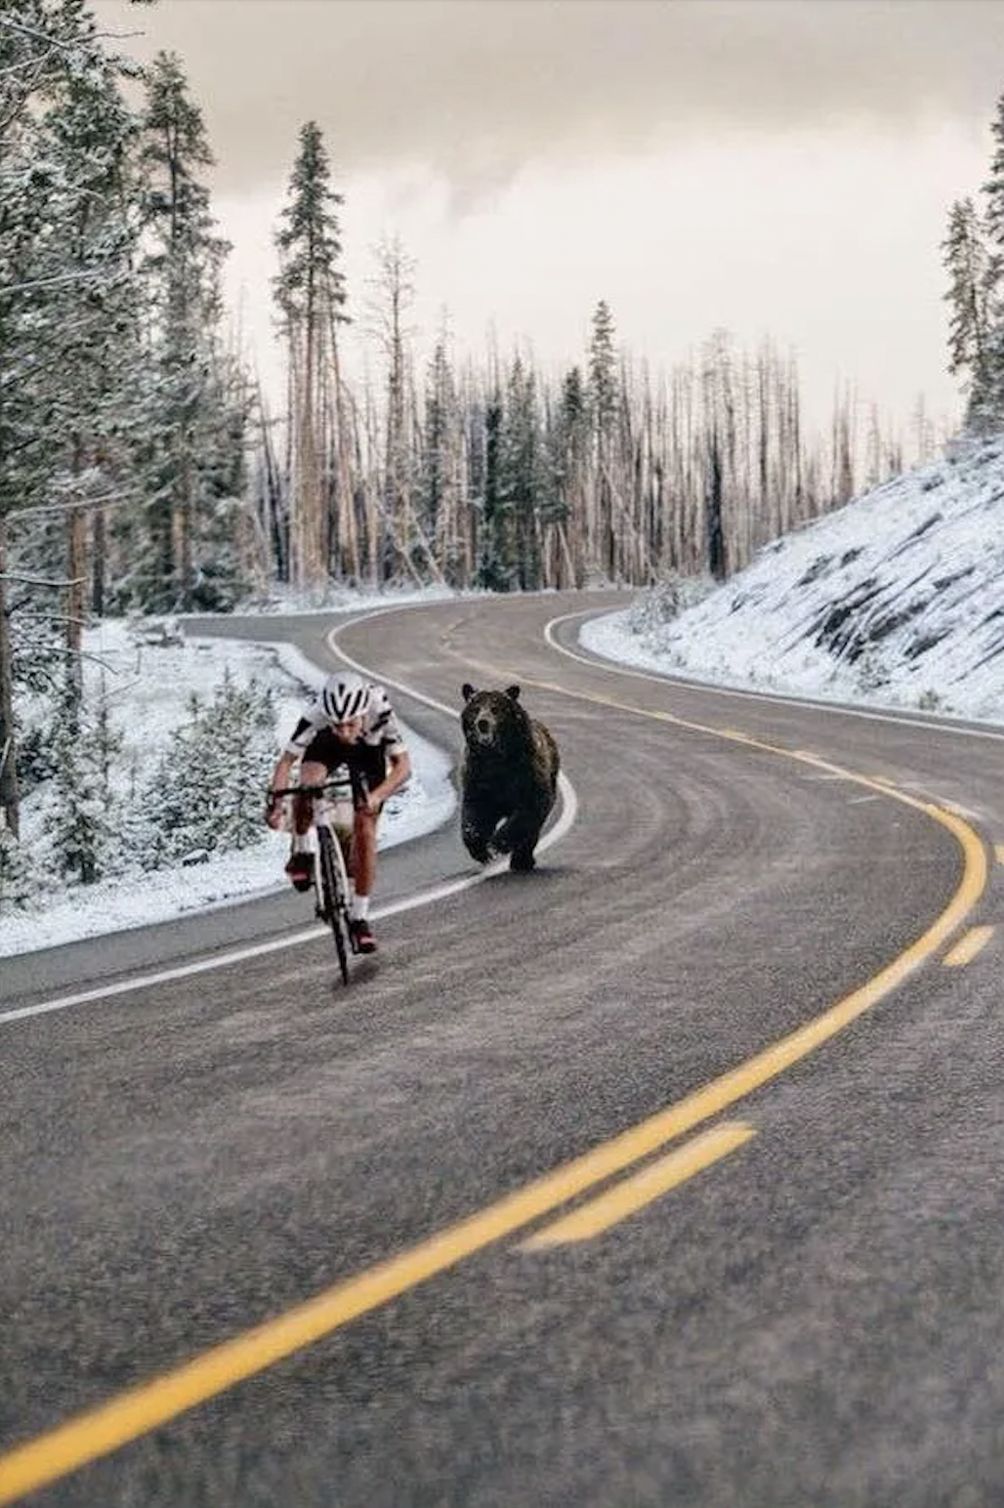 conditions!)

Fake (can see in his glasses)
