Topic:

Storytelling often plays a role in the texts
created by First Peoples.

In paragraph form, support this statement by discussing the essay “You’ll Never Believe What Happened” is a Always A Great Way To Start by Thomas King.

Please include at least ONE direct reference (This means you must directly incorporate at least one quote from the essay).

General Guidelines:

- Paragraph Response (250-300 words). Going over that word count is fine. Use the t-chart on the back to set up your ideas
- Write in third person (don’t use “I”) and present tense.
- Have an intro and concluding sentence.
- Include the name of the novel and the author in your intro.
- As always, use the highest level of vocabulary possible.
- Incorporate your quotes smoothly into your own sentences.
- Topic sentence should present an argument, not just repeat the topic.

Whenever possible, instead of using the word “shows” use:

Demonstrates
Highlights
Emphasizes
Illuminates
Reveals
Displays

Thomas King “You’ll Never Believe What Happened” (Essay #1)

List 8-10 key events that happen, or ideas that are discussed in Essay #1 (in order) Key quotes are acceptable as well. | List a minimum of 5 quotes that apply to the topic of “storytelling.” Include the page number of the quote as well ie: (King 10).

Developing Thesis Statements

Thesis statements are integral to essays/paragraphs. Here are some tips for developing strong thesis statements.

- Thesis statements briefly summarize the arguments that you will be proving in your essay/paragraph.

Topic: Identity

Here is an example: In Keeper in Me by Richard Wagamese, the protagonist Garnet struggles to create an identity for himself after growing apart from his cultural roots -he creates this identity through forging relationships with his long-lost family, finding his own history and embracing his Ojibway culture.

This is a thesis statement because it names the topic (identity) and presents a provable argument AND the details on how it will be proven (family, history, culture)

In this essay I will write about identity in Richard Wagamese’ Keeper in Me.

This is not a thesis statement because it simply mentions the topic, it does not present an argument.

2. In formal essays do not use “I” or mention the word essay

3. Take a topic and narrows it (you want to make it different from other essays written on the same topic)

4. Avoid vague language (like “it seems”)

5. Should pass the “so what” test, meaning that it is something someone could argue against. For example, the thesis Garnet is a character in the novel The Keeper in Me does not pass the “so what” test because it is unlikely to evoke any opposition.

6. Always include the author and title in the statement

7. Sometimes it can be helpful to start with a preposition. For example, While Keeper in Me by Richard Wagamese seems at first glance to be purely about Garnet’s search for identity, the novel also explores the human need to be part of a greater whole, in this case the protagonists’ Ojibway community, history and culture.

Now you try:

Topic: Storytelling in “You’ll Never Believe What Happened is Always a Good Way to Start” by Thomas King

Thesis: ________________________________________________________________________________________________________________________________________________________________________________________________________________________________________________________________________________________
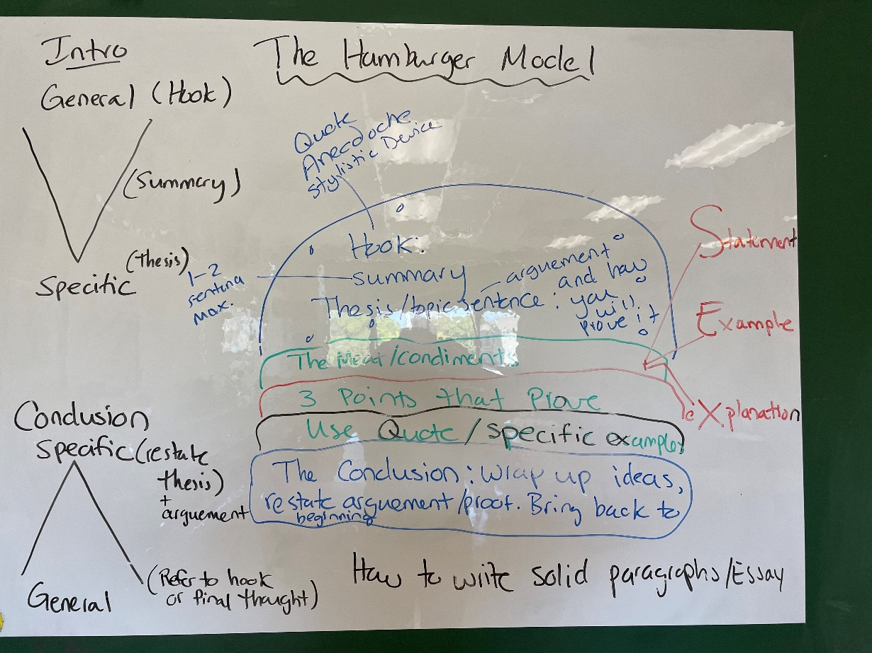
Hook:_______________________________________________________________________________
Summary: ___________________________________________________________________________
Thesis: _____________________________________________________________________________

Point #1: ____________________________________________________________________________
Quote: ______________________________________________________________________________
How it proves Thesis:___________________________________________________________________

Point #2: ____________________________________________________________________________
Quote: ______________________________________________________________________________
How it proves Thesis:___________________________________________________________________

Point #3: ____________________________________________________________________________
Quote: ______________________________________________________________________________
How it proves Thesis:___________________________________________________________________

Conclusion: __________________________________________________________________________

