English 9 Mrs. Fitton 6“Read, read, read. Read everything – trash, classics, good and bad, and see how they do it. Just like a carpenter who works as an apprentice and studies the master.” -William Faulkner

Introduction: English 9 is a skills based course that aims to sharpen student’s minds and to provide pupils with strategies to become better readers, writers and connoisseurs of literature.

Course Objectives: Students will develop the ability to:

*Develop confidence in reading, writing and speaking *Recognize literary devices in writing
*Read actively by taking notes, questioning & annotating *Develop proficient speaking and presentation skills
*Write expository, descriptive and narrative paragraphs as well as a basic essay
*Read and reflect upon reading via discussion/writing/creative projects *Have FUN with literature!

Curriculum Organizers. Learning Outcomes (Students will learn to:)

1. Oral Language Communicate effectively through public speaking, acting, sharing opinions,
(Speaking and listening) debating and working in groups. Learn techniques to persuade/critique/engage others. Students will also learn how to become active listeners

2. Reading and Viewing. Read and view to comprehend the deeper meaning of a variety of fiction and nonfiction. We will also sharpen critical analytical skills through constant practice with a variety of texts and mediums.

3. Writing & representing. Express ideas meaningfully, clearly and creatively. Apply a range of strategies to improve writing by assessing their own work and others.
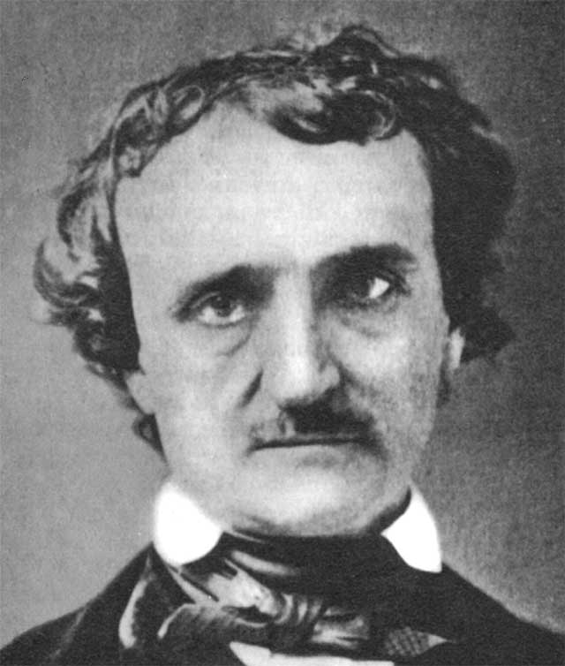
Assessment and Evaluation
-Conducted on an ongoing basis.
-Criterion referenced (students know in advance how they will be marked)
-Quizzes, projects, analysis of material, written assignments, discussions, simulations.
Mark Breakdown
Terms 1,2,3 & 4 = 80% Exam = 20%
The pen is mightier than the sword!
-E. Bulwer-Lytton
Materials – Bring EVERY day: Binder; Paper; Pencil; Texts
Expectations
1. I will endeavor to keep homework to a minimum. Most assignments will be done in class. In return, I expect that all students will make every effort to attend each class on time. Parents will be contacted when students have unexcused absences or excessive lates. If you must be absent from a class, it is your responsibility to pick up the assignments you missed, preferably before class.

2. Come to class on time, prepared and ready to work. Treat everyone with respect.

3.Catch up on missing assignments in a timely manner. Students with missing assignments will be asked to stay in at lunch or attend homework room. Use the website to keep caught up if you must miss class

4. During class discussions leave all electronics in your bag. During independent work you may use an ipod, but please do not use your cell phone in class.

Email: efitton@summer.com Website: efitton.weebly.com
English 9 - We few, we happy few, we band of brothers!

“Books are the carriers of civilization. Without books, history is silent, literature dumb,
science crippled, thought and speculation at a standstill.” – Barbara W. Tuchman
Tentative Schedule: (these units may appear in any order)
Unit 1: Death, Destruction and one Happy Day (AKA Short Stories)
We will be interacting with stories and participating in various activities to help connect to the plot and the main ideas.

Unit 2: Please Stop Laughing at the Stone Monster Once and Speak Up:
You will be given a choice of four novels about bullying. Various activities will be given for the books to help you achieve a deeper understanding.

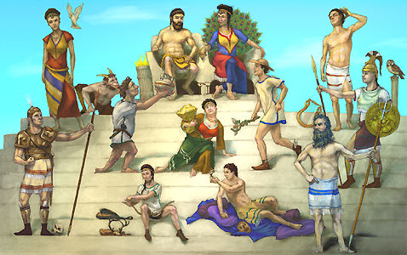
Unit 3: Marvelous Men and Malignant Monsters
We will study an assortment of Greek mythology, the King Arthur myths and creation myths. We will use a variety options to show your understanding.
Unit 4: Study thy play thou foul pestilent foot licker
We will study Shakespeare’s A Midsummer Night’s Dream. Get ready for some fun reading of the play out loud in class! We will make Shakespeare come alive while learning about his life and times. The movie will be shown. Disclaimer: Pepto-Bismol may be required on the last day of the unit

Unit 5: Nonfiction Texts
In this unit we will explore texts such as directions and articles. Emphasis will be placed on reading strategies, understanding the texts and even writing your own directions for your classmates to follow!

Unit 6: Modern Poetics
We will use a combination of written, performance and music poetry to learn the elements of a poem

Unit 7: Lovely Literature and Dandy Discussions
Again you will be given a choice of novels and we will do a variety of fun activities to increase your understanding of your text.* (See next page for more details)

Congratulations, you are now an English genius!

*Literature Circles allows students to choose a novel of their choice. They will study the novel in groups using roles and small group projects as a basis for discussion and as an avenue to discover the meaning of their novel.

*A primary goal within School district 67 is to improve student literacy by fostering independent reading for all students. The success of the Literature circle program is dependent upon offering current and relevant novels that will engage students. Therefore, some novels may contain realistic and mature themes. Student will be briefed on the style and content of each text prior to making their individual selections. Parents with interest in Literature Circles are encouraged to contact the classroom teacher.

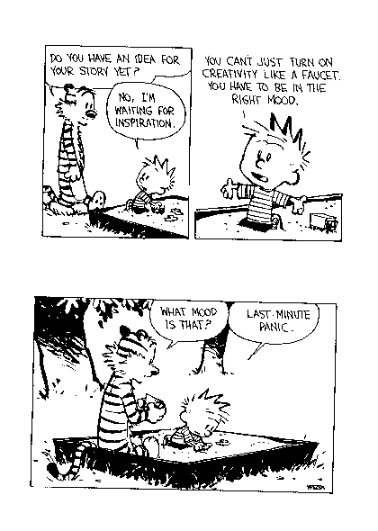

Please review this outline with your parents and have them sign it and include their email address and phone number and hand it back to me no later than Friday September 7. Email
will be my primary mode of contact. My email address is: efitton@summer.com. Please do not hesitate to email me if you (or your parents) have any questions. I am also available by phone at 770-7620.

---------------------------------------------------------------------------------------------------------
Student Name: _________________________________________________________

Parent(s) Name(s): _____________________________________________________

Signature: ____________________________________________________________

Email and phone number: (P) _____________________________________________
(E)_____________________________________________

