EFP 12 Literature Circles Unit Name: ____________

Objective: To allow you to have some selection in your reading material, but still have a chance to work on and discuss deeper themes and ideas with your classmates.

Expectations for the unit:
-Reading time: 15-20 minutes per day in class, and 15 minutes (minimum) at home each night.
-Reading awareness: (thinking about what you’re reading as you are reading it) See sticky note/significant passage assignment
-You must finish a minimum of one novel by _____________________. If you finish one earlier you may move on to another.
-You must complete all of the assignments for the unit

Sticky Notes/significant passages:

While you are reading your novel, you should be paying attention to details and keeping track of different things that you notice. During the reading of your novel, you will be responsible for choosing a minimum of 15 quotes or passages that you think are significant. If you own a novel of your own you should get in the habit of using a pen or pencil to make notes in the margins. As this is not an option for a class novel, you may either use sticky notes to mark important quotes, or you may record your quotes on a separate page in your notebook. These quotes will become extremely important for assignments to be completed during the unit. You may choose quotes that highlight the following things:

-Anything you believe may be a major theme or issue in the novel
-Important details about character (both characterization and development)
-Images or symbols that appear more than once
-Passages you find confusing and want to figure out
-A detail that simply stands out to you for some reason
-Something that you can make a personal connection to, or that you can see is similar to a movie, song, or something else you have experienced
-Language that you find powerful or memorable
-Something that creates a strong emotional response in you
-Something you had never considered or didn’t know before
At the end of your novel you will hand in your notes.

Note: Your notes should explain why you chose a particular passage in about 2-3 sentences.

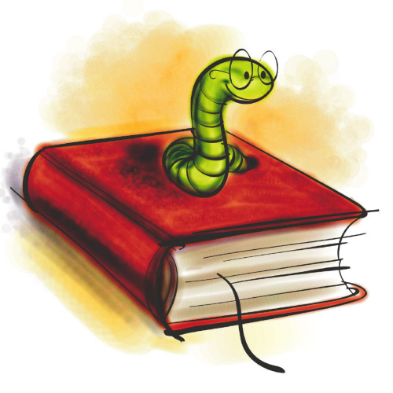
Sticky Note Example:

“For once a story is told, it cannot be called back. Once told, it is loose in the world” (King 10)
Explanation (I will show you two ways I would have responded to this quote, you just need to do one on your sticky notes):
1. I chose this quote because I think that it represents a theme of the essay. King is trying to show why a story is never just a story, it has an impact on the world when it is taken seriously. This can be seen with the creation story Genesis which has framed Western worldview.
2. I have a personal connection to this quote as it reminds me of the power of gossip. Stories that are spread without any truth can harm a person forever. I had a friend in high school and there was a rumor going around that she had had a relationship with another student in our class. It wasn't true, but people believed it because they "heard it from a friend." It ruined her social life and reputation, yet it was a completely made-up story.

Novel: __________________________________

Group Members:

1. _______________________________

2. _______________________________

3. _______________________________

4. _______________________________

5. _______________________________

6. _______________________________

Break up of Reading:

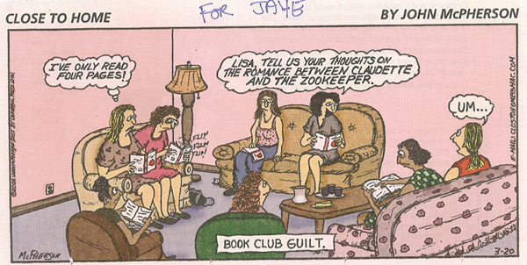
_______________: receive books

_______________ page: ___________

_______________page: ___________

_________________________: Be done book.

