English 12 First Peoples Mrs. Fitton

Class Website: http://efitton.weebly.com Teacher email: efitton@sd67.bc.ca

“We’re all neighbours: that’s the reality. This land has the potential for social greatness.” Richard Wagamese

Welcome to English 12 First Peoples! This course meets all the curricular requirements set forth by the Ministry of Education for English 12, but the focus is from a First Peoples perspective. Not only will students receive the skills and knowledge required to navigate through an increasingly complex 21st century world, but they will also have the added benefit of working with materials that present authentic First Peoples voices and help foster reconciliation.

Note: While the focus in EFP 12 will be primarily on First Peoples voices from British Columbia, it is important that students also have an opportunity to study texts that reflect First Peoples perspectives from elsewhere in Canada and throughout the world. Indeed, students should come to recognize the diversity that exists among First Peoples.

Course Guiding Principles: The First Peoples Principles of Learning

- Learning ultimately supports the well-being of the self, the family, the community, the land, the spirits, and the ancestors.

- Learning is holistic, reflexive, reflective, experiential, and relational (focus on connectedness, on reciprocal relationships, and a sense of place).

- Learning involves recognizing the consequences of one’s actions.
- Learning involves generational roles and responsibilities.

- Learning recognizes the role of indigenous knowledge.

- Learning is embedded in memory, history, and story.

- Learning involves patience and time.

- Learning requires exploration of one’s identity.

- Learning involves recognizing that some knowledge is sacred and only shared with permission and/or in certain situations.

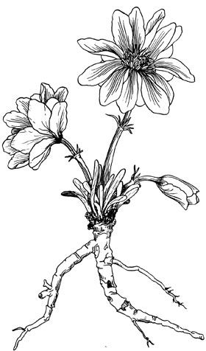
Curriculum Organizers: (Students will:)

1. Oral Communication
-Gain the ability to communicate effectively and purposefully.
-Understand the importance of oracy and the oral tradition in First Peoples cultures, including the maintenance and preservation of those cultures.

2. Writing and Representing
-Develop the ability to create, produce or present a wide range of written and visual texts
-Gain confidence and competence in communicating effectively in a range of forms and styles to suit specific purposes and audiences.
3. Reading and Viewing -Gain the ability to understand and respond to a wide range of literary, informational, and persuasive written and visual texts. -Be able to not only comprehend the ideas communicated in a text but to apply them in new contexts. -Be able to make connections between different texts and, if necessary, view and comment on one text through the lens (perspective) of another.

Re-write policy:
All assignments in the course may be re-submitted. Students are encouraged to use this option to improve their skills. Students may have up to one week to re-write any assignments.

Texts: Some example texts we will study.
Rabbit Proof Fence (Movie) Whale Rider (Movie) Smoke Signals (Movie) First Contact (TV series)
The Truth About Stories - Thomas King (Essays/Lectures) Angry Inuk (Movie), Highway of Tears (movie), Monkey Beach (movie), Trickster (TV series), various lit circle novels, non-fiction, poetry, and short stories

Note: many of the texts in this course deal with sensitive and mature subject matter. If needed, an alternative text can be provided.

Final Project: Inquiry Project on Reconciliation. Students will have a choice to deepen their understanding of a topic connected to the course that they are interested in, or investigate what reconciliation looks like in the career that they want to pursue.

How to succeed in English FP
1. Be willing to step outside your comfort zone. You will get as much out of this course as you are wiling to put into it. 2.The class is only complete when you are here –so show up!

-I will endeavor to keep homework to a minimum. Most assignments will be done in class. In return, I expect that all students will make every effort to attend each class on time. Parents will be contacted when students have unexcused absences or excessive lates. If you must be absent from a class, it is your responsibility to pick up the assignments you missed, preferably before class. Use my website to help you stay caught up.

3. Treat everyone (peers, me, guests) with respect. Use devices responsibly.

4. Be on time and ready to go. Field trip days meet at bus.

5. Coffee for Mrs. Fitton never hurts 😊.

“Stories are wondrous things. And they are dangerous”-Thomas King
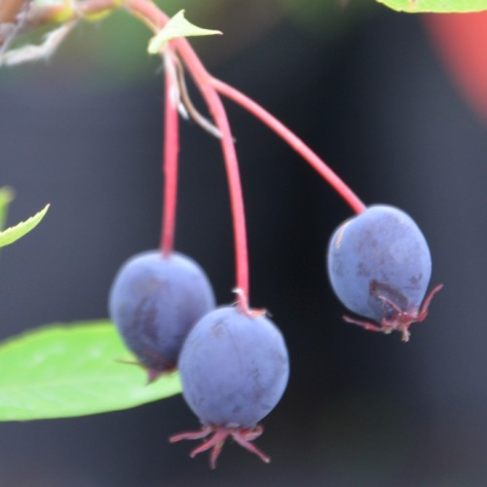
Tentative Schedule:
Unit 1: Siya? (Saskatoon Berry) September/October
Theme: Innovative thinking and new learning
Key Skills: Creative writing and course themes introduction
In this unit, we will be introduced to the philosophy and big ideas behind the course as well as learn the key components of creative writing and presentation.
Field trips: Enow’kin Centre, Downtown, Skaha Bluffs, Mall, water ceremony (Skaha lake), multicultural banquet, meet kindergarten buddies
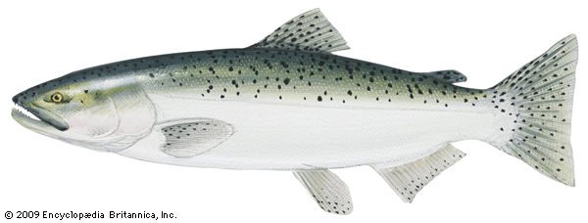
Unit 2: Ntityix (Spring Salmon) October/November/December)
Theme: Navigating your own destiny, showing perseverance, and overcoming obstacles
Key Skills: Novel study, poetry, film study, non-fiction
In this unit you will choose a novel and study it in small groups. We will also have a poetry café, study the movie Rabbit Proof Fence and the issues facing Australia’s Aborigines and learn about the current Canadian issue of Missing and Murdered Indigenous women
Field trips: Café, Farm, Art Gallery, kindergarten buddies, museum,

Unit 3: Skemxist (Black Bear) January
Theme: Wisdom and self-awareness that comes with learning about one’s history, culture and traditional knowledge
Key Skills: Personal Narratives, storytelling, Inquiry Project
In this unit we will write a personal narrative and complete an inquiry project of your choice
Field Trips: Munson Mountain, Finish visits with kindergarten buddies, final project.

