Socials 9 Name _________________________
Mrs. Fitton

Chapter 8 Active Study Review

Test set up: 23 multiple choice, 5 cartoon analysis, 1 map of Eastern Canada, 5 define and explain significance. One small paragraph/labeled diagram

I. The Explorers

1. Where was a North American Viking settlement found in North America? What evidence showed that they had been there? What happened to the Vikings that made them leave Canada?

2. Who was Columbus? Why did he come to North America? What happened to him in the end?

3. John Cabot
- Describe his “Letters Patent”

- How were those letters an indication of a feeling of superiority to the natives in North America?

- What resource did Cabot exploit in North America?

III. The French Explorers

1. Jacques Cartier and the Iroquois
- Describe the relationship between Cartier and Taignoagny and Domagaya.

- What “false” resources did Cartier believed he had found? What were they?

- What valuable resource did Cartier actually bring back to Europe?

V. The Founding of New France

1. Samuel de Champlain
- What was Champlain’s first settlement? What happened to it?

- Describe Champlain’s alliance with the Algonkians and Montagnais.

- What new technology allowed the French to defeat the Iroquois in one of their many battles?

- Why did Champlain form an alliance with the Hurons?

- Which company took over Champlain’s fur trade enterprise after his capture by the English?

VI. Settlement and Colonization

1. The Jesuits

- Why were the Jesuits more successful than other missionaries?

2. The Coureurs de Bois
- Who were they?

- Describe brothers-in-law Radisson and de Grosseliers
- VII. The Royal Colony of New France
1. Describe the theory of mercantilism. List some resources that Europeans wanted to bring back from North America
2. In 1663, what steps did France take to set up a colony in New France

3. Jean Talon
- What position did he hold in the new colony of New France?

- Who were the “filles du roi”? What was their purpose?

- Describe the steps Talon took to improve life in New France

VIII. Life in New France

1. The Seigneury
- Describe the responsibilities of the seigneur and what a seigneury is

2. The Habitants
- Briefly describe the life of a habitant

5. The Seven Years’ War and the Fall of New France
- What area of land was fought over by the French and English?

- Describe the fate of the Acadians during this war

- Who were James Wolfe and the Marquis De Montcalm ?

- Describe how Wolfe and his forces deceived the French from Wolfe’s Cove

- What was the final result of the Seven Years’ War in North America?

IX. Aboriginal Groups in Canada
1. Choose one of the 6 Aboriginal groups we studied and either write a small paragraph or draw and label a diagram describing the following
a. geography and agriculture (region, farming and hunting/gathering)
b. community life and government (social organization, leaders, laws)
c. religion and myths (gods, ceremonies, sacred animals, rituals)

PLAN HERE (list paragraph points, or sketch drawing)

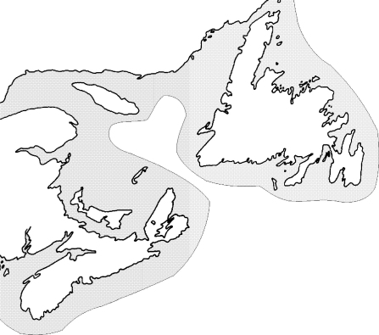X. Map:
1. On a map of Eastern Canada, be able to identify the following:

1. Pinpoint and name the first Viking Settlement in North America.
2. Label the province where most Acadians are from.
3. Label the St. Lawrence River mouth
4. Label Quebec
5. Label the “Grand Banks” where all of the Cod were found.

