IS year 4 Name: _______________________ Canada in the 19th century
Preamble: Mackenzie King once said: “Some countries have too much history, we have to much geography .“ To help us understand what he meant, we are going to investigate how our geography has influenced our history by creating short teaching videos of one of the following 7 topics from Canada’s 19th century.
Topics:

- Confederation
- Metis Rebellion (1st and 2nd)
- The Indian Act
- War of 1812
- 1837 Rebellion
- National Railway
- Cypress Hill Massacre/creation of NWMP

Projects: Choose from one of the following presentation methods (groups of 3-4, presentations should be 3-5 minutes long)

- Render forest
- RSA Animate (draw on white boards and speed up)
- Ted Talk
- Historical Minute
- John Greene’s “Crash Course in History”
- Skit
- Talking tableaus
- Large on chalk board/white board comic strip

Must also include a 1-page (maximum) handout that summarize the 5 w’s of your topic, its connection to the statement of inquiry and 2-3 infographics. Must also cite your sources on the back of your handout ( I will show you how)
Topic: ______________________________________________________________________________
When did it happen:

Who was involved:

What happened (include 8-10 key points)

Interesting facts:

Why was this event significant in Canadian history?

How does this event relate to our statement of Inquiry (Understanding time space and place helps us understand our perspectives, history and identity), in other words, how was our geography a factor in all of these events? Think about things like where we are located, how large our country is, our landscape etc.)

Sources (where you got your information and pictures for your handout).

Example Handout for (Must include information from all the note headings and at least two-three pictures with captions)
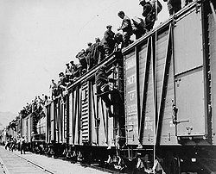
Canada’s Response to the Great Depression

Who: Prime Minister Bennett and Mackenzie King, The CCF, Social Credit party, and Unione Nationale, Canadians

Where: All over Canada

When: 1929-1939
The On-to-Ottawa Trek
What:
-King: Wouldn’t give a 5 cent piece to a Tory Provincial government, provincial gov’t can take care of it
-Bennett: Dear Mr. Prime Minister, Tighten Belt, poverty builds character, New Deal, 20 million to provinces, Pogey, Work Camps, unemployment relief act, tariffs,
-Farmers: Tree Screen, Trash Farming, Stubble Farming, Prairie Farm Rehabilitation Act
-Canadians: distractions from the Depression such as Grey Owl, The Dionne Quints, Mini-golf, Movies
-protests such as The On-to-Ottawa Trek, Regina Riot and Vancouver Sit-ins, -Vote for other parties such as the CCF, Social Credits, Unione Nationale

Why:
-While the responses helped Canada deal with the Depression, nothing but total war after the beginning of World War Two would truly end The Great Depression

Interesting Facts:
-to get the pogey you had to declare publicly that you were destitute
-One person died in the Regina Riot
-Public work projects like bridges and roads that literally went nowhere were used to put people to work
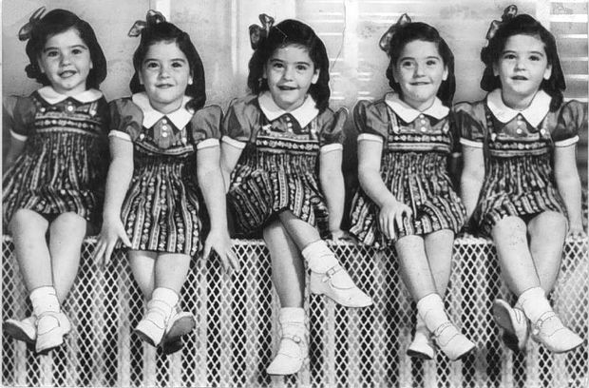
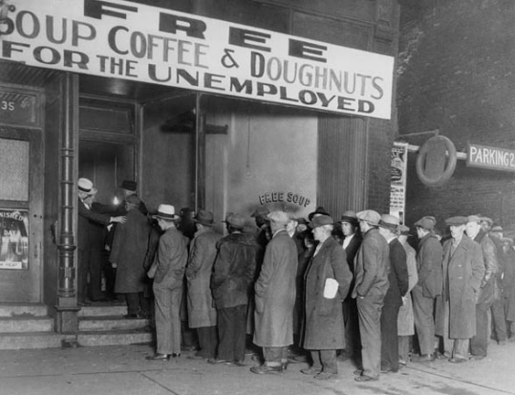
A food bank The Dionne Quints

Achievement Level | Criterion A: Knowing & Understanding | Criterion B: Investigating | Criterion C: Communicating
0 | The student does not reach a standard described by any of the descriptors below.
1-2 | - demonstrates basic knowledge and understanding of content and concepts with minimal descriptions and/or examples. | - collects and records limited information, not always consistent with the research question, | - communicates information and ideas in a limited way, using a style that is limited in its appropriateness to the audience and purpose,  - documents sources of information in a limited way
3-4 | - demonstrates adequate knowledge and understanding of content and concepts through satisfactory descriptions, explanations and examples. | - uses a research method(s) to collect and record mostly relevant information, | - communicates information and ideas satisfactorily by using a style that is somewhat appropriate to the audience and purpose,  - sometimes documents sources of information using a recognized convention.
5-6 | - demonstrates substantial knowledge and understanding of content and concepts through accurate descriptions, explanations and examples. | - uses research method(s) to collect and record appropriate relevant information, | - communicates information and ideas accurately by using a style that is mostly appropriate to the audience and purpose,  - often documents sources of information using a recognized convention.
7-8 | - demonstrates detailed knowledge and understanding of content and concepts through thorough accurate descriptions, explanations and examples. | - uses research methods to collect and record appropriate, varied and relevant information, | - communicates information and ideas effectively and accurately by using a style that is completely appropriate to the audience and purpose,  - consistently documents sources of information using a recognized convention.

