Language and Literature Year 4 Name: ____________________
Bullying Lit Circle Summative Assessment
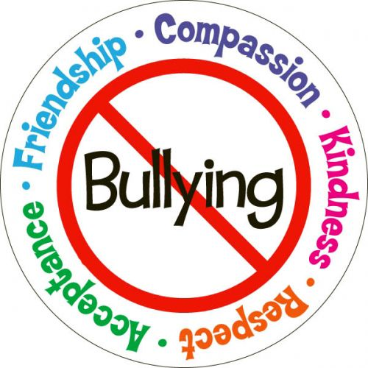
Inquiry Question: Will understanding different characters and their perspectives help create empathy in us and in time, help create a world where we embrace our differences?
Global Context: Fairness and Development
Goal: Demonstrate/highlight the negative impact of bullying and help change other peoples’ perspectives in order to affect change
Role: Activist whose task is to promote a positive change in our community
Audience: Peers/staff/Penticton/Community/World
Situation: You have been hired by a non-profit organization to promote a bully free environment and create compassion for others
Product; You will create a: Pamphlet, TED talk, info-graph, bulletin board, button/sticker/bracelet (and campaign to introduce to the school), art or poem (rap, written, Spoken word), video, create a fundraiser for a group that helps with bullying issues (YES project, pink wrist campaign), Show a video at lunch with an anti-bullying message, include a short informational presentation, attend a meeting (p-flag, special needs support groups), create a children’s book and share it in an elementary classroom, your own idea
You may work by yourself or with one other person
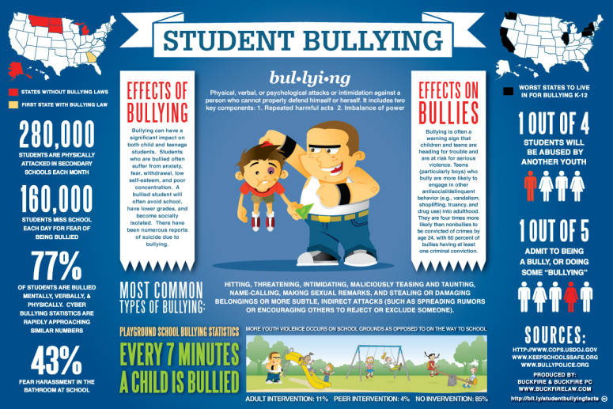
With your summative assessment, you will also include a written reflection (200-300 words) that explains the following:
- How your project meets the goal of the GRASP
- How it helps answer our inquiry question (see above)
- How a character in the novel you read would have benefited from your project
- The process and steps you engaged in to create your product
- Any obstacles you encountered and how you overcame them
- Your favourite part of this assignment
- Why you chose that particular product
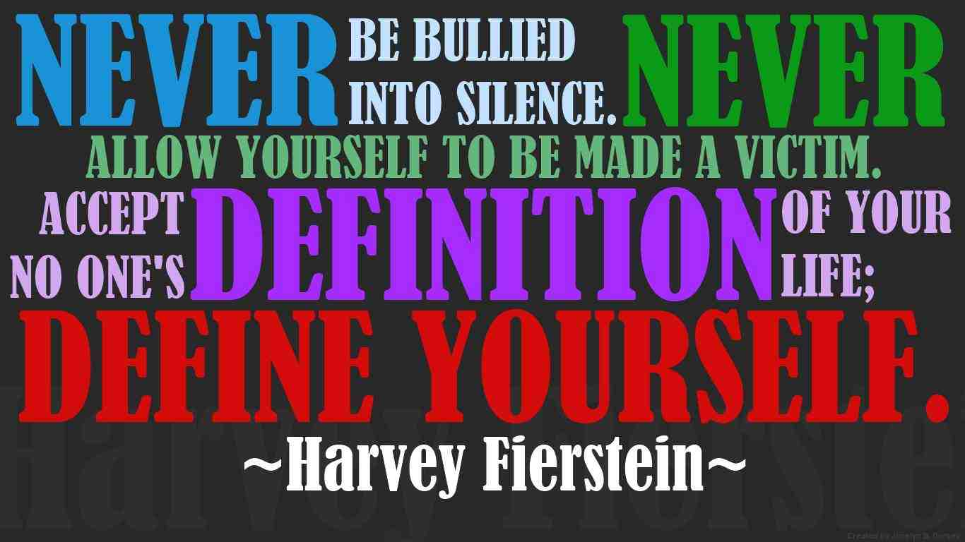
- Do you think that you are self-directed? Do you have to be told exactly what to do all the time? Or are you able to challenge yourself and take responsibility? Did you use class time well? If you finished early did you wander around with nothing to do? Or did you try to make use of your time?
- What were your strengths in this project? What could you do to be more successful next time? hat were your strengths

